

**Digital Content Operations**

**Process Documentation**

**Version X.X | DD-MMM-YYYY**

# Document Control

**Document Version History**

This table shows a record of significant changes to the document.

|  |  |  |  |
| --- | --- | --- | --- |
| **Version** | **Date** | **Author** | **Description of Change** |
| 0.1 |  |  |  |

# TABLE OF CONTENTS

Document Control 2

TABLE OF CONTENTS 3

INTRODUCTION 10

ABBREVIATION & ACRONYMS 10

1 On Boarding- Steps to be followed by new Producers 11

1.1 Catalog 11

1.2 Mailbox Set-Up Guide 11

1.3 Pre-requisites 11

1.4 Essential URLs 12

2 Commerce catalogue management 13

2.1 ATG Overview 13

2.2 Login to ATG 14

2.3 Introduction to ATG UI 15

2.4 Creating a new project 16

2.5 Working on a project 17

2.6 Deleting a project 19

2.7 Basic structure of ATG in VHA 21

3 Device Launch 23

3.1 Device Launch Overview 23

3.2 Creating Device 27

3.3 Adding Feature values 30

3.4 Adding Key Features 32

3.5 Adding Category 33

3.6 Creating Device SKU 34

3.7 Creating Handset Media Gallery 38

3.8 Creating Media assets for Device SKU 40

3.9 Adding the Price of the device 43

3.10 Creating a Bundle 44

3.11 Creating Bundle SKU for a new Device 48

3.12 Creating a Discount 52

3.12.1 Creating a Discount SKU 54

3.12.2 Modifying Plan SKU based on Discount SKU 57

3.12.3 Modifying Device SKU based on Discount SKU 60

3.12.4 Modifying Bundle SKU for a Discount SKU 60

3.13 Lock Conflict Resolution 62

3.14 Publishing in ATG 64

3.15 Device Launch Analytics – Classification File 65

3.16 Here is the list of what needs to be exported from ATG: 65

4 Bank BSB code creation 66

4.1 BSB Overview 66

4.2 Steps for updating the code 66

5 Prepaid recharge plan E2E testing 69

5.1 Overview 69

5.2 Prerequisites: 69

5.3 Following are the steps to create a new Prepaid recharge plan in ATG: 69

5.4 E2E process for recharge plan update/launch 74

6 Prepaid Refresh Documentation for reference: 75

6.1 Prepaid Refresh Overview 75

6.2 Project Description 75

6.2.1 Impact Overview 75

6.3 Prerequisite: 76

6.3.1 PAF/PCRS Document - contains the scope of the refresh. 76

6.3.2 ATG Configuration log – contains all the specifications like External SKU ID, Inclusions, top-up profile, Recharge type, expiry etc. for the new/existing plans. 76

6.3.3 Disclaimer Guide – contains the terms for the new plans. Might be generic, update as required. 76

6.3.4 Rates and charges – to be shared with the stakeholder and get it approved. 76

6.3.5 CIS document. 76

6.3.6 QA Environment for Testing. 76

6.3.7 Design and Copy. 76

6.3.8 How to read the config Log: 76

6.4 Plan/Bundle Set up: 77

6.4.1 Refer ATG Documentation for setting up new plans and bundles in ATG. 77

6.4.2 Refer WCS Documentation for setting up price-points in WCS. 77

6.5 ATG Configuration: 77

Starter Pack Journey: 77

6.5.1 Create Plan, Plan SKU, Bundle SKU. 77

6.5.2 Associate the child SKU’s to their parent. 77

6.5.3 Associate the parent to the category. 77

Note: The plans won’t be adding to cart if the parent is not associated to the category. 77

Recharge Journey: 77

6.5.4 Create Plan and Plan SKU. 77

6.5.5 Associate the child SKU’s to their parent. 77

6.5.6 Associate the parent to the category. 77

Note: 77

6.5.7 There are multiple journeys for recharge say Uni-sim Activation, Voucher, Wallet and Self-Serve. Separate SKU’s needs to be created for each journey. 77

6.5.8 ATG Cache needs to be cleared for the plans to reflect in My-Vodafone after pushing the ATG project to production. 77

6.5.9 URL’s for clearing ATG Cache: 77

• Username/Password: admin/atgflush 77

• https://myaccount.myvodafone.com.au/flush_cache 77

• https://activation.services.vodafone.com.au/flush_cache 77

6.6 E2E process for testing: 77

7 Logistics Update 78

7.1 Logistics Overview 78

7.2 Logistics Steps 78

7.3 ATG Inventory update 84

7.4 Out of Stock 85

7.5 In Stock 85

7.6 Country Code Update in ATG 86

8 Web content operations 87

8.1 WCS Overview 87

8.2 Login to Webcenter 87

8.3 Introduction to Webcenter UI 89

8.4 Creating a page and it’s components 89

8.5 Creating a Row100 and Row Container asset 95

8.6 Creating a Free Text Module asset 97

8.7 Creating a Link asset 98

8.7.1 Inserting a link asset into a module 100

8.8 Creating an image asset 101

8.9 Inserting an image asset into a module 103

8.10 Creating a document asset 104

8.11 Creating a banner asset 106

8.12 Creating a Hot Offer Banner module 108

8.13 Creating an Icon CTA module 110

8.14 Creating an accordion asset 112

8.15 Creating a Price point asset 113

8.15.1 Creating Plan Highlight 116

8.15.2 Creating Plan Filter Option 117

8.16 Creating a Promo bar 117

8.17 Creating a button on an image 119

8.18 Creating Mega Menu and Footer 121

8.19 Creating Form 125

8.19.1 Creating form fields 126

8.19.2 Testing a Form using Source code 130

8.20 Creating and updating Critical Information Summary 131

8.20.1 Creating a CIS asset 131

8.20.2 Archiving a CIS asset 134

8.21 Setting up Device Landing Page 134

8.21.1 Creating an Bundle asset 134

8.21.2 Creating an device asset 135

8.21.3 Refreshing the device listing page 136

9 Caching in WCS & Audit Process 138

9.1 How to clear the cache of a page 138

9.2 Audit Process 141

10 Half Price for Prepaid MBB and Voice 141

10.1 Half Price Overview 141

10.2 Ticker for Hot-offers page 142

10.3 Prepaid Homepage and homepage VCA changes 142

10.4 Prepaid Plans Page / Prepaid Broadband Plans page VCA changes 142

10.5 MCP page VCA changes 143

10.6 Hot-Offers 143

10.7 ATG changes 143

10.8 Working in ATG 143

10.9 Touch Points 144

10.10 Westpac Offer 144

10.11 Cart deep links 145

11 BAUs 145

11.1 BAU Overview 145

11.2 Creating New support Pages 146

11.3 RTDM 146

11.4 Vanity URL 147

11.5 Short URL 148

11.6 Retire and Redirect 148

11.7 Promo code creation 148

11.8 Long Terms 149

11.9 Campaign Page creation and Updates 149

12 User Creation, Termination and Password Reset 149

12.1 UAM Overview 149

12.2 User Creation 149

12.3 Password Reset 150

12.4 User Termination: 151

13 Offers 151

13.1 Offers Overview 151

13.2 Upgrades Offer 152

13.3 Delivery of the offer 152

13.4 Urgent/Reactive Offers 152

# INTRODUCTION

The purpose of this guide is to provide detailed information and steps for content management in VHA. It also provides detailed information about the best practices followed by the producers.

# ABBREVIATION & ACRONYMS

|  |  |
| --- | --- |
| **Abbreviation or Acronyms** | **Definition** |
| VCA | vodafone.com.au |
| CMS | Content management system |
| MBB | Mobile Broadband |
| CIS | Critical Information Summary |
| SKU | Stock Keeping Unit |
| ATG | Art Technology Group |
| EOL | End of Life |
| OHU | Only Handset Upgrades |
| OTP | One Time Password |
| PAF | Pricing Approval Form |
| PIR | Post Implementation Review |
| PCRS | Project Charging Requirements Specifications. |
| RTM | Requirements Traceability Matrix |
| SIMO | SIM Only |
| TTL | Through The Line |
| UAT | User Acceptance Training |
| ETL | Extract Transform Load |
| PRC | Product Catalogue |
| AWS | Amazon Web Services |
| BAU | Business as usual |
| CRO | Conversion Rate Optimization |
| GWP | Gift with purchase |

# On Boarding- Steps to be followed by new Producers

## Catalog



## Mailbox Set-Up Guide



## Pre-requisites

**Proxy settings**

* Launch IE -> go to Tools menu towards the top right -> click on Internet options at the end of the menu.

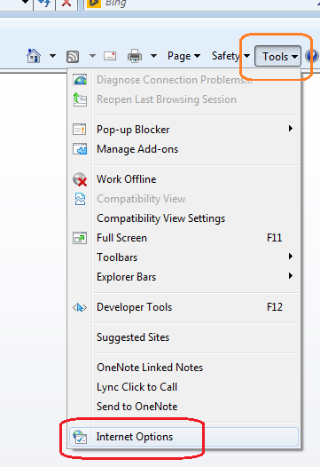

Update the proxy details under the “Connections” tab by clicking the “LAN settings” button and then filling Address = 10.127.2.123 and port = 8800. Then click “Advanced” button and enter the below under “Exceptions” *\*aws.vodafone.com.au, sit*application_int.staging.model3.test.estore.aws.vodafone.com.au, *.staging.shop.prod.estore.aws.vodafone.com.au.* Update by clicking “OK” to save the settings on the dialog box.

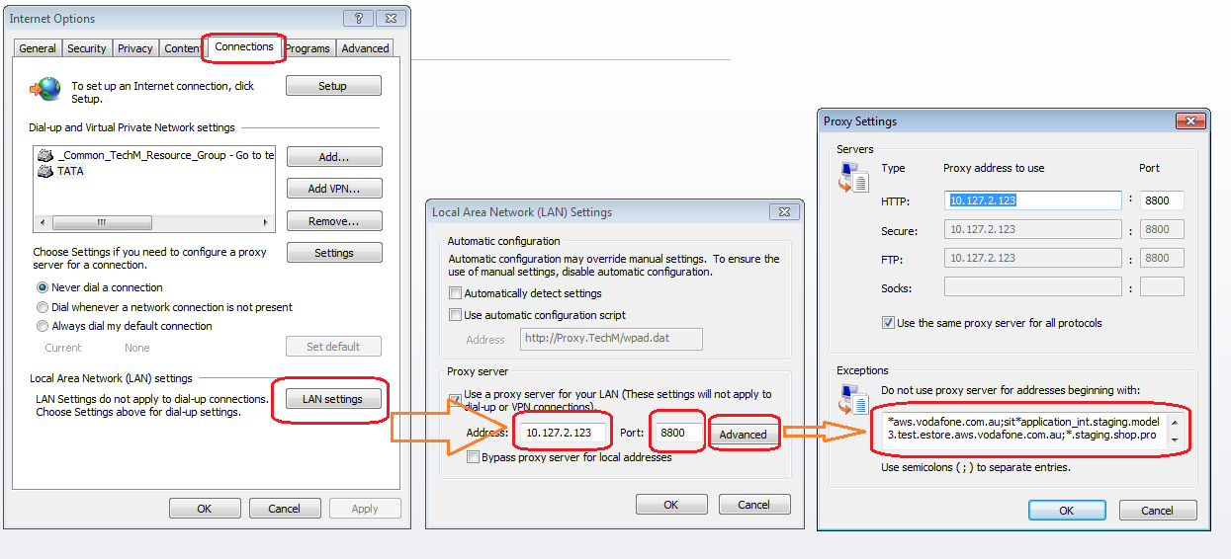

*Firefox UI:*

If the user interface is not visible on Firefox and the error message says to install a plugin, then Adobe Shockwave player for Firefox should be installed.

## Essential URLs

Vodafone Live Site : [www.vodafone.com.au](http://www.vodafone.com.au)

|  |  |
| --- | --- |
| **URL** | **Links** |
| **VHA OWA** | <https://webmail.vodafone.com.au/owa/auth/logon.aspx?replaceCurrent=1&url=https%3a%2f%2fwebmail.vodafone.com.au%2fowa> |
| **OWC** | <http://cas.auth.vca-refresh.prod.ucms.aws.vodafone.com.au/cas/login?service=http%3A%2F%2Fauth.vca-refresh.prod.ucms.aws.vodafone.com.au%3A80%2Fsites%2Fwem%2Ffatwire%2Fhome> |
| **Staging URL** | <http://auth.vca-prod.prod.ucms.aws.vodafone.com.au> |
| **Delivery URL** | <http://vca-prod.prod.ucms.aws.vodafone.com.au/> |
| **ATG Dev** | [http://bcc.prod.estore.aws.vodafone.com.au/atg/bcc/home#](http://bcc.prod.estore.aws.vodafone.com.au/atg/bcc/home) |
| **ATG Staging** | <https://staging.prod.estore.aws.vodafone.com.au/> |
|  |  |
| **Wiki** | <https://vodafone.atlassian.net/wiki/spaces/DDP/pages> |
|  |  |
| **Agile VHA Jira Board** | <https://vodafoneaus.atlassian.net/secure/ManageRapidViews.jspa> |
| **Digital Campaigns Project WIP** | <https://vodafoneaus.atlassian.net/secure/RapidBoard.jspa?rapidView=299> |
| **To Raise BAU Requests** | <http://intranet.vodafone.com.au/resources/digital-work-request> |
| **Invalidator (Clear cache)** | <https://invalidate.aws.vodafone.com.au/invalidation/EC10H5QBHFEIP/I26PJMYZM9TRP8> |
|  |  |
| **Cludo** | <https://my.cludo.com/#/login?returnUrl=%2F1761%2Fdashboard> |
| **Twitter Validator** | <https://twitter.com/login?redirect_after_login=https%3A%2F%2Fcards-dev.twitter.com%2Fvalidator> |
| **Facebook debugger** | <https://developers.facebook.com/tools/debug/> |
|  |  |
| **TO-DO_LIST** | <https://docs.google.com/spreadsheets/d/1ybAs21Z5Sh3uoTcjojtKXy_4znfhxE5oSEh0pdns0fY/edit?ts=5a0a7d1c#gid=1386834576> |
| **Site IA** | <https://docs.google.com/spreadsheets/d/1W5RjYWHCXZdJT4fNjIgNEChrvPno1H5-GDXU1GMclfg/edit#gid=0> |
| **Offer List** | <https://docs.google.com/spreadsheets/d/1CSiuH8AgaVEEYiAgWPr00-_EriP47FRSmKLMngDADNI/edit#gid=155078380> |
| **Daredevils's Calendar** | <https://docs.google.com/spreadsheets/d/1UW52T2qnZ9Jf6xwuVtgH4O9AKFX8yiYaYcrrC0a5GbE/edit?ts=5b22129c#gid=0> |
| **Daredevils's BugTracker** | <https://docs.google.com/spreadsheets/d/1a5zmoyG25PZT55kMkdxxKbCyrQjcIQunI2cYit2MdY4/edit?ts=581fd273#gid=2126269685> |
| **Daredevils's checklist** | <https://docs.google.com/spreadsheets/d/1JEfLKQ8japlNBVi3r6iyYbZWaRBbCqcDoWroN_jCGeg/edit#gid=1041117507> |

# Commerce catalogue management

Below are the Topics for Content Publishing steps involved while working with ATG

## ATG Overview

We are using Webcenter Sites to build all the pages located in shop.vodafone.com.au/e-store part. In another word, we use it to build VHA(Vodafone Hutchison Australia)'s portal website which shows more than following content to customers:

• About VHA

• Services & Products provided by VHA

• Customer care content

• Links to other sites within domain VHA

It also helps VHA release new phone, plans, services and campaign in short time to earn more customers.

1. All the URLs which are of the form shop.vodafone.com.au /e-store part belong to ATG.
2. All the images and related files will be given by Visual Designers. Sometimes we use an existing asset in which case it’s better to search for the asset in ATG. If we don’t find the asset we should create a new asset.
3. All the text to be added to the website will be provided by Copywriters.

## Login to ATG

Go to the ATG launch site on a standard browser. The login screen is seen as below:

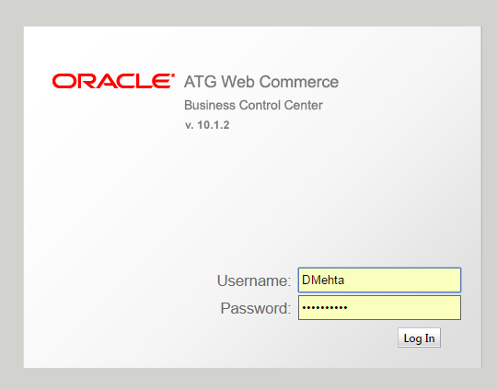

Enter the username and password accordingly.

## Introduction to ATG UI

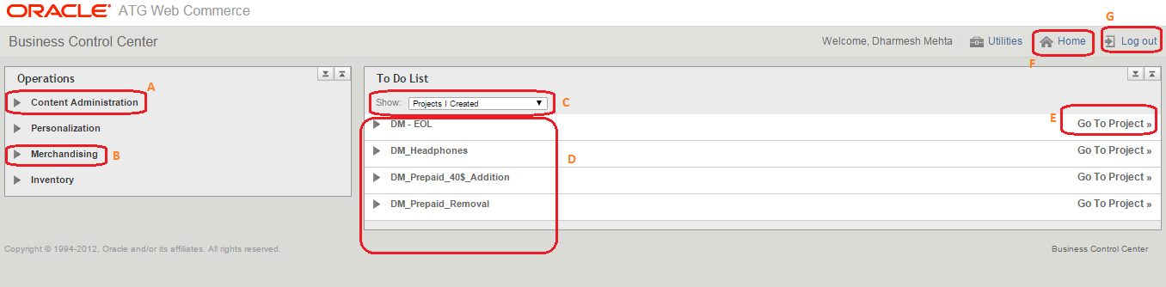

A: All the admin activities which can be done by the user (provided the admin rights are granted). The activities include Admin console which lets the user to flush the project to Production instantly.

B: Merchandising (🡪Manage Commerce Assets) is used to create a new project. This new project does not impact the staging or Production unless it is published explicitly.

C: This to do list is used to filter out the projects.

D: As per the filter set for the “To do list” (see C above), the projects are listed here.

E: This option “Go to Project” is used to publish the resources specific to the project to staging and production step by step. In case we need to make some changes we can also revert back the project from staging or production.

F: This is link to home page.

G: Option to log out of ATG console.

## Creating a new project

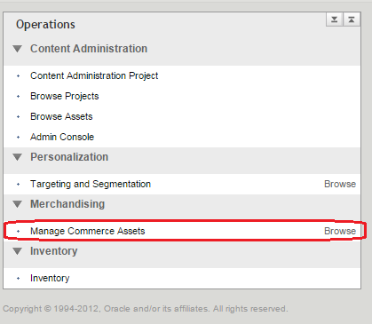

1. Click on “Manage Commerce Assets” under “Merchandising”.
2. Enter meaningful “Project Name” and “Project Description”. Standard practice is to put your initials (“DM” in the e.g. below) and a short project description, all separated by underscores (_). Example shown below for $40 half price offer removal:

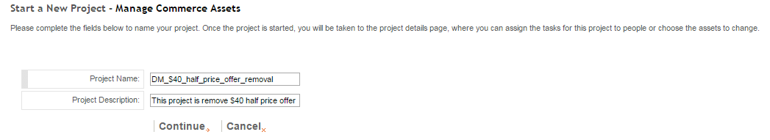

1. Click on Continue to create the project or click Cancel if you do not want to create the project at present.

## Working on a project

To start working (authoring) on a project, go to home (see above section 4.5 for going to home page), and click on the Project Name to expand the options.

**Before expanding:**

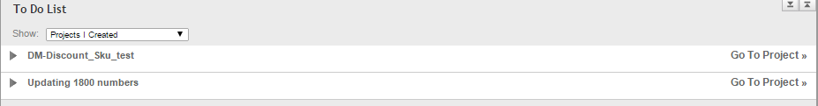

**After expanding:**

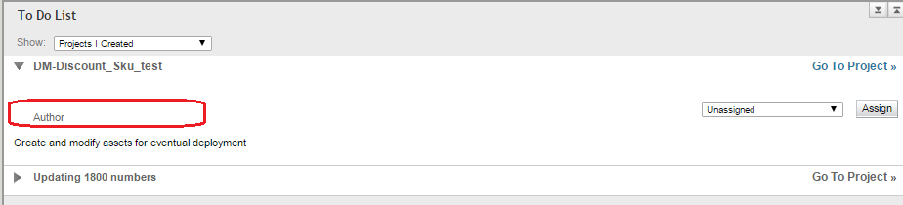

Click the “Author” option which will take you to the authoring page as shown below.

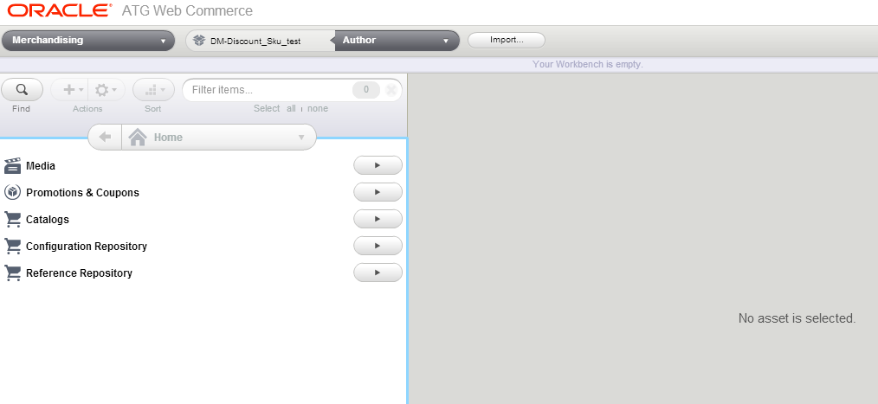

All objects which are edited in the project will be inside the project box on top as shown below:

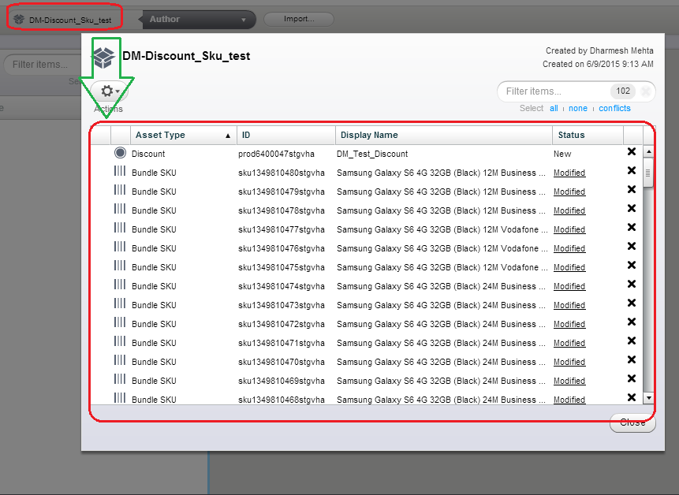

## Deleting a project

There are 2 ways you can delete a project.

1. While in Authoring mode, click on “Author” and then select “Delete Project” option

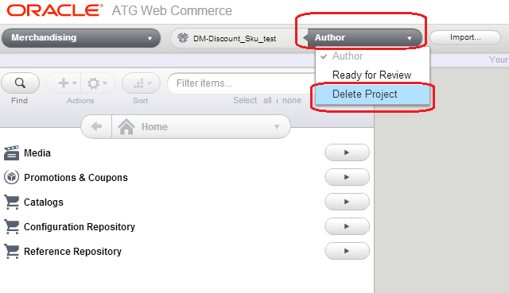

Give the reason for deleting the project as comments and click on “Continue” to confirm deletion or click “Cancel”.

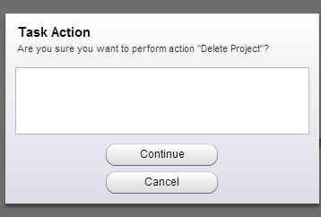

1. Click on “Go to Project” option for the project to be deleted on home page

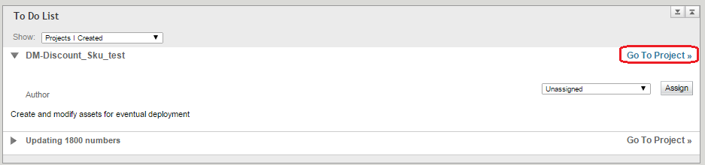

Under “Author” actions, select the “Delete Project” option.

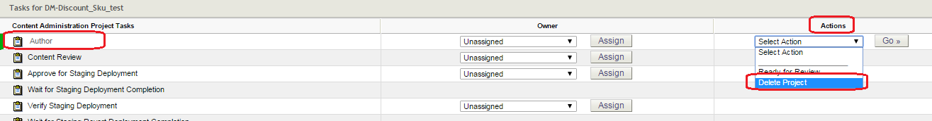

## Basic structure of ATG in VHA

Below is the basic structure of ATG. The majority of tasks can be completed within these assets.



**Device:**

These assets contain the basic information regarding the device which isn’t colour or capacity related.

*Items within this asset include:* Name, Why buy this, 4 key features, device specifications.

**Device SKU:**

These assets contain information regarding the device specific to the colour and capacity.

*Items within this asset include:* External SKU id (device), friendly URL, Hero bundles, device images, prepaid price.

**Bundle:**

These assets are created to join the bundle SKUs to the catalogue tree.

**Bundle SKU:**

These assets are created to link all the other SKUs together.

*Items within this asset include:* links to device SKUs, plan SKUs and discount SKU, device/plan price

**Plan:**

These assets contain information regarding the plan.

*Items within this asset include:* more info/tell me more tab, ranking, associated categories

**Plan SKUs:**

These assets contain additional information regarding the plan.

*Items within this asset include:* Name, Proposition ID, Plan ID, External SKU ID, Term, Calls included, Data included, Standard national, CIS link, Term and Conditions, Plan Group, Plan price.

**Discount:**

These assets are created to join the discount SKUs to the catalogue tree.

**Discount SKU:**

These assets display a discount SKU underneath the relevant bundles in the device/cart pages

*Items within this asset include:* Name, Highlight, Highlight override, font-image-id, Discount Type

# Device Launch

## Device Launch Overview

* The list of device we are going to publish on the site will be present on Device Launch Schedule Group.
* The device launch schedule is a group on chatter that is run by the devices head from the devices team. Within this group you will find the calendar of upcoming devices that is updated weekly. Due to the sensitivity of the information, the launch schedule cannot be printed out.
* In this chatter group, one pagers for new devices can be found. They are created by the devices team and are used by both the copywriters and producers use to extract the information they need to launch a new device. One pagers are uploaded a month in advance. Using the one pager we will update the features and key features for the device.
* To gain access to Device launch Schedule chatter group, log in to chatter, search "Device Launch Schedule" and request access.

**Pricing Master Matrix**

* The pricing master matrix is an excel document that is used business wide and is put together by the billing team. This matrix features the pricing and device codes of all devices the business offers and should be referred to first when launching a new device, price change or if there is a discrepancy online. The master matrix is loaded into Siebel every night.
* To gain access to the master matrix, email to billing team and they will add you to the distribution list.

**Stakeholders**

| **Assets/Touch points** | **Department** |
| --- | --- |
| Pricing | Pricing team |
| Device Specifications, features and imagery | Devices team |
|  | Marketing/Design |
| External SKU ID and delivery times | Logistics team |
| Design & Content | Digital Copywriter |
|  | Digital Copywriter |
|  | Devices team |
|  | Legal |
| World Manuals | External |
| Live URLs | SEM |
| OHU Publication | Tech M |
|  | Tech M |

**Legal approval**

* All factual changes on the website must be approved by our Marketing Legal team. This team has a 48 hour turn around time. Each department has two urgents they can use each week to expedite an approval to within 24 hours.
* Approval will not be granted by the legal team until all relevant terms are included. Terms for a product can be found on the intranet under [disclaimer guides](http://intranet.vodafone.com.au/forms-policies/disclaimer-guides). Our legal team also requires us to seek approval from any relevant stakeholders involved in the project, the list of required stakeholders can be found on the intranet under [Collateral sign off checklist](http://intranet.vodafone.com.au/Disclaimer-guides/Collateral-Sign-off-Checklist_v16.pdf).
* The following preamble must be included in the email with the necessary areas filled out, this needs to be sent every time you submit a piece of collateral for review.

**Touch points**

To ensure a smooth journey for customers, the following pages must also be updated when we launch a device:

* [4G phones and devices page](http://www.vodafone.com.au/personal/4g-phones-and-devices)
* [Android homepage](http://www.vodafone.com.au/personal/android/home)
* [iPhone homepage](http://www.vodafone.com.au/personal/iphone)
* [Hot offers page - Consumer](http://www.vodafone.com.au/personal/hot-offers)
* [Hot offers - Business](http://www.vodafone.com.au/business/hot-offers)
* [iPad for business](http://www.vodafone.com.au/business/devices/tablets)
* [MBB for business](http://www.vodafone.com.au/business/devices/mobile-broadband)

Designers and copywriters will be able to provide the necessary assets for these touch points.

**Device imagery**

[Requirements can be found here:](https://vodafone.atlassian.net/wiki/spaces/DDP/pages/56887748/Device+image+requirements)

**Handset sizes (all front facing images, unless specified):**

eStore touchpoints

- Cart Thumb 43x62 JPEG

- Cart Image 112x182 transparent PNG

- Device Page 462x387 JPEG (4G Badge if applicable)

 - Gallery Large Front: 215px width (No white space)

- Gallery Large Back: 215px width (No white space)

- Gallery Large Side: 215px width (No white space)

 - Gallery Thumbnail Front: 65x65 thumbnail image

- Gallery Thumbnail Back: 65x65 thumbnail image

- Gallery Thumbnail Side: 65x65 thumbnail image

VCA touchpoints

- 4G ready/ device page 120x120

- Plans carousel: 130x236

- Offer module 360 image 250x160

**Tablet sizes (all front facing images, unless specified):**

eStore touchpoints

- Cart Thumb 43x62 JPEG

- Cart Image 112x182 transparent PNG

- Device Page 462x387 JPEG (4G Badge if applicable)

 - Gallery Large Front: 215px width (No white space)

- Gallery Large Back: 215px width (No white space)

- Gallery Large Side: 215px width (No white space)

 - Gallery Thumbnail Front: 65x65 thumbnail image

- Gallery Thumbnail Back: 65x65 thumbnail image

- Gallery Thumbnail Side: 65x65 thumbnail image

VCA touchpoints

- 4G ready/ device page

**MBB sizes (all front facing images, unless specified):**

eStore touchpoints

- Cart Thumb 43x62 JPEG

- Cart Image 112x182 transparent PNG

- Device Page 462x387 JPEG (4G Badge if applicable)

Please test these images as we have had sizing issues before

- Gallery Large Front: 215px width (No white space)

- Gallery Large Back: 215px width (No white space)

- Gallery Large Side: 215px width (No white space)

- Gallery Thumbnail Front: 65x65 thumbnail image

- Gallery Thumbnail Back: 65x65 thumbnail image

- Gallery Thumbnail Side: 65x65 thumbnail image

 VCA touchpoints

- 4G ready/ device page

**ETL & PRC**

* During every device launch ETL and PRC should be run.
* Currently for small devices we are running the ETL, incase of high end device launch we should involve the eTech and BSS IT teams to run ETL and PRC
* This ensures that all new devices SKUs and pricing are being received by Fusion and then Siebel and responding back to ATG to complete a customer sale. This also refreshes the content in OHU (upgrades).

## Creating Device

Every device which gets launched by Vodafone is added in ATG. The device details page which has the information about the colour, capacity, price and features of the device is built using the information added in ATG authoring system.

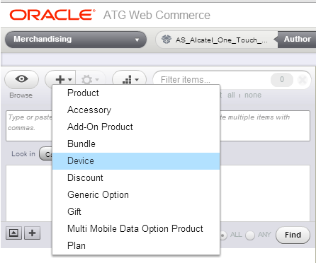

1. For creating a new device, click on the ‘+’ button and select device.
2. Enter the name, management display name field and select the appropriate brand name for the device.

The management display name is the name by which the asset will be known inside ATG. It is always a good practice to add the variant “3G/4G” in the name.

1. Fill all the required fields. You may refer an existing asset inside ATG.
2. Ranking can be selected based on the appearance of the device on the device listing page. The lower the ranking of the mobile the higher it appears on the device listing page.

If you want your device to come up first on the device listing page add a rank of 1. Please note that this field is not exclusive and more than one device can have same rank. In such a scenario coding will determine the order of display of mobile.

1. Medium description field determines the content of “Why buy this?” section on the page. The content of this field is provided by copy writers.

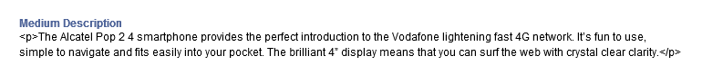

1. For adding the Features refer section 9.1.
2. For adding the Key Features refer the section 9.2.

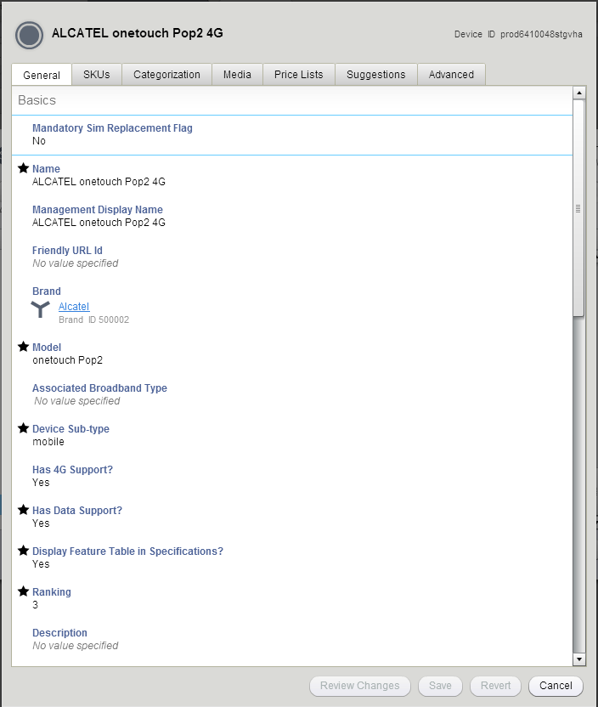

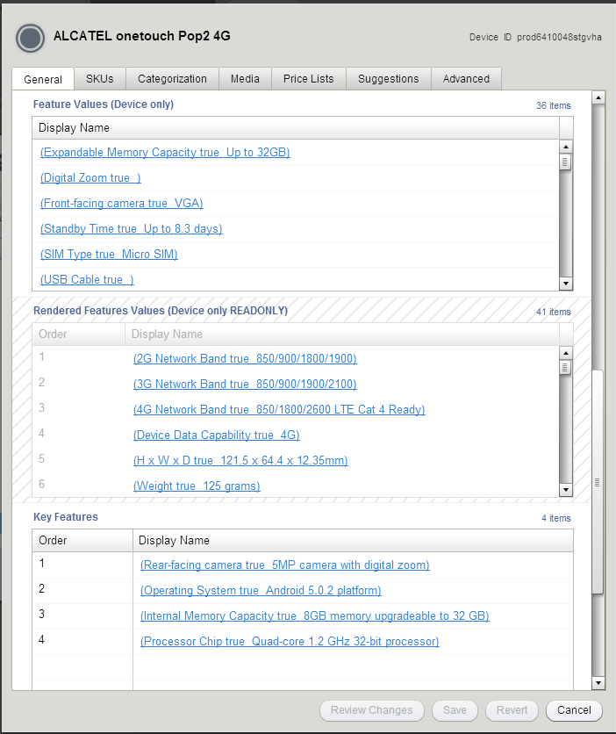

## Adding Feature values

Every device has features which are common across different colours and capacities of the phone. All these features are added in this section. You need to refer a One-pager document to be able to add the features. You need to make sure that you add the maximum number of features present in One-pager document.

1. Each feature has its own category. Select appropriate category for each feature. Some of the features present on One-pager document does not have corresponding category in ATG. Hence you should leave out that feature. For selecting appropriate category you may refer to existing device asset.
2. Feature’s text value attribute determines the text which is to be displayed for the feature. This field is not a required field and can be left empty.
3. Select the Boolean value as ‘yes’.
4. Click on save.

Please note that certain features will be Booleans only i.e. the features will either be present or not. In this case you just need to add the category.

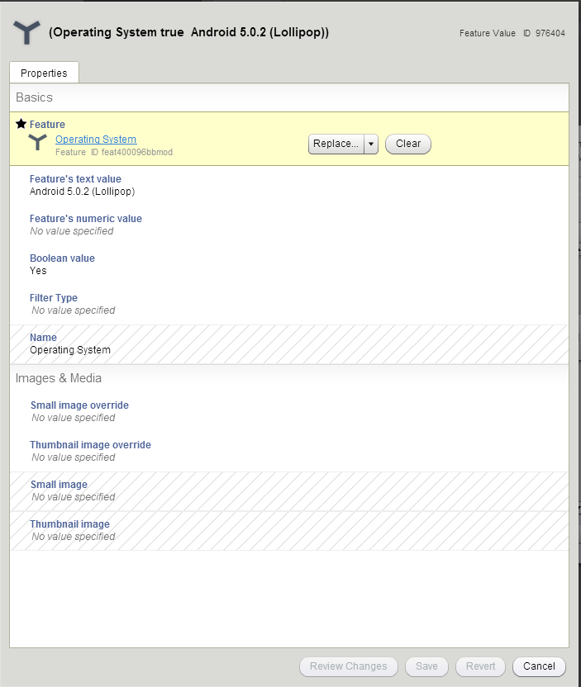

## Adding Key Features

Key features section is determined by the copy writers. You can add 4 key features. They should be added in the order in which they are provided. While the process of creating a key feature is same as that of a feature they are different in the aspect that key feature has an additional image added.

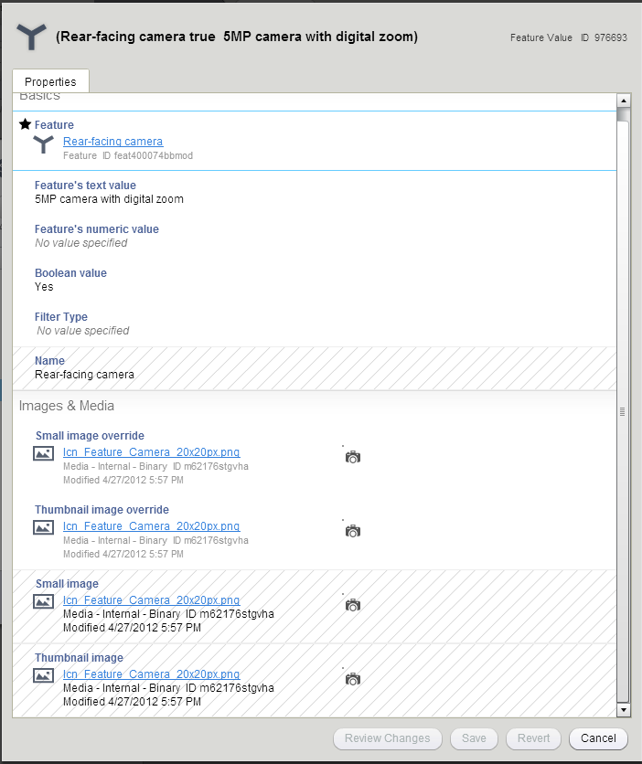

For images and Media, an appropriate icon is selected from the search field. The best practice is to use the text “icon” or “icn” as the search parameters. You may also refer an existing asset for getting the exact image for corresponding field. You can rearrange the features and the order according to the list given to you in the copyright document.

## Adding Category

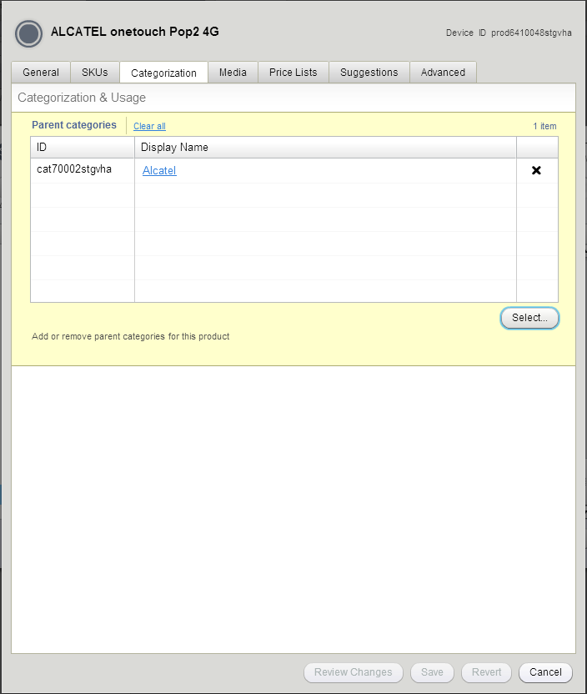

Go to categorization tab, select the appropriate device category and save. In case of prepaid devices we need to add them under pre-pay bundle SKU.

Adding an appropriate category is important. Since it is not a mandatory field it is easy to miss. But its importance is high. If a parent category is not selected then the asset will not get added to cart. Categorization tab is also not visible from the beginning. Once you fill all the relevant details then you can add the category.

## Creating Device SKU

1. Go to SKUs tab and create a new device SKU. This way the parent child relationship between device and device SKU is automatically made. You may create a standalone device SKU as well but then you will need to add the SKU to the parent device.

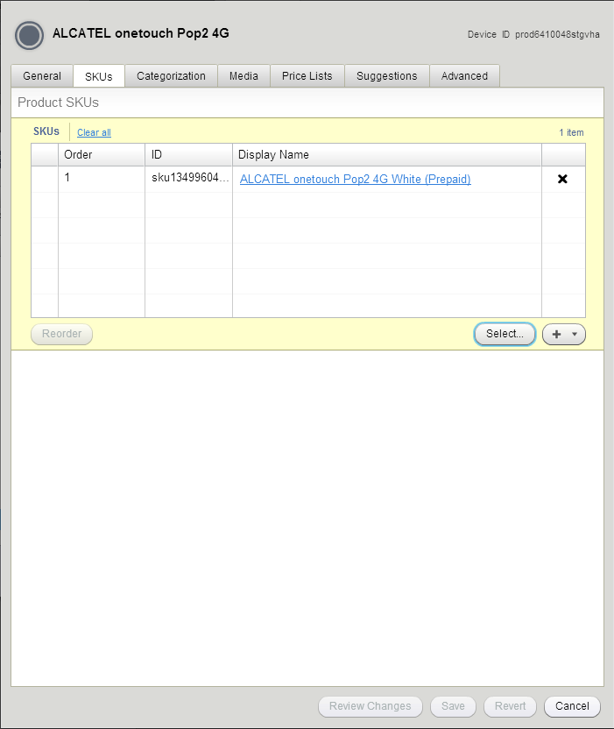

1. Enter the name, management display name.

The name of the device is important and should be added carefully as the name gets displayed on the website. The format of adding a name of the device is:

[Name of device] [3G/4G] [32GB/64GB/128GB] [Colour of the device]

If the device has only one capacity then no capacity is added in the name. But even if there is only one colour of the device, the colour is always added.

1. The External SKU Id is present in the one pager document and must be added as is.
2. Provide the appropriate URL name in the Friendly URL Id field.

The friendly URL field contains the destination URL of the device. This URL will be present on shop.vodafone.com and will have all the features of the device present on the page. Any spaces in the field are to be replaced with ‘-‘and all characters should be in small letters.

1. Select the channel as “Acquisition” in the channel field for prepaid and select the channel as “All” for postpaid devices.
2. In the colour field, give the name of the respective mobile colour.
3. Select NO on ‘Hide on Landing Page’ field.
4. Add the colour of the device on the small colour image field. Usually the color of the device would be as white.jpg or black.jpg. Hence you can search by the name or you can refer an existing asset.

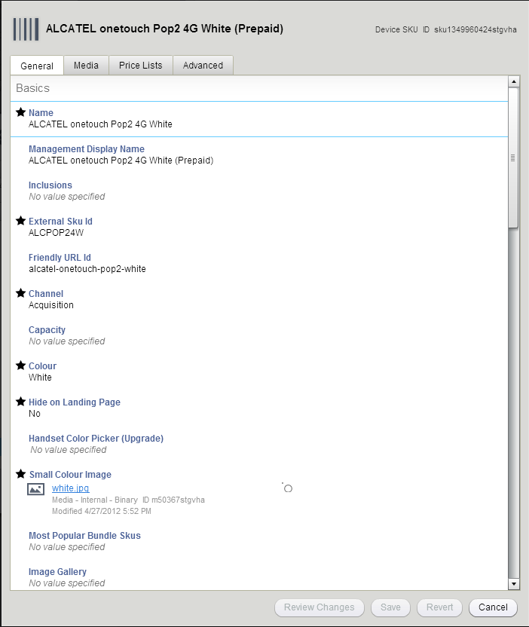

1. Handset media gallery contains the images which form a part of gallery on the device detail page. Refer section 9.5 for creating a Handset Media gallery.
2. Select yes for *Has Customer Upgrade Option* attribute.
3. Select yes for is *available* attribute.

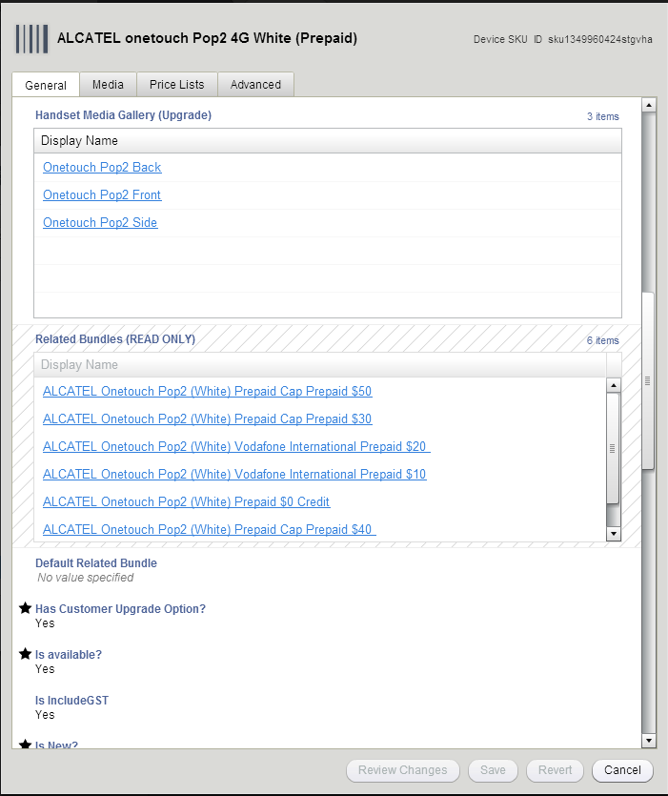

1. Enter the fields ‘Is New’ as ‘No’ and ‘Is Online Only’ as ‘Yes’.
2. For the field Post-pay SIM Code, enter the code as per the type of the device whether it is postpaid or prepaid.
3. Click Save.

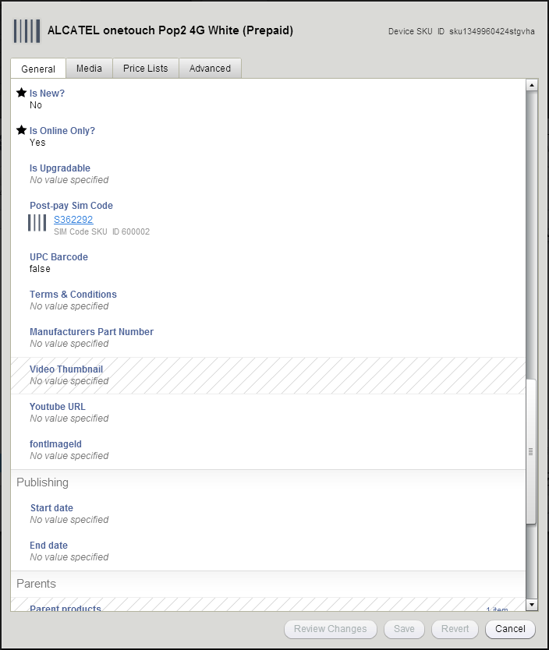

## Creating Handset Media Gallery

Handset media gallery contains the images which are displayed as gallery images on the device detail page. Every image present here has a fixed dimension.

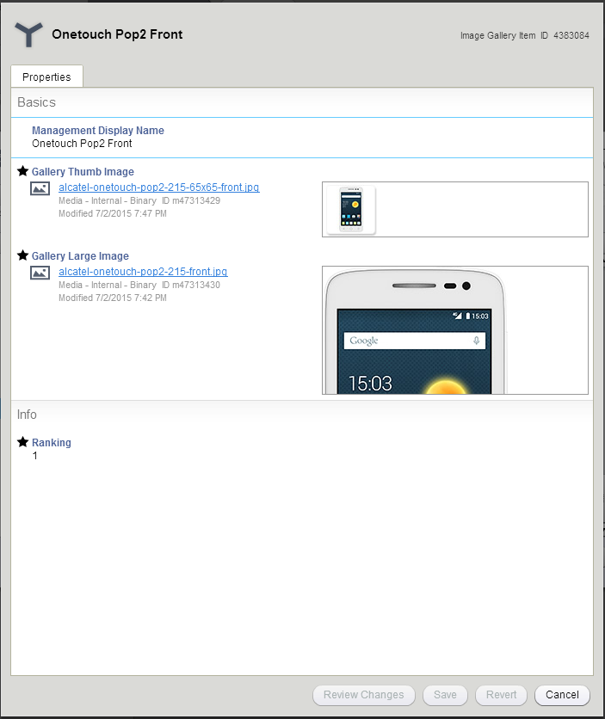

1. There are Front, side and back images. Specify respective category (Front/Back/Side) as suffix in the Management Display Name.
2. For the Gallery Thumb Image and Gallery Large Image, an appropriate image with the appropriate size should be created.
3. To create an image asset click on ‘+’.
4. Browse for the appropriate image and upload to ATG. The name field is automatically filled once the image is uploaded. Select the parent as ‘device gallery images’.
5. Select the ranking as ‘1’ for front image, ‘2’ for side image and ‘3’ for back image.

Image size for Thumb image is 65x65 and large image is 215x403.

## Creating Media assets for Device SKU

The images present in the Media tab are present on device detail page and also inside cart.

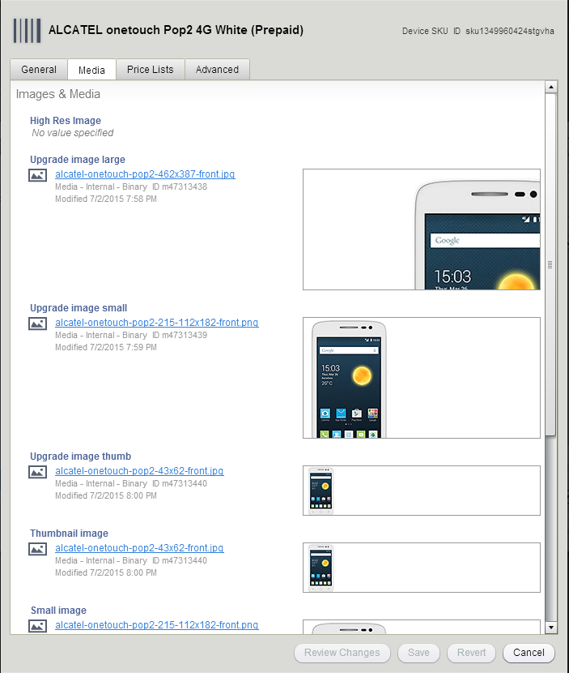

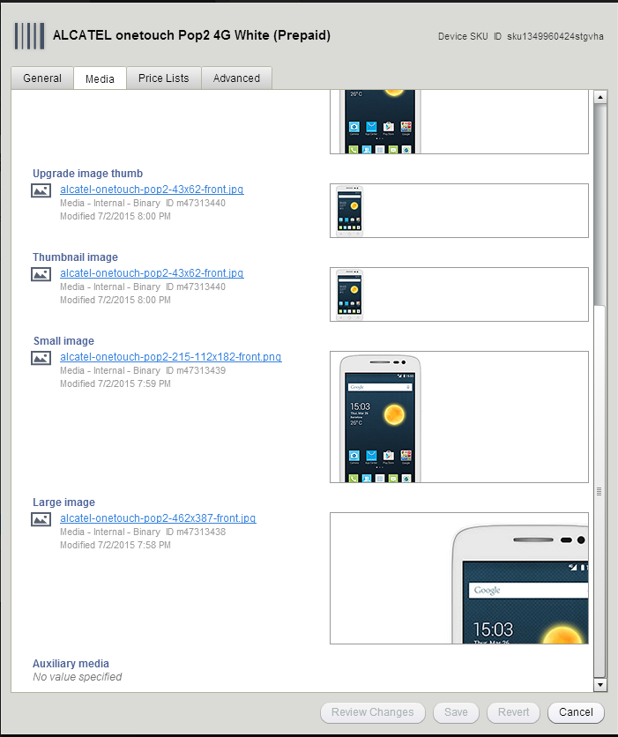

1. Go to Media tab of the device SKU, follow the same steps of Handset media gallery images with the below mentioned sizes for the categories large image, small and thumbnail images.

Image size for large image is 462x387, small image is 112x182 and for thumb image is 43x62.

1. Copy the respective image id and add the image to other corresponding three fields.



1. Click Save on completion.

## Adding the Price of the device

The price of the device is added in the Price Lists tab. This is for the Prepaid device.

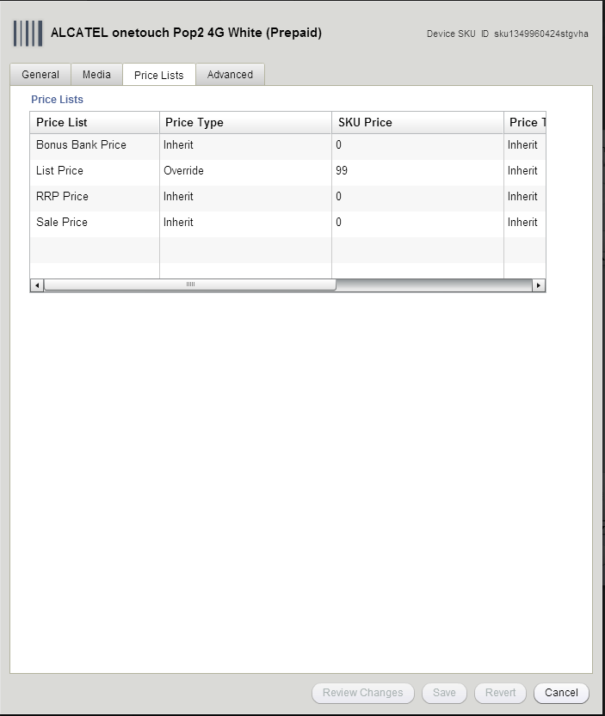

Go to the Price Lists tab of the Device SKU and select override as price type and add the price of the device in the List Price column. In case of the post-paid devices we need to run the ETL so that the price is reflecting on the device page. After running the ETL make sure to push the project after 30 minutes gap.

Refer: <https://vodafone.atlassian.net/wiki/spaces/DDP/pages/685704548/How+to+run+ETL+production+job>

Once we are live with the Device. We need to make sure we have updated the inventory. When it is a pre-sale we need to make sure that the Presale message is being updated.

Note: For Prepaid Mobile Broadband Devices you will usually have a specific started pack which is directly specific to the device. The Details for the same plan will come from business side.

When making updates for an MBB Device you must update three key points

* CIS
* Plan inclusion
* Terms and Conditions

## Creating a Bundle

All the different types of SKU are related with each other inside a Bundle SKU. A bundle SKU has three main attributes among others: Included Device, Included Plan and Included Discount. A customer actually buys a Bundle SKU on Vodafone shop site. Every Bundle SKU has to have a parent.

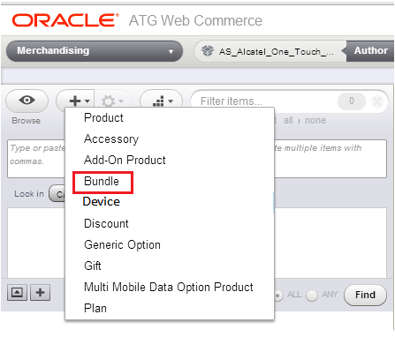

1. For creating a new Bundle, click on the ‘+’ button and select Bundle.
2. In General tab, enter the Name field having the name of the device followed by the version with the suffix ‘Bundle’ inside braces. The same name has to be entered for Management Display Name.

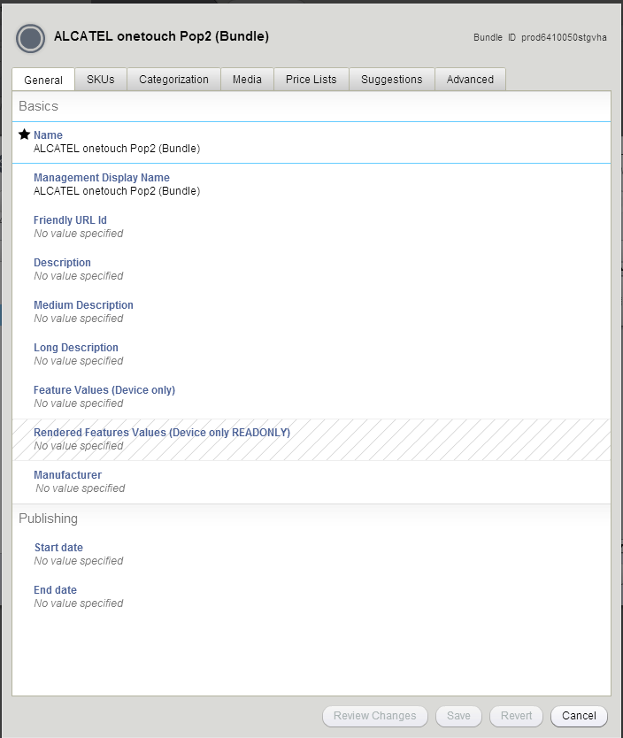

1. In Categorization tab add the corresponding category.

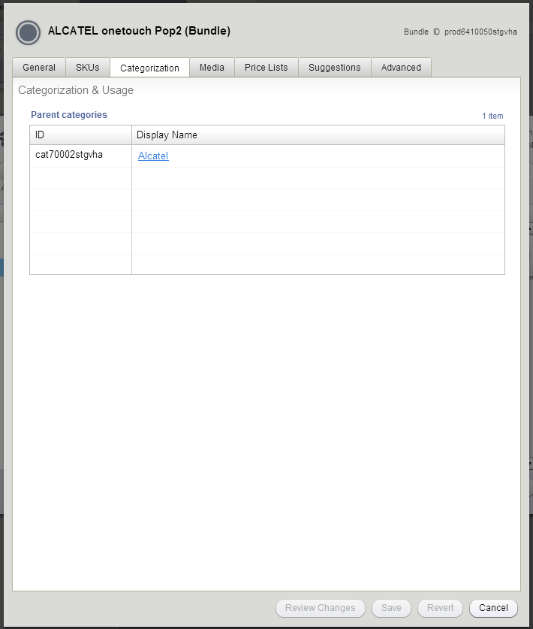

1. Click on Create.

## Creating Bundle SKU for a new Device

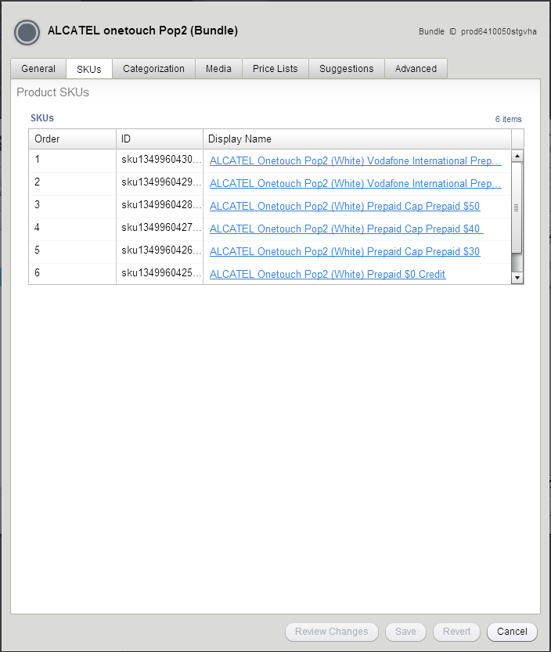

1. Go to SKUs tab of the Bundle and create a new bundle SKU. This way the parent child relationship between bundle and bundle SKU is automatically made. You may create a standalone bundle SKU as well but then you will need to add the SKU to the parent bundle.
2. We can create bundle SKUs for both prepaid device as well as for postpaid device. The simplest way of creating new bundle SKUs for a new device is to search for existing bundle SKUs based on device type i.e. prepaid or postpaid.

Creation of a bundle SKU for a Plan is very rare. However when a new device is getting launched then new bundle SKUs is created.

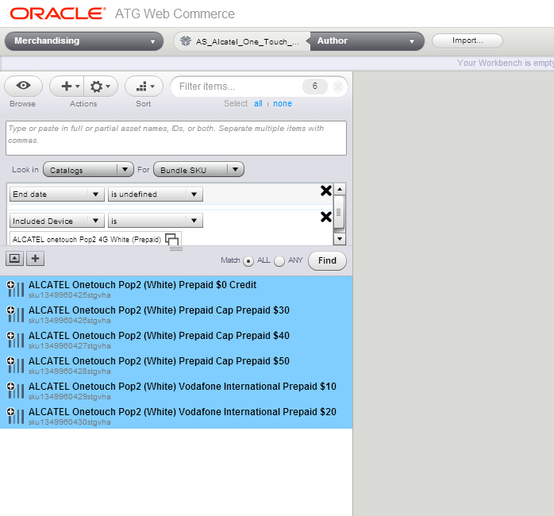

1. You will get a list of bundle SKUs as above. Select all bundle SKUs and click on the export option present on the actions button.

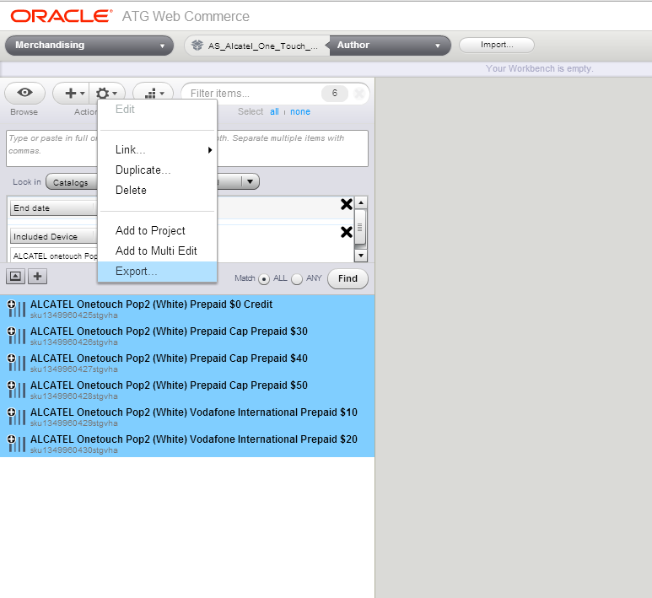

1. On clicking export, following window appears. Make sure to click on Select All on left rail.

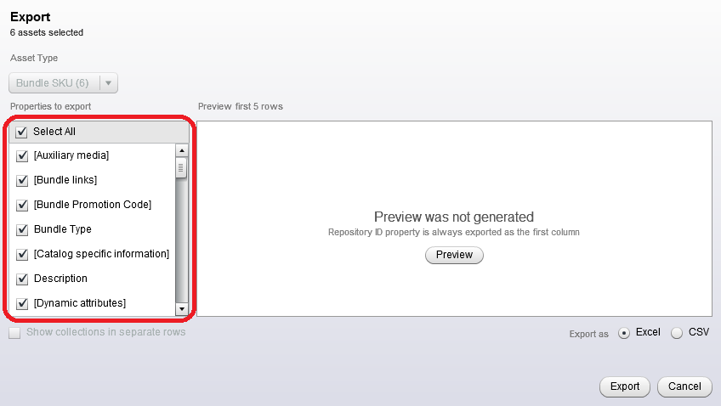

1. Click on Export. All the details will be exported into an excel format. There you can modify the changes in the columns of ID, include device, include discounts, admin display name and display name. After modifying the changes, click on the import button for importing the changes made.

Since we are creating new bundle SKUs for a device, change the ID column as New for all the rows. Enter the device SKU in the included device column. Change the admin display name and display name accordingly. Add the discount SKU if any in the included discount column.

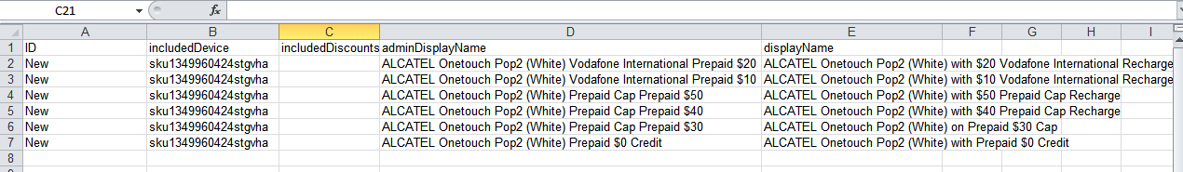

1. Click on Import and if the changes made to excel are correct then the import will be successful. Click on create to create new bundle SKU for devices.

## Creating a Discount

Discounts in ATG are either Device specific or Plan specific.

Device Specific Discounts: This refers to the discount on the price of the device.

Plan Specific Discounts: This refers to the discount on the price of the plan.

1. Click on the ‘Find’ icon

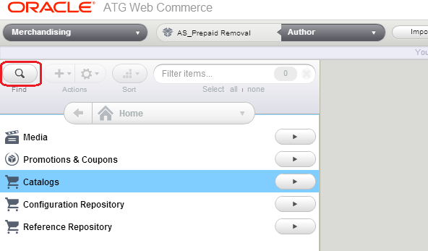

1. The window will flip to reveal second dashboard. Make sure the ‘Look in’ drop down menu is selected as ‘*Catalogs*’ and that the ‘*For*’ option menu is selected to ‘Discount’. The Reason for this is so when you click the  icon you will be able see and create the Discount SKU.

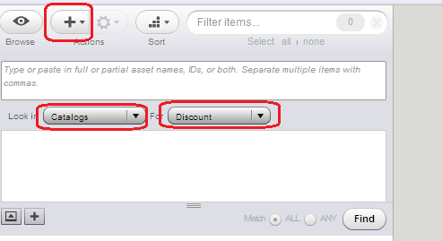

1. When the  is clicked the New Discount window will pop up. Click on it.
2. In the Discount window that pops up enter the following:
   1. Name: Enter discount name for the Discount Parent.
   2. Management Display Name: Enter discount name for the Discount Parent.

Name and Management Display Name should be added as per the Cart copy provided by the copywriters. They are the same.

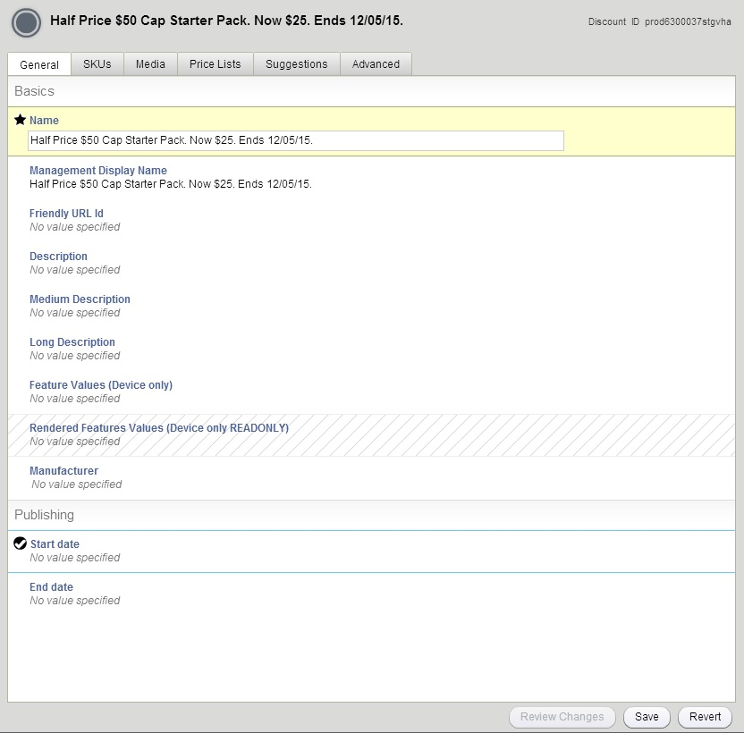

1. This will be the parent for the discount SKU you will be creating.
2. Click on ‘Create’.

### Creating a Discount SKU

1. Creating a discount SKU can be done by navigating to the SKU tab of discount and creating the discount SKU there. This will create the parent-child relationship automatically. You can create the discount SKU separately but you will manually have to add the parent to the Discount SKU.
2. For the former click on the ‘SKU’ tab then click inside the tab.

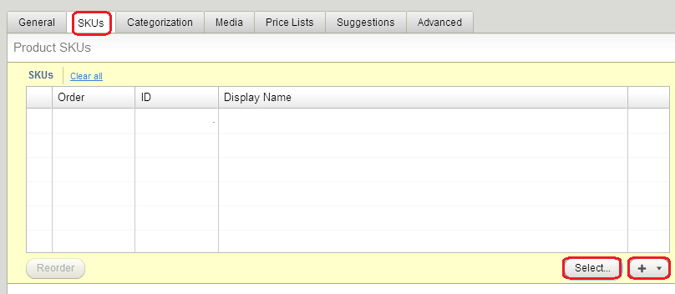

1. Click on ‘New’ and in the subsequent Drop-down menu click on ‘New Discount SKU’.

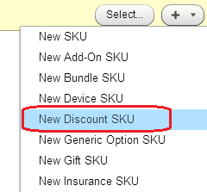

1. In the Discount SKU window that pops up enter the following:
   1. Name: Enter a meaningful name to be displayed in these fields. This usually refers to the name of the discount.

Name and Management Display Name should be added as per the Cart copy provided by the copywriters. They are the same.

* 1. Management Discount Name: Enter the same value as ‘Name’ given above.
  2. Most Popular Offer Text: This is the text to be displayed on the cart page. Note that this text will be inside html tags. Refer to other existing assets for relevant tags.
  3. Recommended Plan Text: This refers to the smaller ‘T&C’ conditions by-line that refers to when the offer is going to end. Again this will be inside html tags. Refer to existing Discount SKU assets to make sure the DIV tags and format you are using are still relevant.
  4. External SKU ID: Mark this as NA.
  5. creditBonusFlag: Default marked as ‘Yes’.
  6. Display On Cart Summary: Default marked as ‘Yes’.
  7. Display on Device Details page(under Plans) & Listing pages: Default marked as ‘Yes’
  8. Is Highlighted: Fill this as ‘Yes’.
  9. Highlighted Description Override: This will be provided by the Legal team.
  10. fontImageId: The value is ‘&#xe800;’ .This will refer to the “Gift” image that will be displayed beside the discount in the cart.

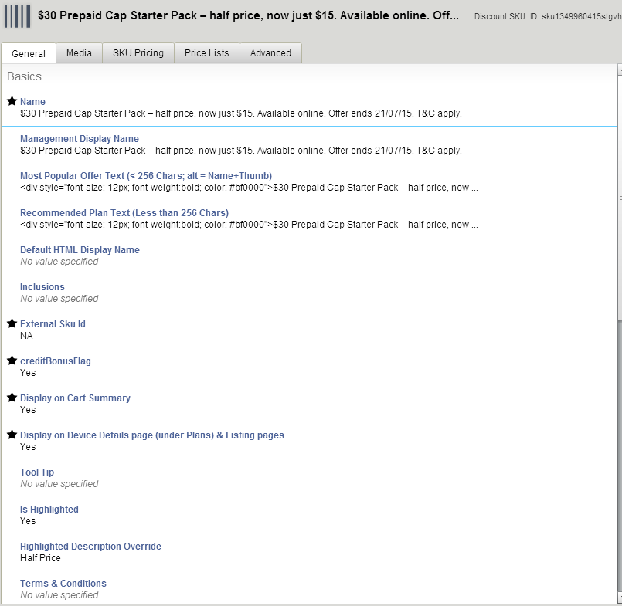

1. Navigate to the ‘SKU Pricing’ tab.

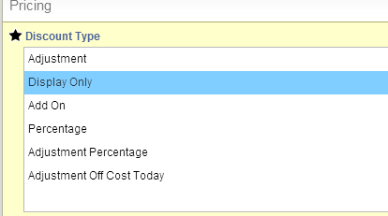

1. Discount Type: In the drop down list select ‘Display Only’
2. Click on ‘Save’.

### Modifying Plan SKU based on Discount SKU

If the discount is on a Plan then the respective Plan SKUs’ should be modified.

1. Identify the plans to which the Discount SKU you have just created must be modified for.

To identify the plans which are going to have this discount you need to identify all the plans for a particular type. Example: $40 prepaid plan has three variants: Multi-fit with device, Multi-fit without device and Nano-fit without device. You need to make sure to identify all the types of plans undergoing discount.

1. Once you have identified and found the Plan SKU to be modified in conjunction with the Discount SKU, double click on it for it to be shown in the window.

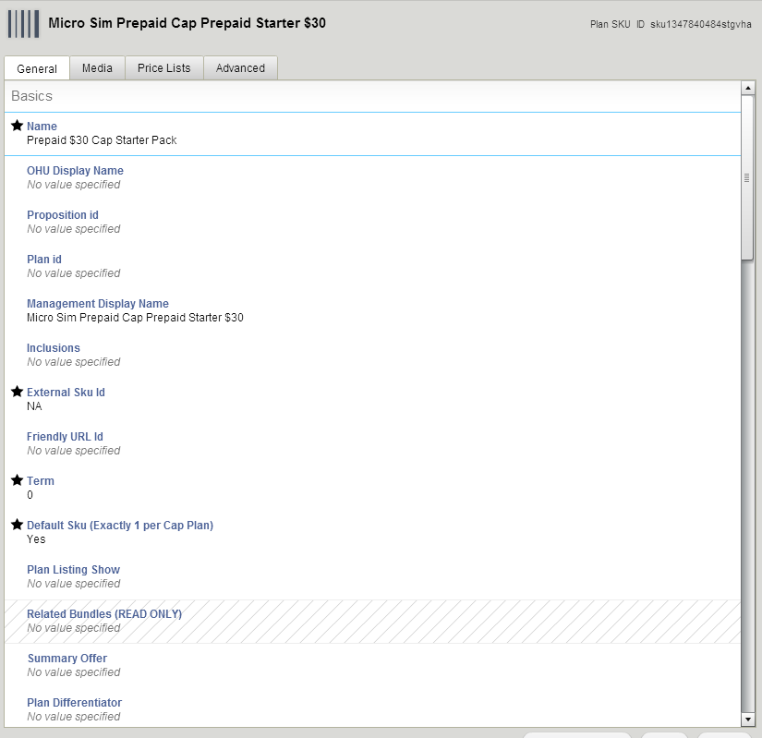

1. Click on ‘Price Lists’ tab. Modify the ‘SKU Price’ for the List Price accordingly. This one is for prepaid alone.

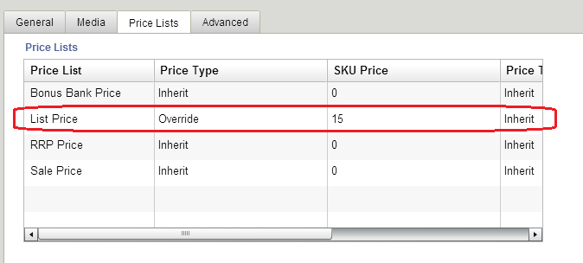

1. In the Plan SKU window that pops up we also need to update the terms and conditions as per the copy deck.
2. Terms and Conditions: The T&C text is enclosed within its own specific html tags. Use the same html tags to include the text specified.
3. Also take care of any links that appear in the T&C column. These will be hyperlinked to their respective sites.

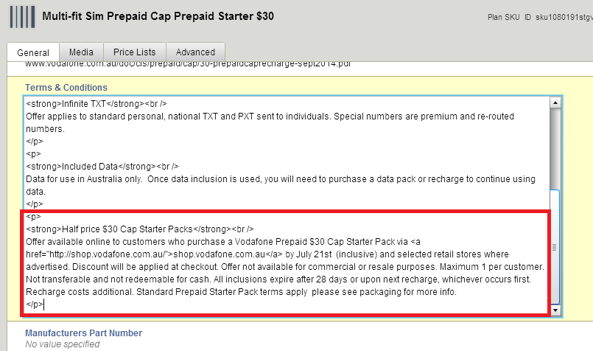

This Text will be provided by the document provided by your Copyright Team

### Modifying Device SKU based on Discount SKU

If the discount is on a Device then the respective Device SKUs’ should be modified. The changes in the Device SKU is same as that we would make for a discount on Plan SKU (refer 10.2). Important thing to note is to identify all the Device SKU. Best way is to go to the parent Device asset and look for its children inside SKU tab.

### Modifying Bundle SKU for a Discount SKU

All the different types of SKU are related with each other inside a Bundle SKU. A bundle SKU has three main attributes among other: Included Device, Included Plan and Included Discount.

If there is a discount on a Plan then the entire bundle SKUs referring that Plan SKU should be updated. This will include bundle SKUs for different devices also.

If there is a discount on a Device then the entire bundle SKUs of that device for different plans should be updated. Each device has different plans associated to it and hence has different bundle SKU. All such SKU should be updated.

1. Double click the Bundle SKU and scroll down to ‘Included Discounts’

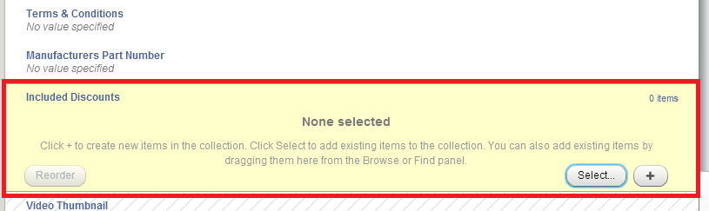

1. The ‘Select Discount SKU’ window will open up. Enter the Discount SKU id of the discount to be added here, click on ‘Find’. 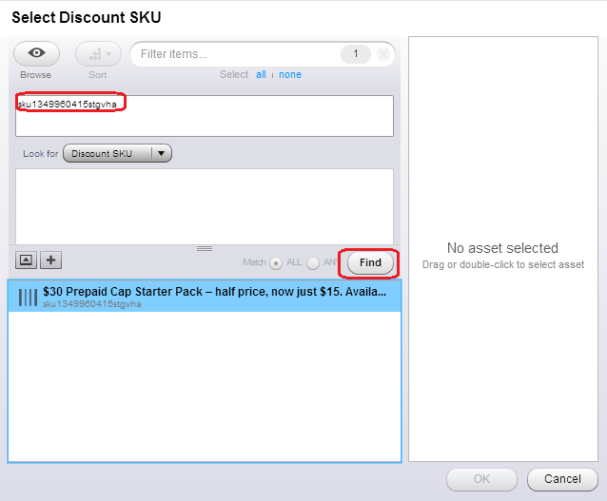
2. Select the Discount SKU and drag and drop into the right hand window.

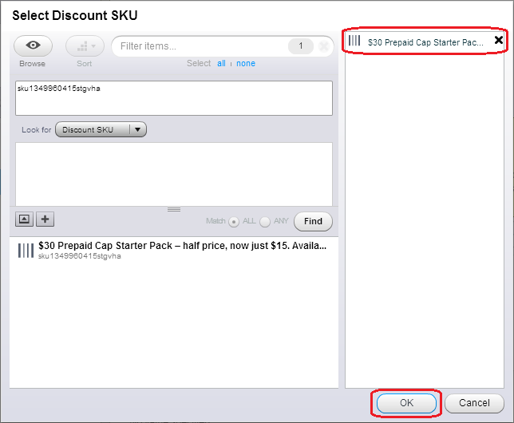

1. Click on ‘OK’.

The Discount SKU you specified is now included in the Bundle SKU.

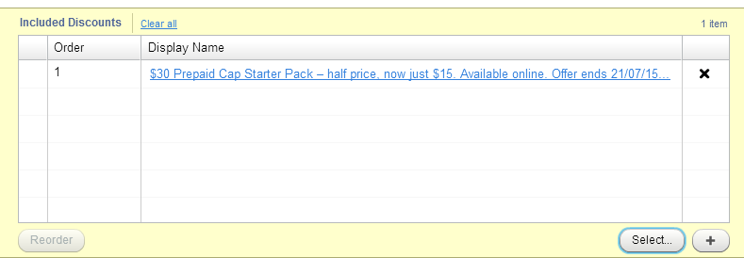

1. Click on ‘Save’.

## Lock Conflict Resolution

Whenever you are working on a project in ATG you are essentially working on a local copy. The changes you are making will not be visible to others. Hence there is a possibility that you and someone else might be working on the same asset. In such a scenario you do not have the changes the other person is making and the other person does not have the changes that you are making. This when moved to Staging will result in Lock Conflict and your project will not move to Staging.

In such a scenario you need to confirm with the concerned person as to whose changes will be going to Production first. If your changes are to go to production, first then you will need to revert the conflicting project from staging and only then you will be allowed to publish your project to Staging and subsequently to Production.

Once the changes have been live you will need to verify the production deployment.

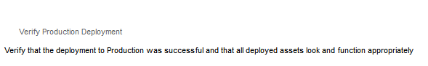

Once done, your changes will be visible to others.

If the copy of the asset that you are having differs from the one that is present in production then you will get a yellow exclamation mark beside the asset.

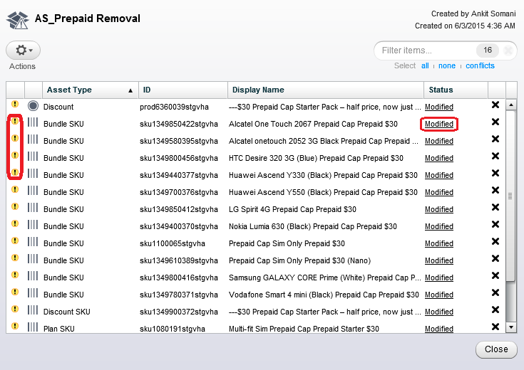

Click on Modified for each such asset and select as applicable. Please refer the screenshot below. This will resolve the conflict of your asset.

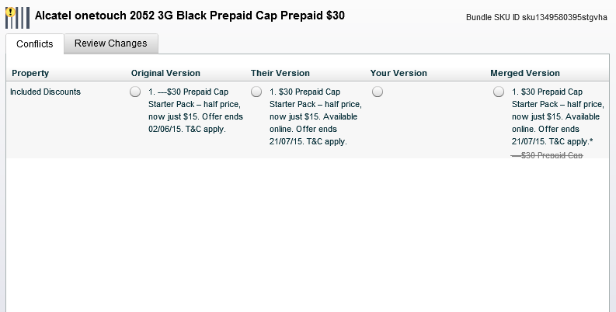

## Publishing in ATG

After completion of task in your local copy, you need to publish the project to Staging to verify the changes. Following are the steps for publishing the asset to Staging:

1. Click on “Go to project” for the project you want to publish.

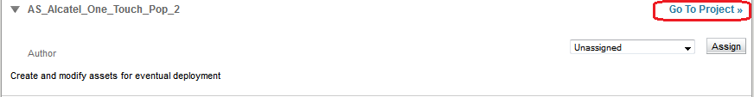

1. Click on “Ready for Review” under Author and add comments in the pop up and click ok.

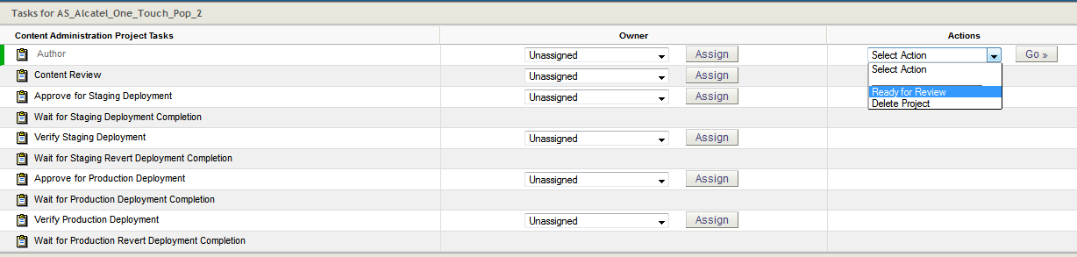

1. Click on “Approve Content” under Content Review.

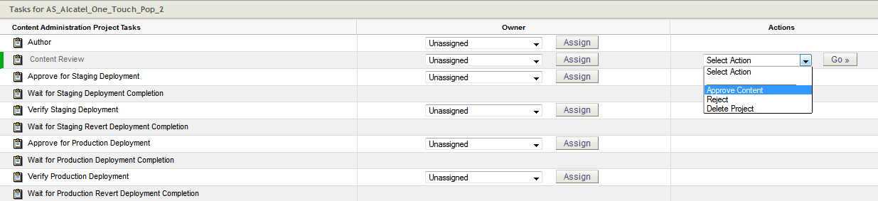

1. Click on “Approve and Deploy to Staging” under Approve for Staging Deployment.

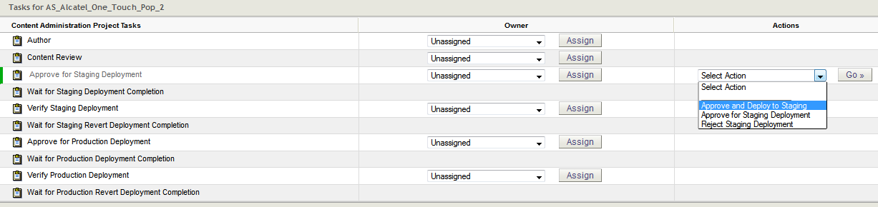

Now the assets have been published to Staging. QA must be done on staging and once it is ready it can be published to Production.

1. Click on “Accept Staging Deployment” under Verify Staging Deployment.
2. Click on “Approve Content” under Approve for Production Deployment.

Now the assets will be published to production. Once the changes have been verified on production then the project can be set as Verified production deployment.

## Device Launch Analytics – Classification File

Whenever a new device is getting its Classification file should be shared with Analytics team. This helps analytics team keep a track of devices getting launched. Following steps should be followed to generate Classification file:

**Process:**

1. Export the 53 files (listed below) from ATG fortnightly or when there is a device launch. (**NOTE to the producers: please send the file at least 2 days before the device is launched)**
2. Send the files to Michael
3. Michael to upload to Adobe

## Here is the list of what needs to be exported from ATG:

| **Export File** | **Field names** |
| --- | --- |
| Device | * Admin display name * Device subtype * Child SKUs * Model (e.g iPhone 8) |
| Device SKU | * Admin display name * Colour * Capacity * Friendly URL |
| Bundle SKU | * Admin display name * Included device * Included plan |

# Bank BSB code creation

## BSB Overview

A BSB (Bank-State-Branch) number is a 6-digit numerical code used to determine a specific bank branch in Australia for domestic payments, and we require this code in order to complete the transfer. We will update the respective BSB codes in the system.

Once or twice a year we will get the inputs for these. Customers enter the BSB during checkout.

## Steps for updating the code

When a customer is making a payment then they are asked for BSB code of the bank. The BSB code entered is verified with the BSB code on record. This BSB code is added in ATG. Whenever a request comes in to add a BSB code following steps must be followed:

1. Create a new Project.
2. On the home page click on “Browse Assets”.

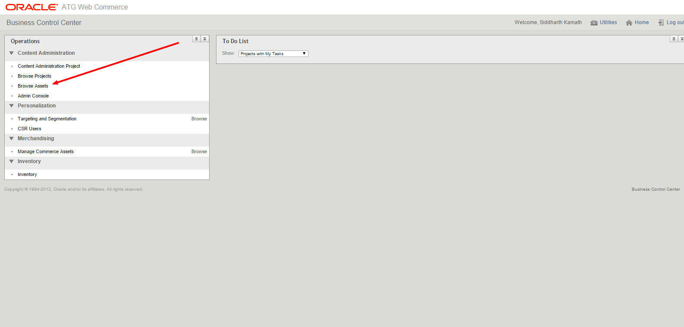

1. On the browse assets page, select Reference Repository and BSB Info from the dropdown.

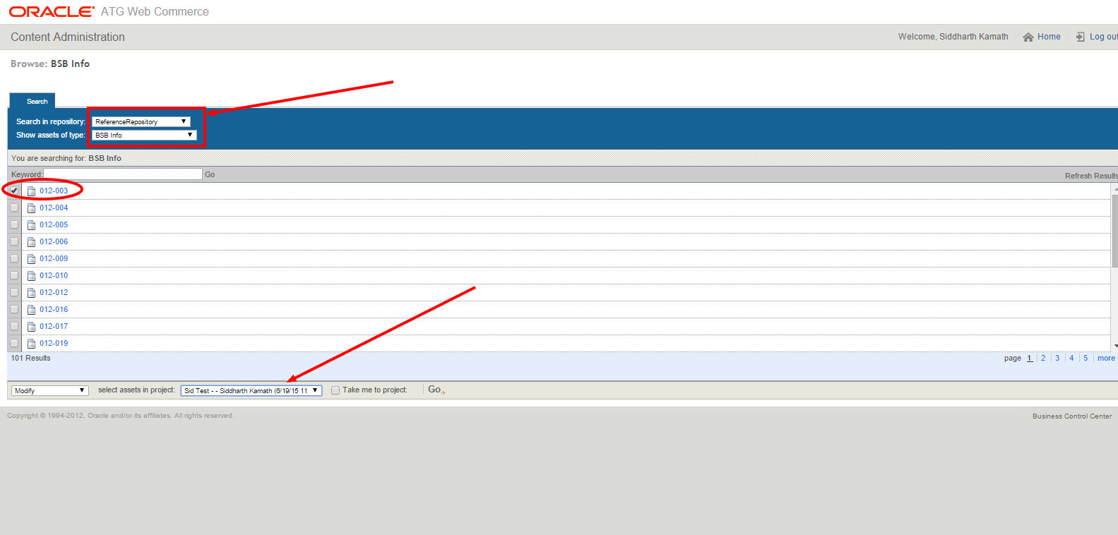

1. When the existing BSB assets are displayed, check any one of the BSBs and select the project you would like to add the asset to which was covered in Step 1.
2. Now in Author mode you should be able to see the BSB. Run an export of the BSB.
3. On the export add the NEW BSB with the below format.



1. Reimport the worksheet back into you project and Publish!

Please ensure that the BSB is now accepted when using Bank Account as method of payment on the Checkout. Note that this applies to all the flows on e-Store i.e.

* Acquisition.
* Second Service
* Upgrades.

Reference:

<https://vodafone.atlassian.net/wiki/display/DDP/BSB+Addition+to+EStore>

# Prepaid recharge plan E2E testing

## Overview

Whenever a new plan is being brought in, End to end testing is performed to make sure that all the applications/systems are configured properly for the new plan. This E2E testing is performed on ATG level as other downstream applications fetch data from ATG through an API. Below are the steps to create a new prepaid recharge plan.

## Prerequisites:

1. Marketing brief for the new plan detailing the price, validity and all inclusions for the plan. (Pricing Approval Form – From Prepay Product owner and Prepaid Billing Lead)
2. Send out a mail to [Cuong.Tran@vodafone.com.au](mailto:Cuong.Tran@vodafone.com.au) and [Vijay.Guruprakash@vodafone.com.au](mailto:Vijay.Guruprakash@vodafone.com.au) (IT – Billing) to set up the top-up profiles.
3. Send a mail to [Joshua.Lette@vodafone.com.au](mailto:Joshua.Lette@vodafone.com.au) (Testing Manager) to let him know of the set-up in any one of the QA environments. Once confirmed make sure the environment is accessible.

## Following are the steps to create a new Prepaid recharge plan in ATG:

1. Search “api” in the products.
2. Combo (Self-serve API) and Combo (Self-serve API) – voucher would be the two Plans where we would make changes.
3. Create a new Plan SKU inside Combo (Self-serve API) plan. The details present in this plan are fetched by other applications.
4. The External Sku Id attribute will hold the SKU id of the plan group.

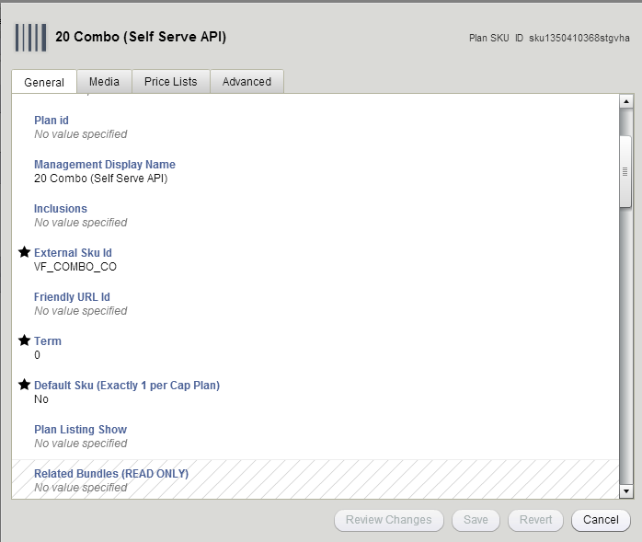

1. If the plan is recharge type then the Term should be set to 0.
2. The Plan essentials link attribute will hold the URL which will point to the CIS page for prepaid section.
3. The terms and conditions attribute will hold the generic terms and conditions for the plan.
4. Make sure to override the List price attribute inside Price lists tab and set the value to the plan value.
5. The REST API specific section in the advanced tab holds huge importance. This is from where Self-serve API fetches its data.
6. Inclusion highlight attribute will hold the total data sold with the plan.
7. Expiry attribute holds the validity period of the Plan.
8. ORPC attribute should be set to Yes as all the plans are available on the upgrade journey as well.
9. The Topup profile attribute will hold the price value of the plan without decimal points.

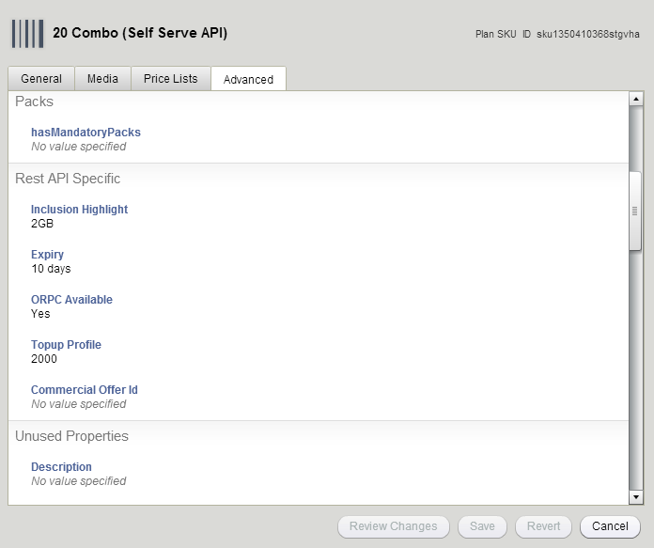

1. Inclusion Options attribute in the advanced tab is where all the inclusions of the plan are stored.
2. Each inclusion must be a different Inclusion Option asset.
3. The data to include in the Inclusion Options attribute can be found in the marketing brief.

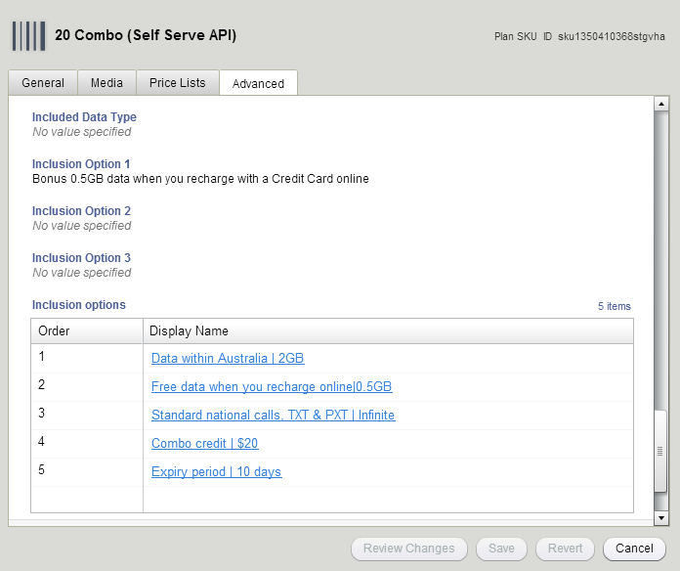

1. There will be another Plan SKU created Combo (Self-serve API) plan. This SKU will exactly be the same except for a change in following two attributes:
2. ORPC available attribute should be set to No.
3. Topup profile attribute should be set as per the value of the plan.

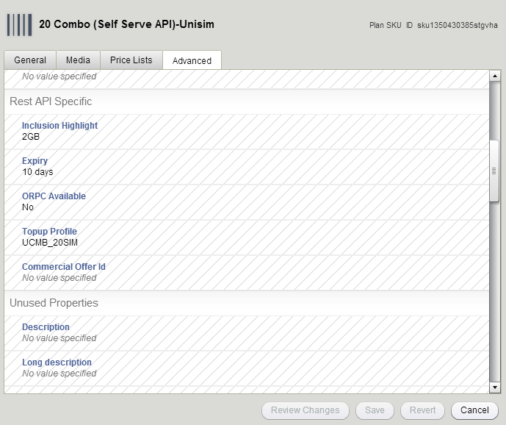

1. The third Plan SKU will be created under Combo (Self-serve API) – Voucher. This Plan SKU will be same as the first Plan SKU with the only difference in Topup profile attribute. This attribute should be left blank.

Once the set-up is completed the project must be moved to staging environment and the following URL must be hit to verify if the data is being fetched as API:

<http://staging.qa1.test.estore.aws.vodafone.com.au/rest/service/ProductCatalog/planSku?externalSkuId=VF_COMBO_CO>

Please note that the above URL will be dependent on the environment you have completed your set up on i.e. QA1 or QA2 or QA3 or QA4.

**Note**

OWCS does not participate in E2E testing of a new plan.

## E2E process for recharge plan update/launch

* PAF received from business.
* Set up in ATG on any of QA environments.
* Verify the changes in ATG using the JSON feed url.
* Siebel receives the JSON source set up in ATG.
* If changes are not reflected, please ask Self Service team to clear cache.
* Testing team to complete the testing.
* With go ahead set up in ATG environment.
* Verify the changes on staging environment.
* During deployment move the ATG project to production and verify the JSON feed URL.
* Self-service team to clear cache so that changes are reflected.
* Any update/new asset needs cache cleared to be reflected.
* Digital campaigns team does not test on Myaccount for changes.

**Note:**

The UNISIM plans present represent the starter packs. For example: For $30, $40 and $50 prepaid combo starter packs there will be also be a UNISIM Plan SKU for the corresponding price. This can be tested on MyAccount starter pack activation journey. You will need the activation key from testers. Any changes made to inclusions on prepaid starter packs must also be made on the UNISIM Plan SKU of corresponding price for the starter pack activation journey.

Please also note that the cache for starter pack activation journey is different from recharge journey and must be cleared explicitly by the Self-serve team.

# Prepaid Refresh Documentation for reference:

## Prepaid Refresh Overview

Prepaid Refresh is project where the plans in the prepaid segment are updated. The project comes through D-forum and will involve different teams like retail, billing, testing, CVM, copy, design etc. The old product CO being grandfathered and a new CO is being created. Billing to test the CO end to end in Digital. Customers are able to Recharge on this new plan online

## Project Description

* Introduce a new prepaid product group (‘commercial offer’) into the market.

### Impact Overview

* The plans of each in-market commercial offer are displayed for recharge in:
  + MyAccount - Recharge
  + MyAccount - Express Recharge
  + UniSIM
  + Legacy Activations
  + All need to be updated to display the new commercial offer - most of the functionality is driven from Pricing config (Fusion, ATG), but a subset of functionality depends on the commercial offer being configured in the list of commercial offers, in each application
* Starter packs of each in-market commercial offer are displayed for purchase in:
  + VCA
  + eStore
  + Functionality is driven from Pricing config (ATG), with the exception of VCA plans display page which is currently built in hard-coded ('growth hack') JS, hence will need to be updated

## Prerequisite:

### PAF/PCRS Document - contains the scope of the refresh.

### ATG Configuration log – contains all the specifications like External SKU ID, Inclusions, top-up profile, Recharge type, expiry etc. for the new/existing plans.

### Disclaimer Guide – contains the terms for the new plans. Might be generic, update as required.

### Rates and charges – to be shared with the stakeholder and get it approved.

### CIS document.

### QA Environment for Testing.

### Design and Copy.

### How to read the config Log:

Config log contains all the data about the plans that is being created and it is the single source of truth for the configuration of the plans. It is provided by the billing team.

Rows – Plans

Columns – Parameters which needs to be configured in ATG. All fields might not be relevant. Refer existing plan SKU for the mandatory fields that needs to be configured.

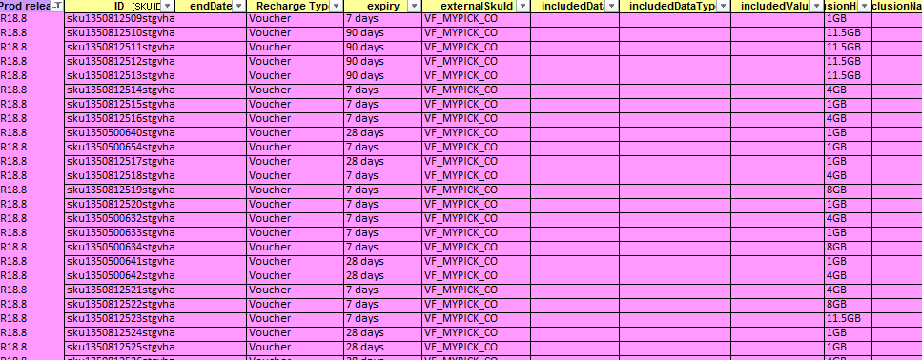

## Plan/Bundle Set up:

### Refer [ATG Documentation](https://vodafone.atlassian.net/wiki/spaces/DDP/pages/69370870/TechM+Process+Documentation) for setting up new plans and bundles in ATG.

### Refer [WCS Documentation](https://vodafone.atlassian.net/wiki/spaces/DDP/pages/69370870/TechM+Process+Documentation) for setting up price-points in WCS.

## ATG Configuration:

### Starter Pack Journey:

### Create Plan, Plan SKU, Bundle SKU.

### Associate the child SKU’s to their parent.

### Associate the parent to the category.

### Note: The plans won’t be adding to cart if the parent is not associated to the category.

### Recharge Journey:

### Create Plan and Plan SKU.

### Associate the child SKU’s to their parent.

### Associate the parent to the category.

### Note:

### There are multiple journeys for recharge say Uni-sim Activation, Voucher, Wallet and Self-Serve. Separate SKU’s needs to be created for each journey.

### ATG Cache needs to be cleared for the plans to reflect in My-Vodafone after pushing the ATG project to production.

### URL’s for clearing ATG Cache:

### Username/Password: admin/atgflush

### <https://myaccount.myvodafone.com.au/flush_cache>

### <https://activation.services.vodafone.com.au/flush_cache>

* [https://selfservice-preprod-1.myaccount.services.vodafone.com.au/flush_cach**e**](https://selfservice-preprod-1.myaccount.services.vodafone.com.au/flush_cache)

## E2E process for testing:

* The wait times are updated for devices which are marked in yellow in the deferred ordering availability sheet.
* Verify the changes in ATG QA and check the changes in JSON feed URL.
* Testing team to test the data in QA environment E2E.
* ATG cache needs to be cleared for the data to reflect in test environment.
* Testing team to complete the testing.
* Fix the issues raised by the testing team both in QA and production environment.
* ATG cache needs to be cleared for every change that is made to the plans.

# Logistics Update

## Logistics Overview

Delivery times are updated based on information sent by the logistics team. This happens usually once a week as part of the stock/supply update. It is more frequent when there's a big device launch. This document is a collection of learning or a troubleshooting guide.

The single source of truth will be the **Deferred Ordering Availability** spreadsheet currently sent out by Logistics. **Digital** will take this file and update the online delivery SLA for the devices highlighted with exactly what is shown in the**Customer Wait Time** column.

* Logistics send out the deferred availability report as required, and highlight any changes in yellow. Digital receive deferred availability report and update the device wait times for those devices highlighted in yellow (and only those items).
* **Digital only acts on this report, not on any body copy in emails or other ad-hoc emails.** The ‘Customer wait time’ shown in this report is exactly what is displayed to web customers.
* Logistics will reduce published wait times for each successive report.

## Logistics Steps

* The wait times are updated for devices which are marked in **yellow** in the deferred ordering availability sheet.
* The device to be EOLed will be called out in the email body and in the deferred ordering sheet highlighted in yellow. API tool has to be refreshed after every device EOL so that the changes reflects on the Device listing pages. Also note that End of product (**EOP**) is not the same as End of Life (**EOL**). We will make changes only if it is marked as EOL.
* Once we have done the Logistics we will send mail to the logistics stakeholder and the DL-AU- Production.
* **NOTE:** Check whether the default wait is **2-3days**.
* For hero devices launches (iPhone 7 etc.) we can manage by exception.
* We will make the updates under the following circumstances
* Refer the Deferred Ordering Availability sheet to perform any one of the action as per the below table for wait time update:

| **Status** | **Deferred Ordering** | **Customer Wait Time** | **Update Action by Producer** |
| --- | --- | --- | --- |
| No Backorders | YES | NA | Set the device to Out of Stock |
| No Backorders | YES | Available (Eg. 2-3 weeks) | Update the wait time as mentioned |
| No Backorders | NO | NA | Set the device to Out of Stock |
| No Backorders | NO | Available (Eg. 2-3 weeks) | Set the device to Out of Stock |
| Out of stock | YES | Available (Eg. 2-3 weeks) | Update the wait time as mentioned |
| Out of stock | NO | NA | Set the device to Out of Stock |
| Switched Off | NO | NA | Set the device to Out of Stock |
| EOL | YES | Available (Eg. 2-3 weeks) | Update the wait time as mentioned |
| EOL | NO | NA | EOL the variant |

**Configuring the wait time and inventory:**

**Step 1**: **ATG** > **Search for Device Delivery Time > Device SKUs - *is defined***

Search for the delivery time to which the device SKU has to be added, associate the device SKU to the delivery time and click Save.

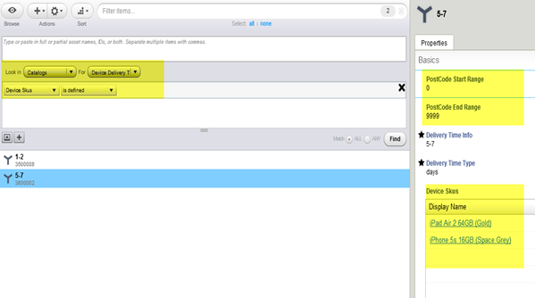

**Step 2**: **ATG > Inventory > Availablility status**

The status will be set to

* Backorderable - Delivery time greater than 5-7 business days
* Instock - Delivery time lesser than 5-7 business days
* Out of stock - when there is shortage of supply

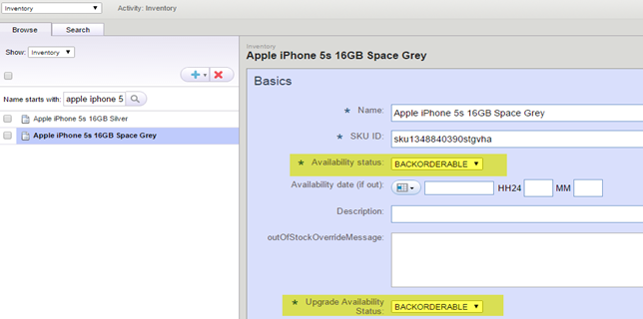

**Step 3**: QA the outcome: Check the delivery time for the devices in production using post codes ranging from 0-9999.

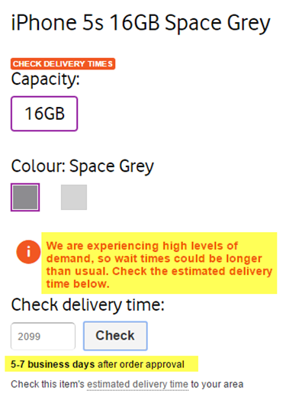

**Example of incorrect configurations:**

The delivery time with no device SKU's associated to them should be **deleted**. Otherwise it will become the default deli very time.

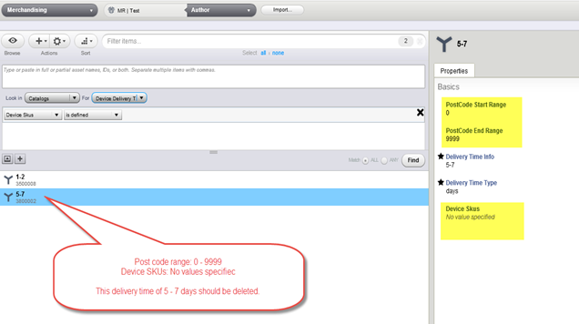

There is no need to associate the device SKU with the delivery time as '2-3 business days' as it is the default delivery time.

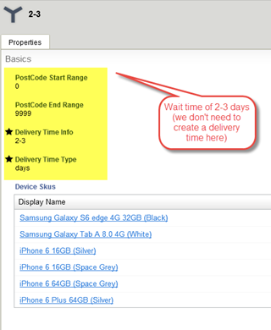

Back-orderable messages should **not** be added for wait times below 5-7 business days.

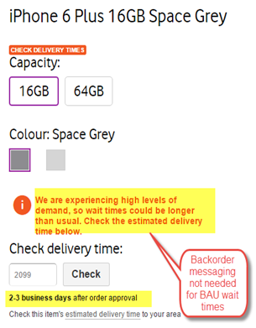

## ATG Inventory update

The inventory section in ATG displays the available stock of a device. There may be lean periods when a device is out of stock but not EOL. In such a scenario the inventory for the device should show as Out of stock so that the customer is not able to add the device to the cart.

The inventory section in ATG is common for staging and production. Hence it should not be fiddled with and should be worked upon diligently.

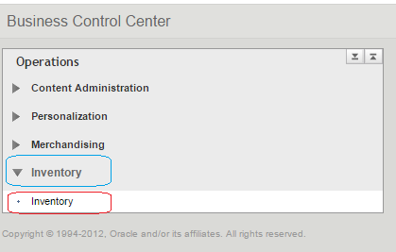

Click on “Inventory” under the “Inventory” module.

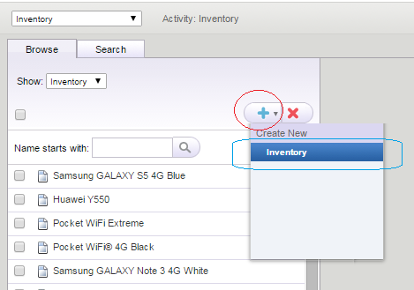

Once the Inventory module launches, click on the “+” sign -> “Inventory” to create a new Inventory.

## Out of Stock

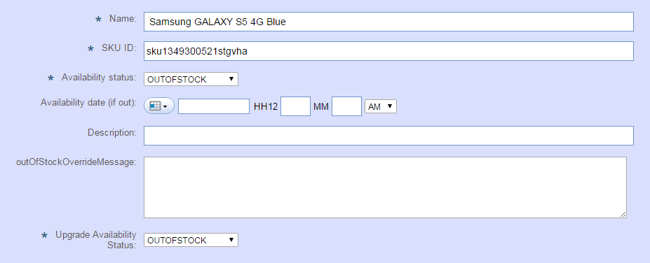

Enter/update the below accordingly in the new inventory update form:

* Device name under “Name”
* Device SKU under “SKU ID”
* Set *Availability status* to “OUTOFSTOCK”
* Set *Upgrade Availability status* to “OUTOFSTOCK”
* Click on the “Save” button on end of the inventory update form to save.

## In Stock

Once the Device is in stock then we can delete this Inventory update. In case the device is frequently in & out of stock then we could retain the Inventory update but mark it “INSTOCK” for both “Availability status” and “Upgrade Availability status” then save.

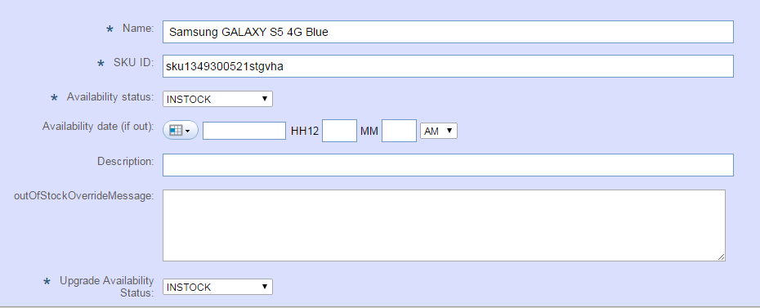

In case the device is EOL then follow the EOL process in CMS/ATG accordingly.

## Country Code Update in ATG

1. Open the **Project** -> click **Go to Project**-> **Assets tab**
2. Click **Add asset to project**. Under **Asset Picker**, search for **Country** asset.

* If the country code needs update, select **Add Existing** and search for the country, add the asset to the project to make changes to it.

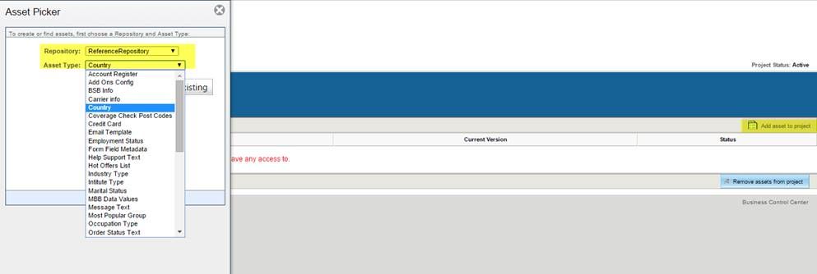

# Web content operations

## WCS Overview

We are using Webcenter Sites to build all the pages located in [www.vodafone.com.au.](http://www.vodafone.com.au./)  In another word, we use it to build VHA(Vodafone Hutchison Australia)'s portal website which shows more than following content to customers:

* About VHA
* Services & Products provided by VHA
* Customer care content
* Links to other sites within domain VHA

It also helps VHA release new phone, plans, services and campaign in short time to earn more customers.

1. All the URLs which are of the form www.vodafone.com.au part belong to ATG.
2. All the images and related files will be given by Visual Designers. Sometimes we use an existing asset in which case it’s better to search for the asset in ATG. If we don’t find the asset we should create a new asset.
3. All the text to be added to the website will be provided by Copywriters.

## Login to Webcenter

Go to the Webcenter launch site as per the environment (sandbox/staging) on a standard browser. The login screen is seen as below:

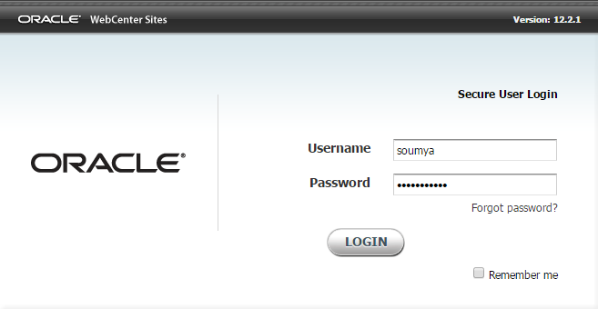

Enter the username and password accordingly.

## Introduction to Webcenter UI

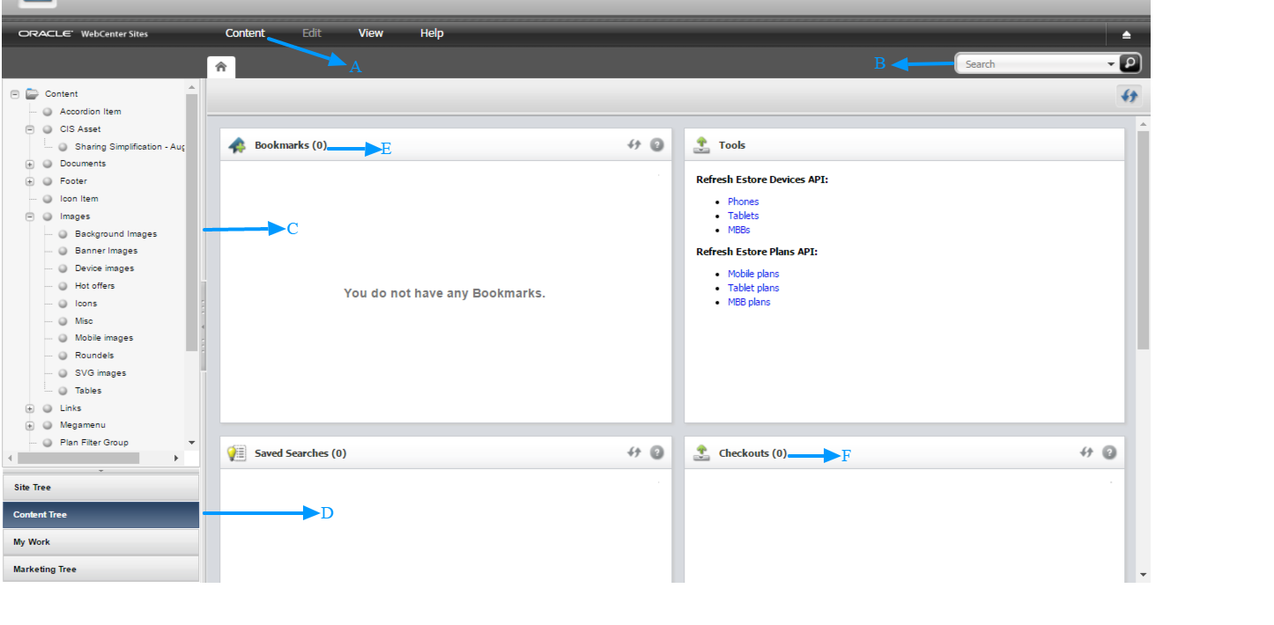

A: Content Tab: To create any new asset.

B: Search option: To search an existing asset. It can be a page, document, link or any other asset.

C: The tree structure for the selected tab on the left bottom pane (see D below).

D: The tree tabs present on OWCS. It can be used for navigation.

E: Bookmarks window holds the assets which can be easily and frequently accessed.

F: Checkout Window holds all the checked out assets (Pricepoint assets only).

## Creating a page and it’s components

Select Content -> New -> select “Page”. This will create a page. This is best practice as the Page is not required to be created and related explicitly.

1. In the new page asset important attributes that are mandatory are as follows:
2. Name: Name with which the asset will be stored in Webcenter.
3. URL: This will determine the URL of the page. Refer to the Screenshot.
4. Template: PageResponsive is the layout which is used currently.

The path of the page is extremely important as this will determine the URL of the page. If the page is placed then the parent pages must also be added to the path attribute.

Currently PageResponsive is the template used by default. There are other templates used based on needs.

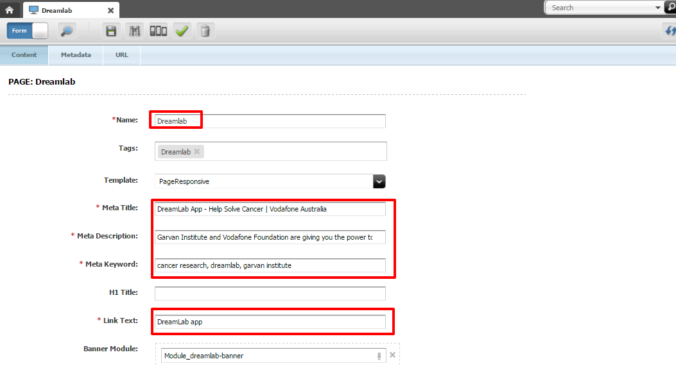

1. Mandatory attributes like Meta Title, Description, Keyword and Link text are to be entered from the copy deck provided by the copywriters.
2. If there is any requirement for page banner, banner asset is added to Banner module attribute. (The banner asset can either be found in the work tree or can be searched by the search option.)

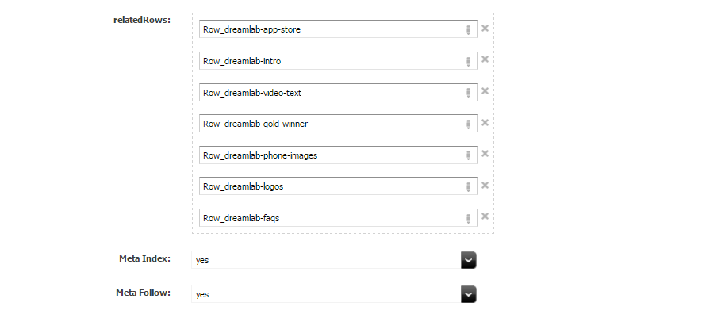

1. The Rows are associated in the related Rows attribute.
2. Select the respective meta index and meta follow from the drop down.

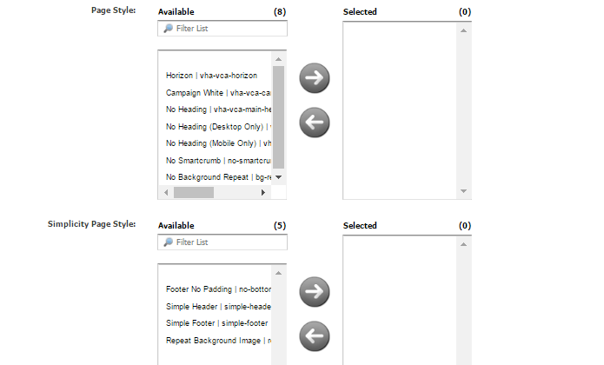

1. Add the required page styles from the available style by selecting and adding to the selected window.
2. If the page requires footer, select the footer in the footer type attribute and select no in hide footer attribute.
3. Enter the analytics name of the page under the Analytics Pagename attribute.
4. Select yes in Show in sitemap if the page is to be made visible in the site map. Refer Screenshot.

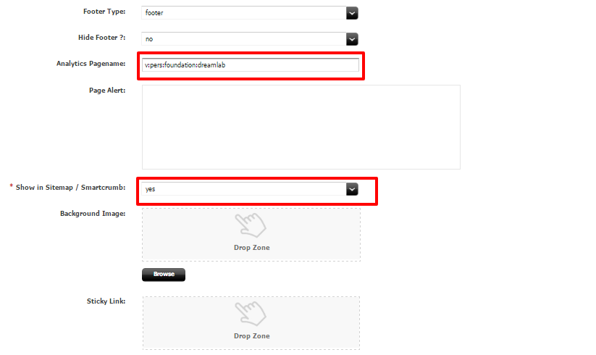

1. Select the respective menu tab for the page (Personal/About/Business) from the content tree and drag, drop it in the menu tab attribute. Refer to the screenshot.
2. Select the respective Footer tab for the page (Personal/About/Business) from the content tree and drag, drop it in the footer tab attribute. Refer to the screenshot.
3. Select the Menu type from the drop down available in the attribute.

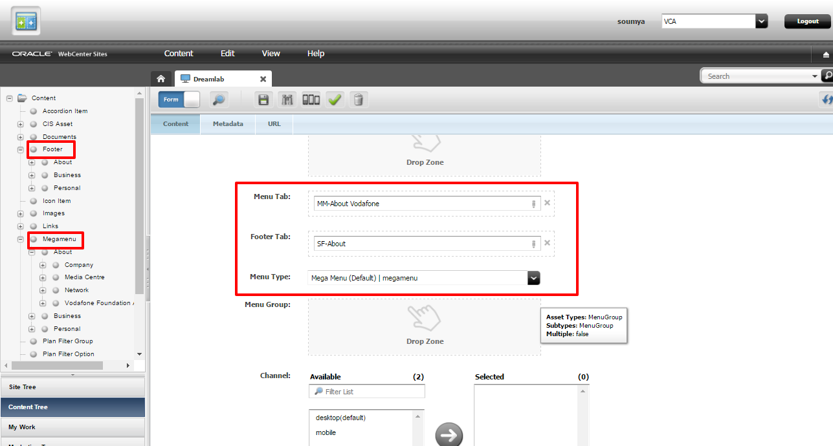

1. Click on the URL tab. The screen appears as below.
2. The relative URL without the domain name is entered in the URL attribute.

Example: For www.vodafone.com.au/foundation/dreamlab - actual URL

We will enter only - foundation/dreamlab in the URL attribute - relative URL

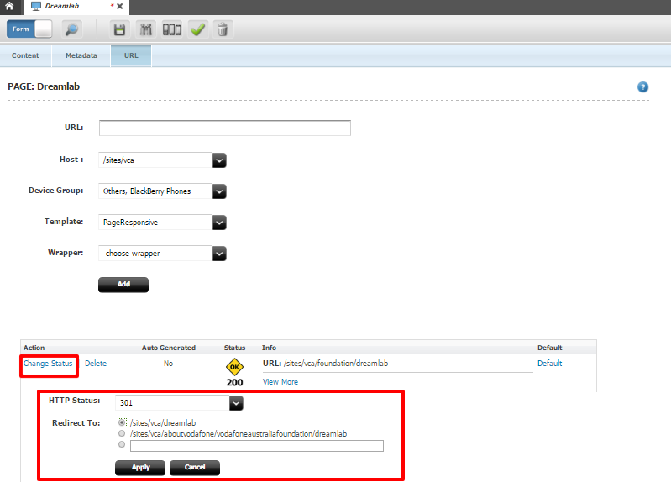

In this case the highlighted text is the domain name which will be appended internally, thereby rendering the required URL.

1. Choose the respective device group, template, wrapper from the drop down and click on the add button.
2. Thus the URL created for the page.

**URL has 2 status.**

1. HTTP Status **200** – is the existing URL
2. HTTP Status **301** – is the Redirect URL which redirects the old URL to the existing URL.

**To create a redirect follow the steps mentioned below.**

1. Create a relative URL.
2. Once the URL is created, click on the change status. Refer Screenshot.
3. Select the HTTP status to be 301 from the drop down and enter the redirect URL in the ‘Redirect to’ attribute.
4. Click on apply. Thus the redirect will be created.
5. Click on the save button to save the page. Thus the page is created.

## Creating a Row100 and Row Container asset

Row holds all the contents that are to be placed in the page. Different modules are all associated to the page via row only.

All the content on the page is divided in the form of rows. There are modules which are attached to the rows and hold the content for the page. The types of rows are defined by their width on the page. Row 100 can hold only 1 module, while Row Container holds up to 3 modules.

1. To create a new row click on Content -> New -> Row. Select **“Row 100”** when you want the row to occupy the entire width of the page.
2. Provide name to the row. The naming convention is to be followed.

The naming convention of an image asset should be followed. It always starts with “Row_” with the short and meaningful name of the page as per brief separated by ‘-’ delimiter denoting the position of where it sits in the page.

1. The Free Text Box module which holds the content to be present in the page is associated to the box1 attribute.

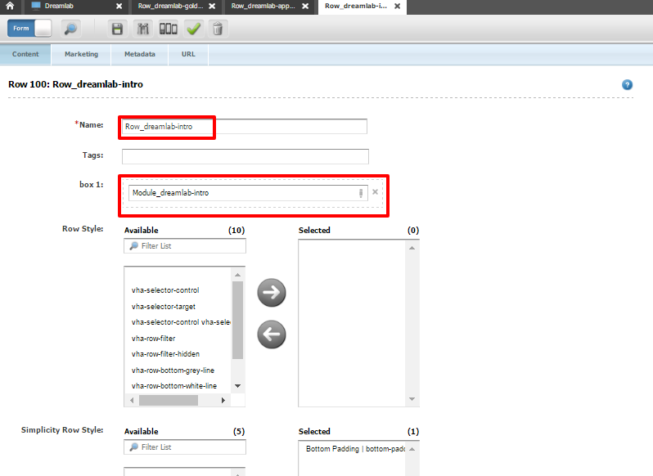

Apart from Row 100, we can also have row 25-75, row 75-25, row 50-50 and row 33-33-33 respectively using row container asset.

1. To create a new RowContainer, click on Content -> New ->Row. Select **“RowContainer”**.
2. For Row 33-33-33, associate 3 modules under the Modules attribute. Refer to the Screenshot.
3. For other row likes 50-50 etc., in the module display attribute, choose the desired format (50-50, 25-75, 75-25) from the drop down and associate the respective modules. Refer to the screenshot.

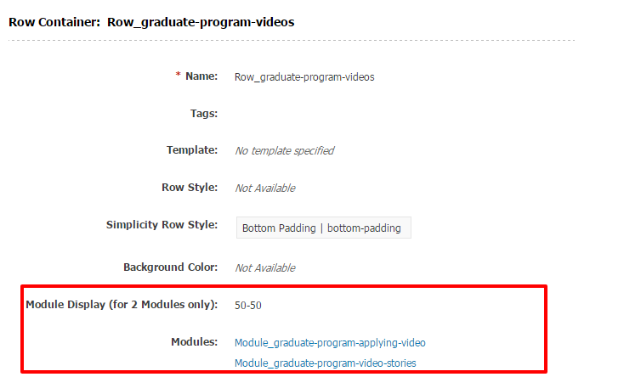

## Creating a Free Text Module asset

The module which is used the most is the *Free Text module*.

1. To create a new Free Text Box module on Content -> New -> **Free Text Box**.
2. Provide name to the free text module. The naming convention is to be followed.
3. Select the template as SPLFreeTextModule. Only then, the content will be visible on the page.
4. If the page contains banner asset, then in the H2 attribute or in the Content space, open <H1> tag and enter the H1 heading.
5. If there is no banner asset, then on the page level itself the H1 heading should be given.

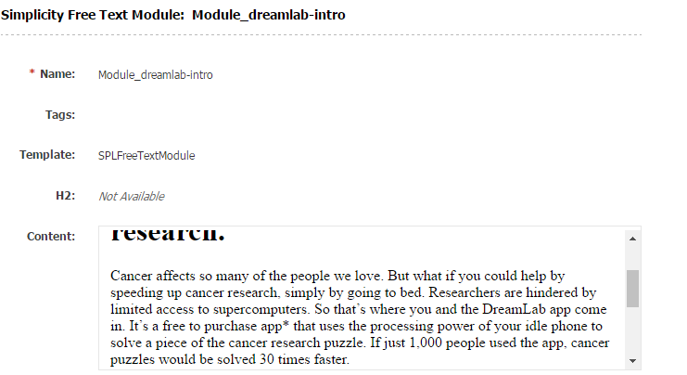

1. The content to be viewed on the page is placed in the Content space available. Once the content is placed in the free Text Editor go to Source and verify if CMS has not added any junk code like “&nbsp;”. If there is any you need to remove them manually.
2. Click on save to save the asset.

## Creating a Link asset

If there is a link to be associated on the page then a link asset is used. This asset can also be shared across different pages. Following are the steps to create a link asset.

1. Click on Content -> New -> Link.
2. You could also create a link asset by navigating to an existing link asset and select the option “Copy” under Edit tab.

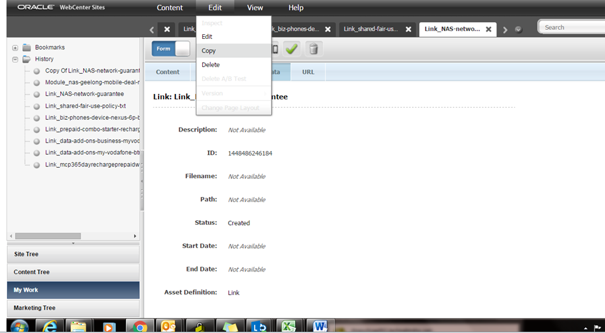

1. Add the name of the link asset.

The naming convention of the Link asset should be followed. This contains four parts. The first part always starts with the Link_ which is displayed automatically. This is followed by the <page-name>, a short description about the link and the type of the link i.e. <txt/btn>. Each part should be separated by ‘-’ delimiter.

1. Place the appropriate folder type from the content tree.
2. Set the link target as _self, if it links to internal pages (within Vodafone.com.au domain are internal pages) and _blank for all the external pages.
3. The type of tracking can be selected from the field ‘**Tracking code type**’ within the link asset. They are:
4. **lid** is used if the link asset is present on the page level.
5. **pid** is used if the link asset is present on the banner level.
6. **v21** is used if the link asset leads to e-store page.
7. If there is an external URL add the URL in the “target URL” field and parameters to the “parameter” field.
8. Type the reference id according to convention. This value will be populated in tracking of the link. It’s very important to follow the convention for tracking.

The convention for tracking links starts with the section of the page where the link is present. It is followed by the type of link i.e. text or image or button. The last part of naming convention refers to the text of the link.

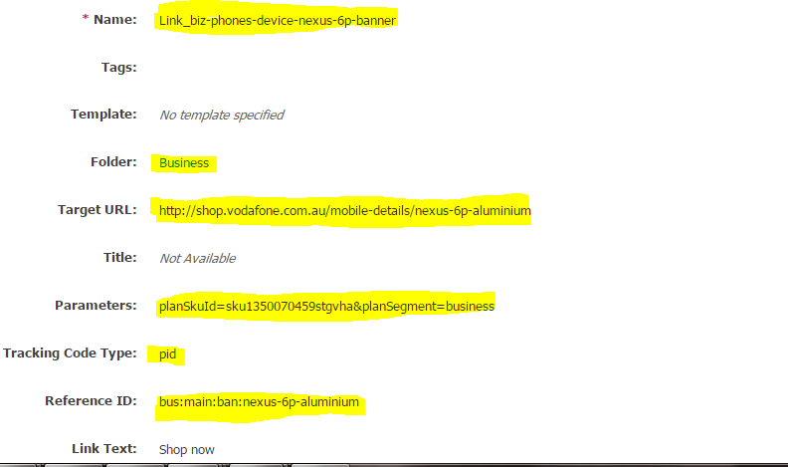

1. If there is an internal link to the page then the respective Page asset must be associated in the Target Page attribute.
2. Add styles for the link buttons using Link Style and the Simplicity Link Style attributes.

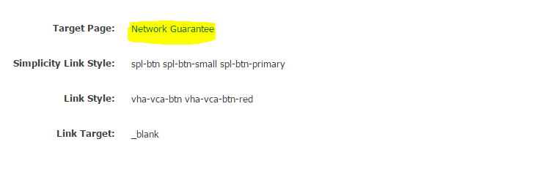

1. Click on save button to save the asset.

### Inserting a link asset into a module

The following steps should be executed for associating a link asset to a module.

1. Open the module where the link is to be associated and edit the free content field.
2. Position your cursor where the link needs to be added.
3. Click on Include asset button on the top right-hand panel of the editor and add the target asset. It should be dropped onto the “Insert Included Asset” box.
4. Choose the template as SPLDetail (The target asset must be readily available from the tree or the Search tab for linking). Refer to the screenshot.
5. Click on save button and your link will be inserted into the module.

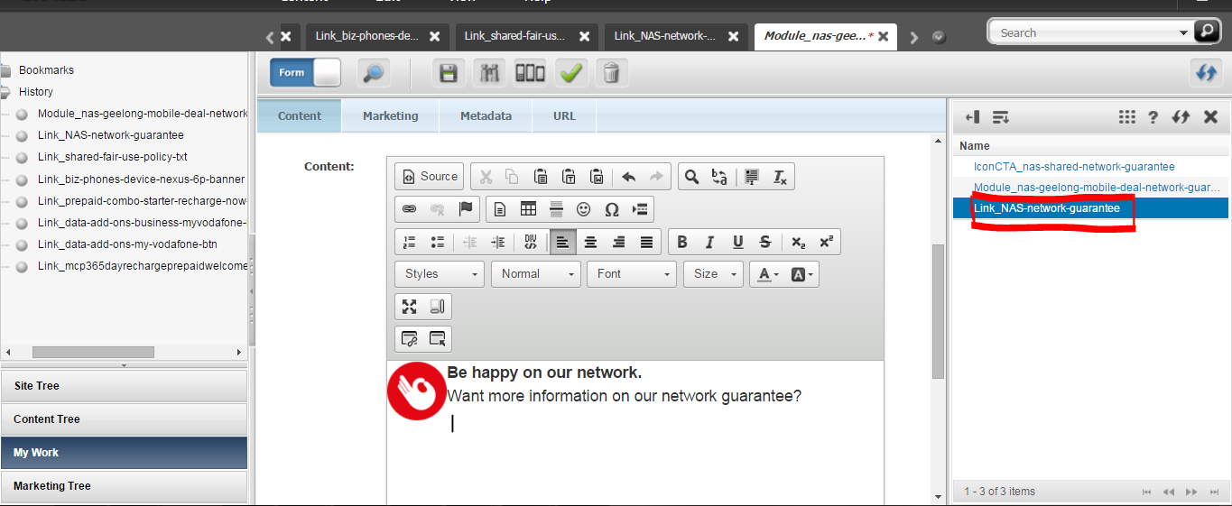

## Creating an image asset

All the images present on the website are in the form of image asset. This asset can also be shared across different pages. Following are the steps to create an image asset.

1. Click on Content -> New and select Image.
2. You could also create an image asset by navigating to an existing image asset and selecting the Edit -> Copy.
3. Add the name of the image asset.

The naming convention of an image asset should be followed. It always starts with “Img_” with the short and meaningful name of the page as per brief separated by ‘-’ delimiter. This is followed by image type (roundel/hotoffers/banner/header) and extra description if required. M/D at the end of the image name denotes whether it’s a mobile or desktop.

1. **The parent folder is to be selected based on the section of the page where the image belongs to.**

If the image is a background image then the folder to be selected is “Background/Banner”. If the image is a part of main body section then the folder to be selected is “Misc” etc., associated the image to the parent folders accordingly to the section of the page it falls.

1. **The image file to be uploaded is always in the “File” attribute.**

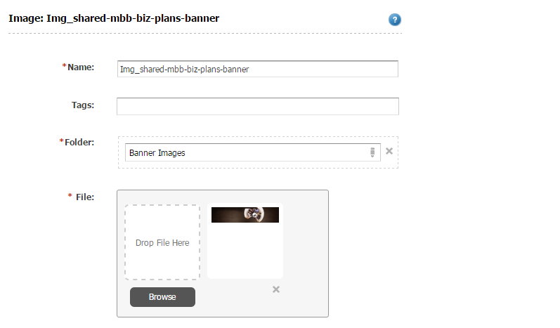

1. **Alt text attribute must hold a name for the image. This field should hold a meaningful name for the image which will describe the image.**
2. **Scalable should be set to ‘yes’ in the presence of mobile version of the image.**
3. **Upload the mobile version image to the mobile image section.**

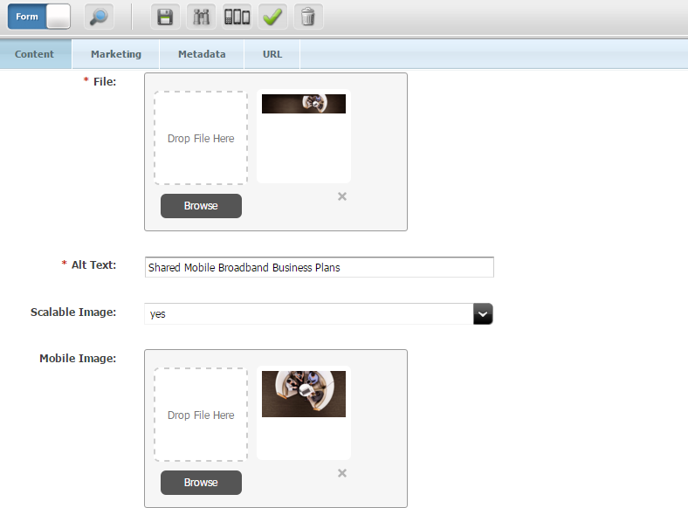

1. Click on save button to save the asset.

## Inserting an image asset into a module

Following steps should be followed for associating an image asset to a module.

1. Open the module where the image asset is to be associated and edit the free content field.
2. Position the cursor to where the image needs to be added.
3. Click on Include asset button on the top right-hand panel of the editor. Refer to the screenshot.
4. Click on Include asset button on the top right-hand panel of the editor. Refer to the screenshot.
5. The image to be inserted is either selected from the tree on the left panel or from the search tab at the right. Refer to the screenshot.
6. Drag and drop the asset in the Insert Included asset window.
7. Select the template as SPLDetail and hit the OK button.
8. Click on save button and your image will be inserted into the module.

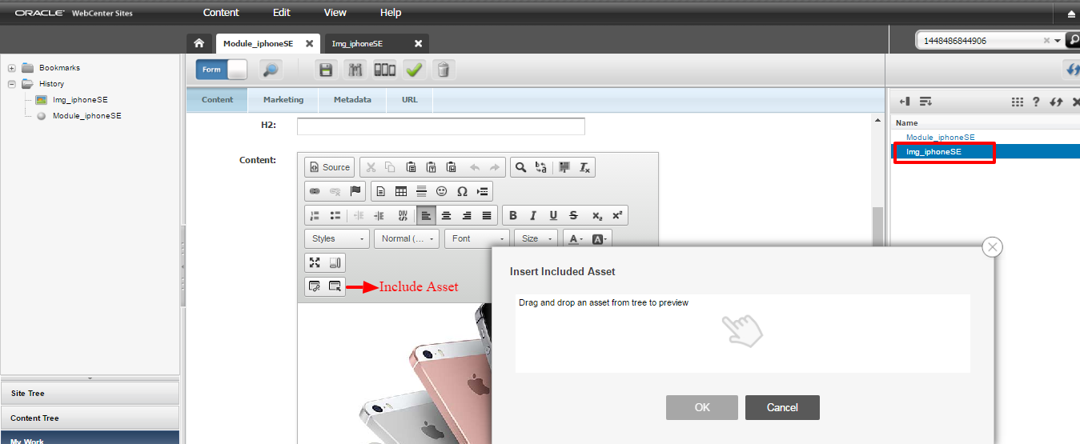

## Creating a document asset

All the documents present on the website are in the form of document asset. This asset can also be shared across different pages. Following are the steps to create a document asset.

1. Click on Content 🡪 New 🡪 Document.

2. You could also create a document asset by navigating to an existing document asset and selecting Edit 🡪 Copy.

3. Add the name of the document asset.

The naming convention of a Document asset starts with DOC followed by AU code and title of the PDF like “DOC-AU10261-$19-Gold-24Month-Plan-for-Select-3-Customers-Only”. In case where AU code is not present, it is replaced by month and year of the PDF like “DOC-Mar2016-$19-Gold-24Month-Plan-for-Select-3-Customers-Only”.

1. **Add the respective parent folder.**

If the PDF is a terms and condition PDF then it is to be added to the respective parent folder eg. July 2015 under Terms folder structure. If the PDF is a media release then it must be added to the respective parent folder eg. June 2015 under Media release folder structure.

1. **The document file is uploaded through “File” attribute. Also note that only pdf documents can only be uploaded and the raw document file name should not have any spaces or $ symbol. Hyphen and underscore can be present.**
2. **The Doc URL attribute will refer to the actual URL of document and must be added carefully. The URL convention is to be followed.**

The first part of URL convention is “/doc”. This is followed by the type of document i.e. media release or terms. The final part of URL consists up of PDF name. It need not be the name given but should be meaningful enough for the document.

1. **Link text needs to be specified.**
2. Click on save button to save the asset.

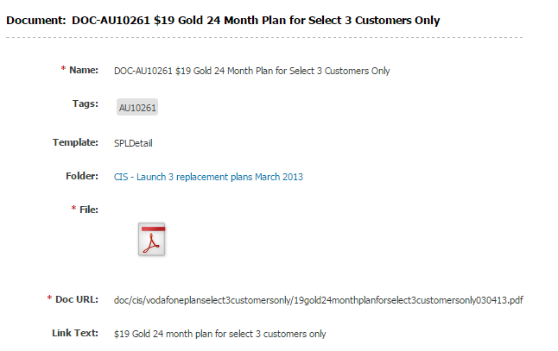

## Creating a banner asset

1. Click on Content 🡪 New 🡪 HTML Banner
2. You could also create a banner module asset by navigating to an existing banner module asset and selecting the Edit -> Copy.
3. Add a name which starts with Module_ followed by a meaningful name specific to page or campaign, separated by hyphen (-)
4. Chose an appropriate template (SPLHTMLBanner).
5. **If the** text and background color **needs to be different, it can be added in** Text color and Background color attribute **with the hex code of the color added.**

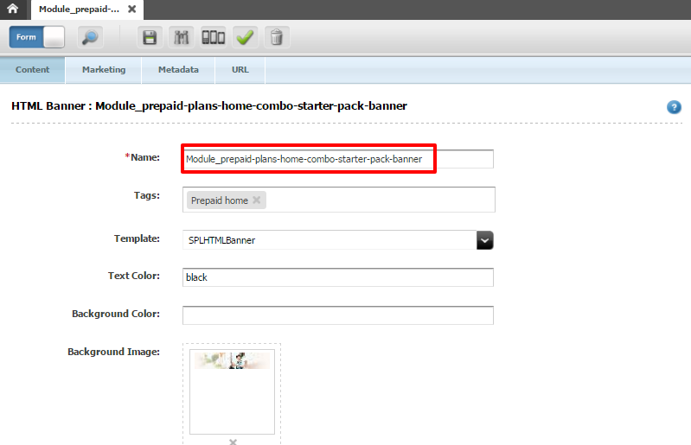

1. Associate the appropriate image asset in the background image and mobile image attribute.

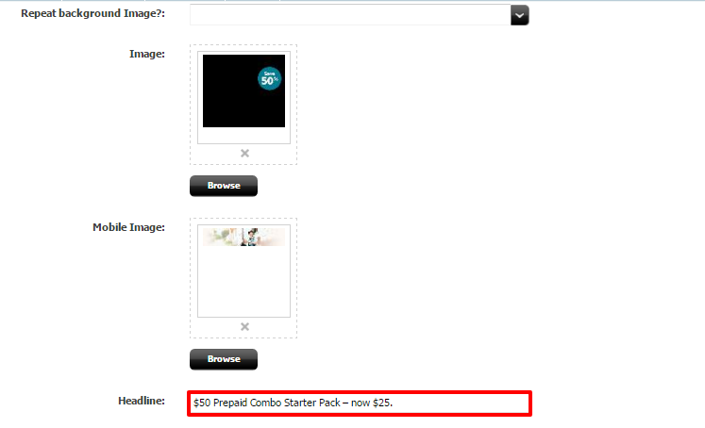

1. **Enter the Headline which describes the heading of the banner.**
2. **Enter the Body Copy which represents the sub-heading of the banner.**
3. **Enter the Note attribute which describes the text on the banner.**
4. **Associate the link assets in Link attribute. As the name suggests, this will hold the destination URL for the banner module link.**
5. Click on save button to save the asset.

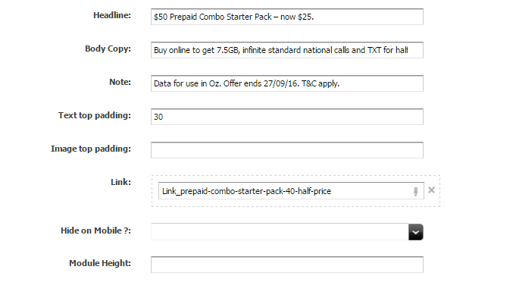

## Creating a Hot Offer Banner module

1. Click on Content --> New --> Module --> GridHotOffers
2. You could also create a Hot Offer banner module asset by navigating to an existing Hot Offer banner module asset and selecting the Edit -> Copy.
3. Add a name which starts with Module_ followed by a meaningful name of the plan separated by hyphen (-)
4. Chose an appropriate template.
5. Enter the H2 which describes the heading of the banner.
6. Enter the Description which represents the sub-heading of the banner.
7. Enter the Note attribute which describes the text on the banner.
8. Associate the appropriate image asset in the Image and Roundel Image (if needed) attribute.

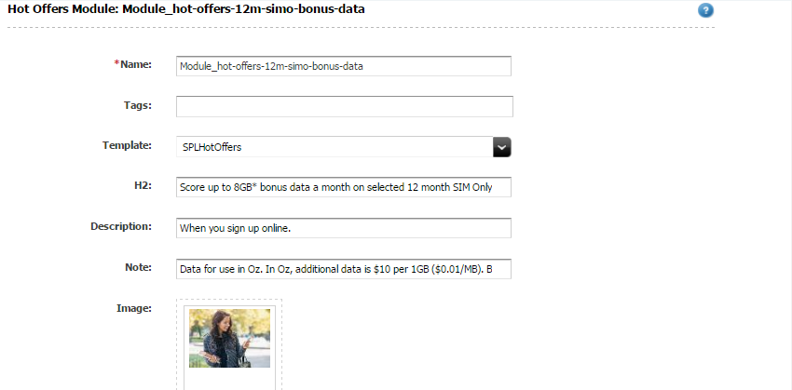

1. Choose the appropriate offer type from the drop down of Offer Type attribute.
2. **Offer types** are:

**Red** for Postpaid Plans related offers.

**Grey** for Device specific offers.

**Green** for Prepaid related offers.

**Purple** for MBB related offers.

1. Associate the link assets in Action Link attribute. As the name suggests, this will hold the destination URL for the banner module link.
2. If the background color needs to be different, it can be added in Background color attribute with the hex code of the color added.
3. Click on save button to save the asset.

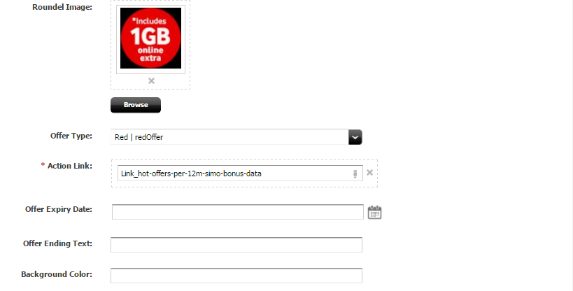

## Creating an Icon CTA module

1. Click on Content 🡪 New 🡪 Module 🡪 GridIconCTA
2. You could also create an IconCTA module asset by navigating to an existing IconCTA module asset and selecting the Edit -> Copy.
3. Add a name to the Name attribute which starts with Module_ followed by a meaningful name.
4. Choose an appropriate template for the Template attribute.
5. Add the heading to the H2 attribute **which describes the heading of the IconCTA module**.
6. **Associate the link assets in Action Link attribute. As the name suggests, this will hold the destination URL for the IconCTA module link.**
7. **If the** text and background color **needs to be different, it can be added in** Text color and Background color attribute **with the hex code of the color added.**
8. Associate the corresponding IconCTA item’s to Icon CTAs attribute.
9. Click on save button to save the asset. Follow the steps below to create IconCTA item.

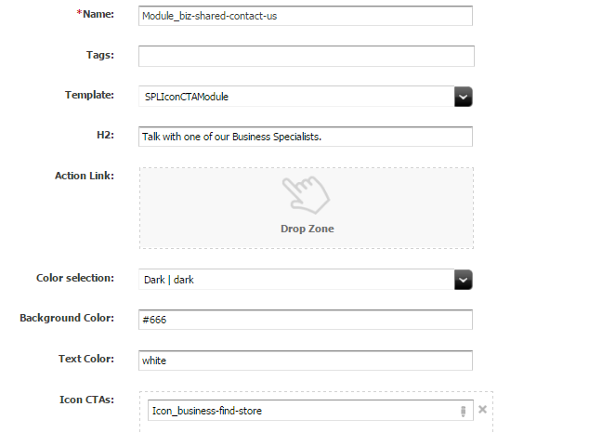

1. Click on Content 🡪 New 🡪 IconCTA
2. You could also create an IconCTA asset by navigating to an existing IconCTA asset and selecting the Edit -> Copy.
3. **In the Folder attribute add the parent folder “Icons” from the content tree.**
4. **The title attribute will contain the text which is to be displayed on the website for the IconCTA.**
5. **Enter the Description which represents the sub-heading of the IconCTA.**
6. **Associate the link assets in Action Link attribute. As the name suggests, this will hold the destination URL for the IconCTA link.**
7. Click on save button to save the asset.

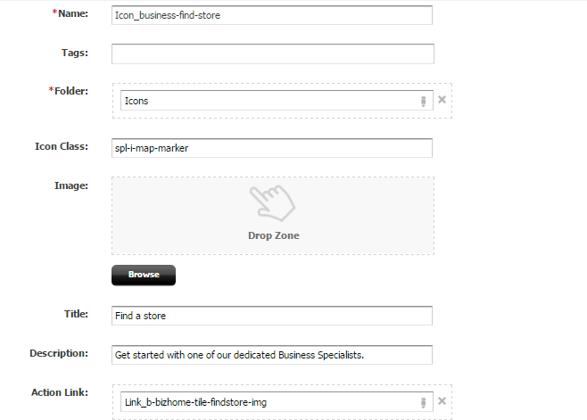

## Creating an accordion asset

Accordion assets essentially represent the dropdowns present on the page. A good example of an accordion asset will be the dropdown of terms and conditions present on the page. This asset can also be shared across different pages. Following are the steps to create an accordion asset.

1. Click on Content ->New and select Accordion Item.
2. You could also create an accordion item asset by navigating to an existing accordion item asset and selecting the Edit -> Copy.
3. Add the name of the Accordion asset.

The naming convention of an accordion asset should be followed. It always starts with “AccItem_” followed by the abbreviation of the website section this link will belong to i.e. ‘biz’ for business and ‘abt’ for about Vodafone. This is followed by the short and meaningful name of the page separated by ‘-’ delimiter. The last part will refer to the content of the accordion.

1. **The title attribute will contain the text which is to be displayed on the website for the accordion.**
2. **In the Folder attribute add the parent folder “Accordion Item” from the content tree. Refer to the screenshot.**
3. **The content of the accordion is added in the “Free Text” attribute.**

Heading of each paragraph must be added inside <p><strong> tag. Each paragraph heading will have a <br/> tag at the end. All the paragraphs including heading text will be added under <p> tag. If the text is added inside Free Text field, it is a good practice to go to source and verify if CMS has not added any junk code like “&nbsp;”. If there is any you need to remove it.

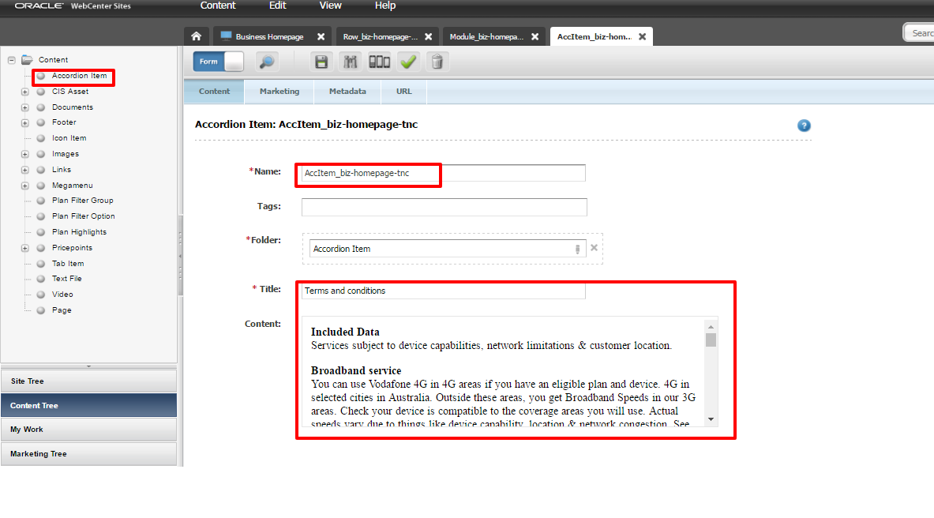

1. Click on save button to save the asset.

## Creating a Price point asset

1. Click on Content 🡪 New 🡪 Price Point.
2. Now For the Folder, go to Content Tree ->Price points ->Business/Consumer-> 12 months/24 months/month to month.
3. Enter the plan SKU Id, Old data inclusions and Data.
4. Under bonus data or offer – enter the offer headline in here.
5. The hot offers can be entered here as Plan highlight and Plan filter options needs to be given in here.

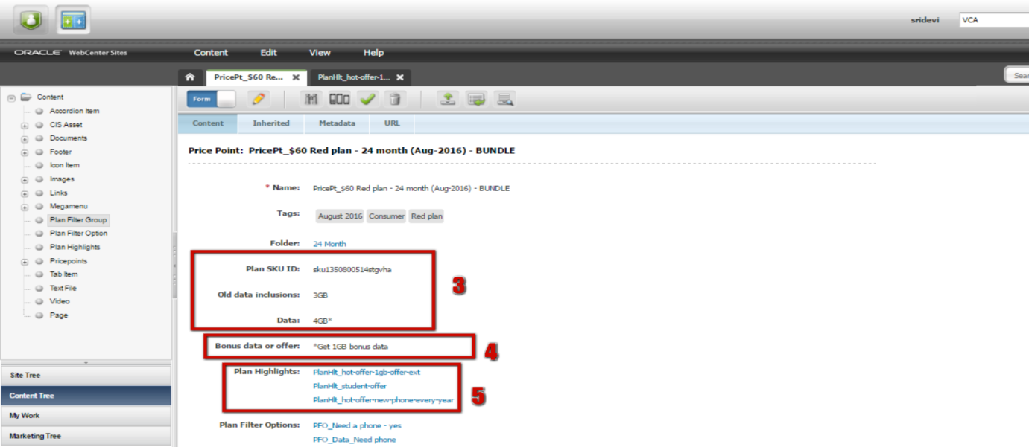

1. The plan price and the total price needs to entered, Contract length and plan label to be filled respective to the plan.
2. The respective CIS needs to be updated in here.

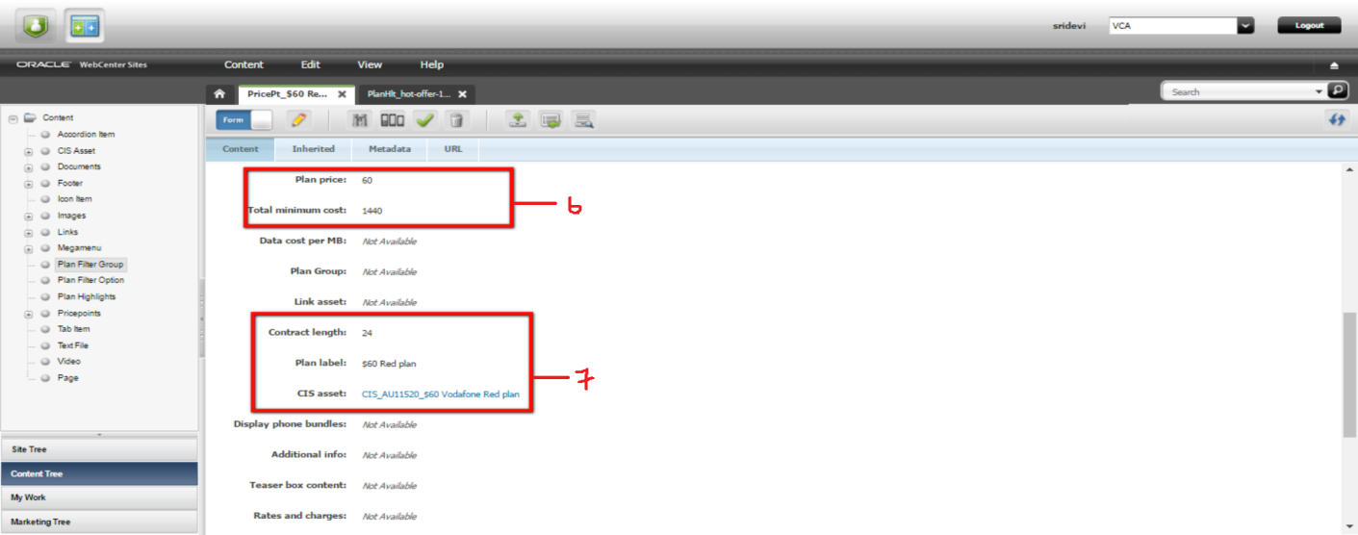

1. The terms and conditions for the price point is picked up from the ATG, hence an ATG project must be present on Production environment.
2. After publishing the VCA changes, we need to refresh the tools in the WCS in order to update the json file. For the plans to display the Terms and Conditions (T&C) from ATG, plans and bundles tools are refreshed. Click on the necessary tool, and press **Refresh Estore API**.

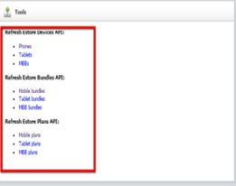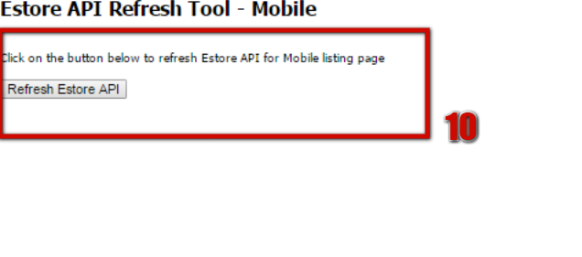

1. Once the tools are refreshed then click the json URL, check for your changes

**Refresh Estore Plans API:**

Mobile plans - http://www.vodafone.com.au/api/mobile_plans.json

Tablet plans - http://www.vodafone.com.au/api/tablet_plans.json

MBB plans - http://www.vodafone.com.au/api/broadband_plans.json

1. Clear the cache and check them in incognito window.

### Creating Plan Highlight

1. Click on Content 🡪 New 🡪 Plan highlight.
2. Select the template as SPLDetail.
3. Now For the Folder, go to Content Tree ->Content->Plan highlight.
4. Enter the label as hot offers.
5. In the title enter the heading from the copydeck and content from the copydeck to be entered in the sub label.
6. Enter the highlight style - special-offer | vha-hl-special

|  |  |
| --- | --- |
|  |  |

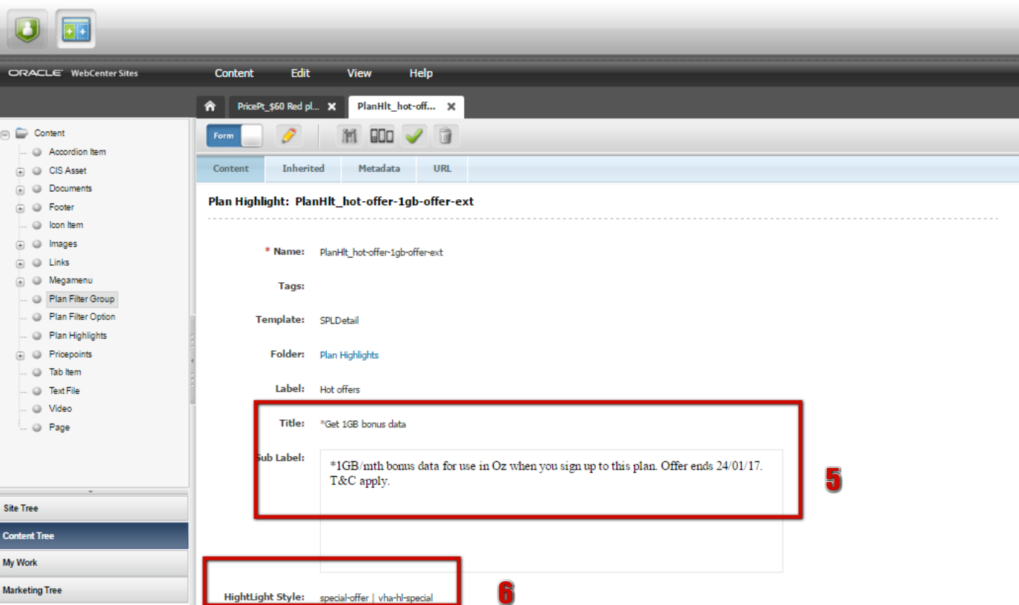

### Creating Plan Filter Option

1. Click on Content 🡪 New 🡪 Plan filter option.
2. Enter the name for the filter option starting with PFO_
3. For the folder go to Content Tree -> Content-> Plan filter option.
4. In the label, give the name of the filter option that needs to be displayed.
5. Select the respective plan filter group.
6. Under the push state URL component enter the detail for what the option is for.

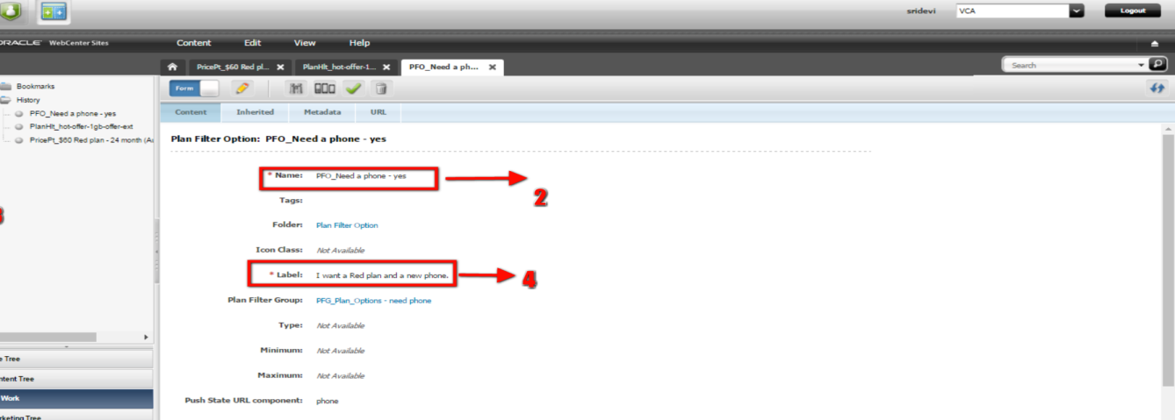

## Creating a Promo bar

Promo bar is present right below the banner of any page. Promo bar is created based on the merchandising requirement.



Following are the steps to create a promo bar.

1. Create a promo bar module by New -> Module. Under the Asset Definitions choose GridPromoBar.
2. Add the name of the Promo bar module.

The naming convention of Promo bar module asset should be followed. It always starts with “Module_” followed by the hyphenated name which describes the Promo bar banner.

1. **Enter the Icon class. This icon appears at the beginning of the promo text.**
2. **Enter the heading size as Small.**
3. **Mention the content to be displayed inside content attribute.**
4. **Enter the color selection as Light.**

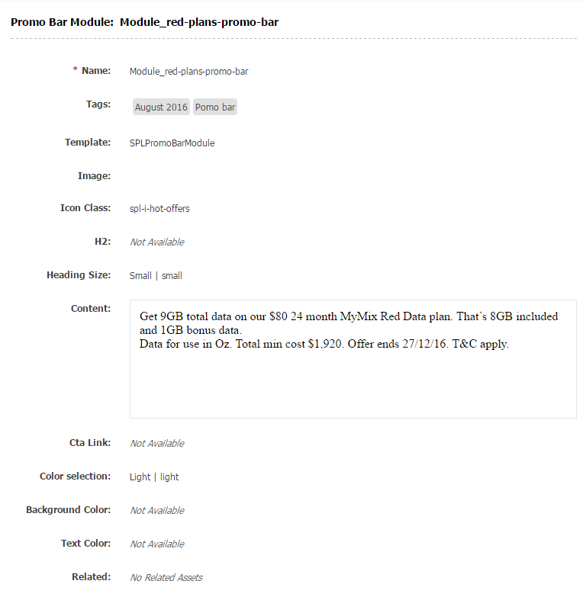

## Creating a button on an image

**Image Map assets are used to create a part of an image as button. This image map assets are associated to image assets under image map attribute. Following are the steps to create an image map asset.**

1. **Click on Content tab-> New and select Image.**
2. **Add the name to the image asset. Follow the naming conventions.**

The naming convention of an image asset should be followed. It always starts with “Img_” with the short and meaningful name of the page as per brief separated by ‘-’ delimiter. This is followed by image type (roundel/hotoffers/banner/header) and extra description if required. M/D at the end of the image name denotes whether it’s a mobile or desktop.

1. **Associate the concerned image map asset in the related attribute separately for Image Map(Desktop/Tablet) and mobile Image Map. Refer to the screenshot.**

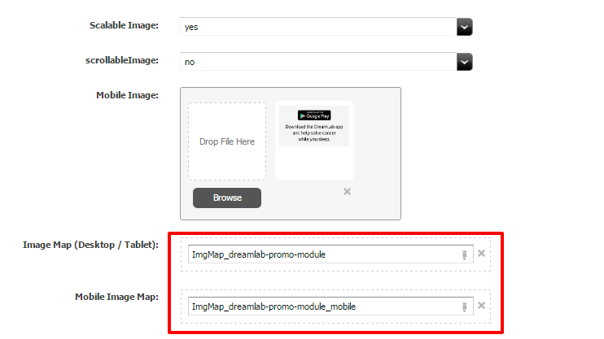

**Image Map Area assets defines the coordinates of the area of image which is to be turned into button. Following are the steps to create an image map area asset.**

1. **Click on Content tab-> New and select Image Map.**
2. **Add the name of the asset. Naming convention should be followed.**
3. **Select the template to SPLDetail.**
4. **Add the coordinates which are specific to the shape that needs to appear as button in the image to the respective Left, Top, Height, and Width attributes. Refer the Screenshot.**

The naming convention of an image map asset should be followed. It always starts with “ImgMap_” followed by the abbreviation of the website section this link will belong to i.e ‘biz’ for business and ‘abt’ for about Vodafone. This is followed by the short and meaningful name of the page separated by ‘-’ delimiter. The next part will refer to the section of the page image map area belongs to. Mobile at the end of the image map denotes whether it’s for mobile or desktop mapping.

It is always a good practice to view an existing image map asset for the coordinates so that they are entered correctly. If an existing image map asset with required coordinates is not present then you should get in touch with designers for the coordinates.

1. **Select Yes in the Transparent Attribute.**
2. **Add the Link asset in the related attribute. This asset will hold the destination URL of the button along with the tracking information.**

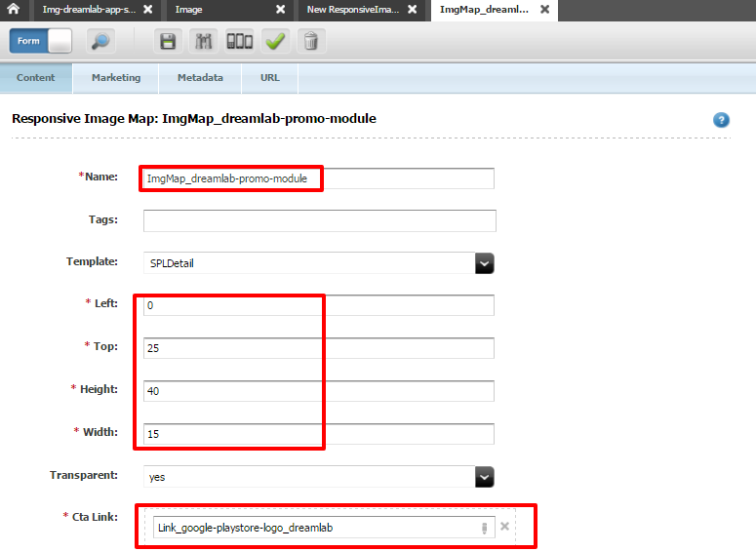

## Creating Mega Menu and Footer

This describes how to build the mega menu and footer for the Vodafone AU website. There are 3 sets of mega menus and footers. The MM and Footer are used for easy navigation of pages trough the sites. There is one mega menu and footer for each of the three sections of the site- Personal, Business and About Vodafone. Let’s see in detail how each mega menu and footer is structured.

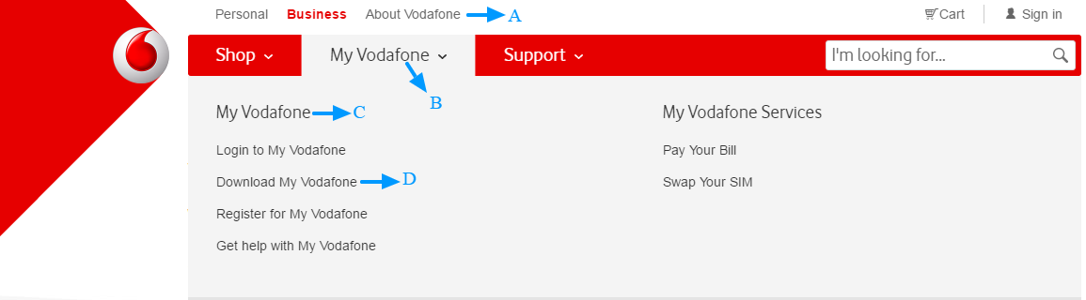

**Figure 1: Mega Menu**

**In Figure 1 :**

**A: Menu Tab**

**B: Menu Group**

**C: Menu Column**

**D: Links**

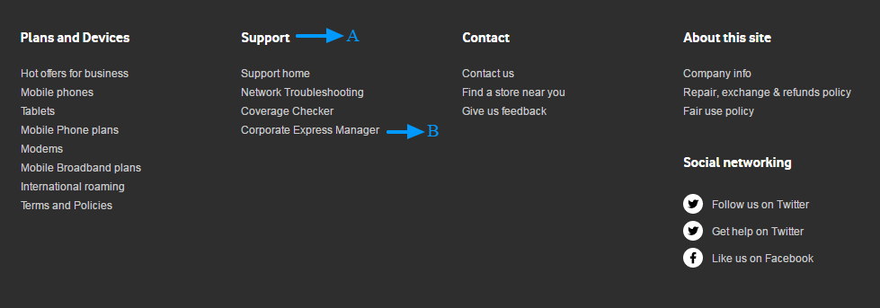

**Figure 2: Footer (there is only one Menu Group for each footer)**

**In Figure 2 : A: Menu Column B: Links**

To build a mega menu and footer:

1. Build the **link**. Ensure that you associate it to the correct folder in the Mega menu/Footer folder within the Content Tree.
2. Create the Menu Column then drag and drop the appropriate links to the respective Links attribute.

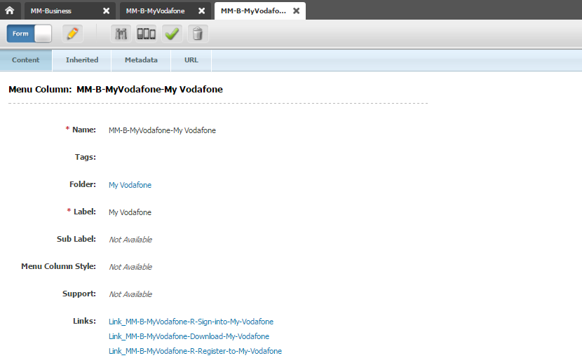

The naming convention for Menu column, groups and tab asset should be followed. It starts with either mega menu (MM) or footer (SF) followed by which column it placed (Business/About/consumer) with specific menu group name separated by delimiter ‘-‘.

1. Create the Menu Group then drag and drop the appropriate Menu Column(s).

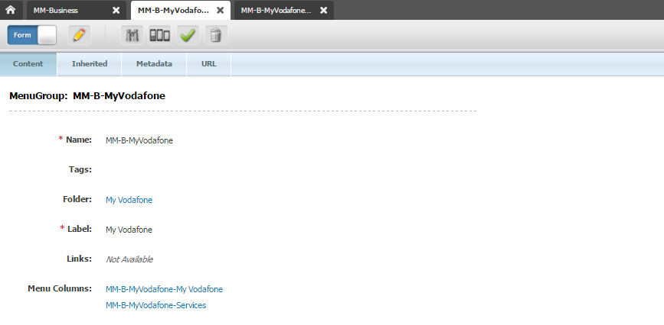

1. Create the Menu Tab then drag and drop the appropriate Menu Group(s).

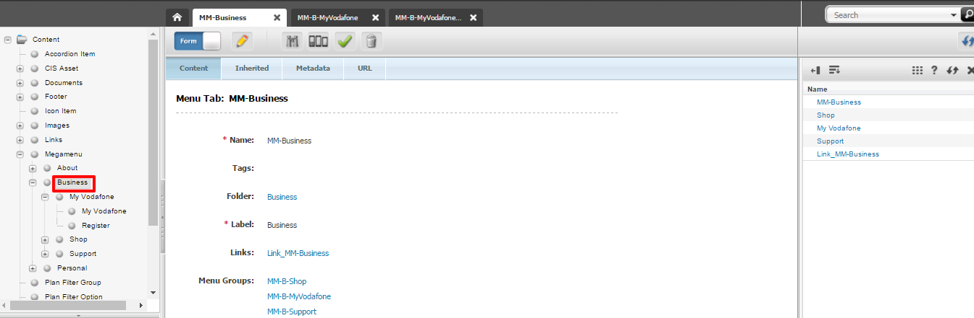

The Menu Tab is then associated to the corresponding folder in the site tree. Here Menu Tab MM-Business is associated to the business folder under the mega menu in the site tree.

## Creating Form

* 1. Within the row, create a FormModule - this will automatically populate a couple of fields which you will later need to update with information once you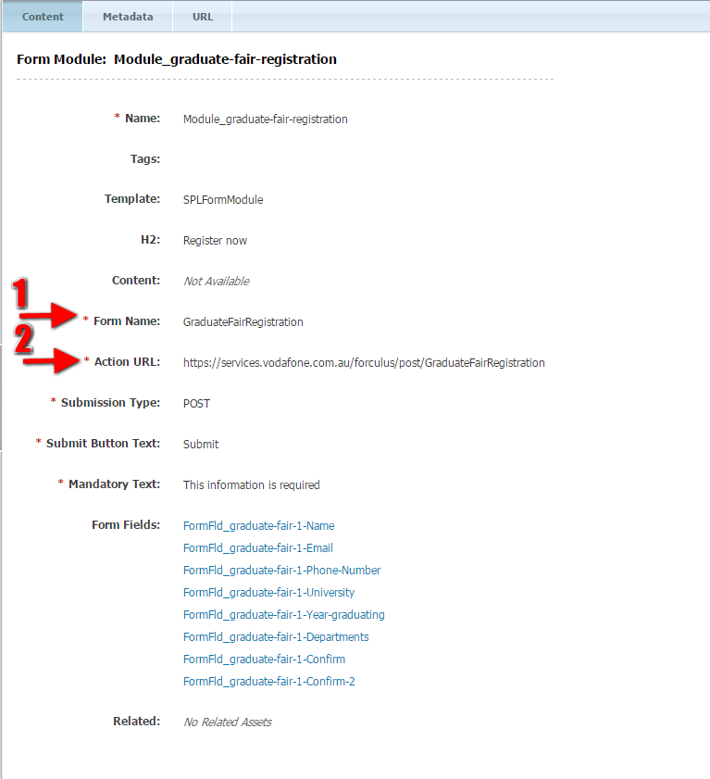have set up in Forculus, as well as mandatory information needed on the page (submit button and explanation for the red asterisk mandatory fields).

**Form name**: must be unique and not currently used in forculus ie. GraduateFairRegistration

**Action URL**: Include the form name after post ie. https://services.vodafone.com.au/forculus/post/GraduateFairRegistration

* 1. Associate the Form Fields which you create from the bookmarks.

### Creating form fields

Next you need to find and/or create the fields that make up the form (Form Fields) which are available in a number of formats and have different purposes and capture information differently.

Form fields can be re-used across multiple forms and because some are used regularly and should be consistent in format (i.e. name, contact number, email etc) it is worth taking a look at existing form fields and reusing where possible, to avoid creating duplicates.

If using an existing form field, find the Form Field and add to your bookmarks. Remember not to change any of the settings within as the Form Field may be in use on another live page. After adding the form fields to the form module, in order to rearrange them, hold the form field and move across to rearrange.

If creating a new form field, you need to determine the type and style of Form Field, you need to update the following fields (Refer Wiki document for more description)

* + 1. **Name** - follow standard naming conventions. i.e. f-'project'-'page'-'field description'.
    2. **Label** - this is the question or header text that will display on the form page.
  1. **Field Name** - the header that will identify the data captured in Forculus.
* Every field name needs to have the prefix **dur_**or**per_**(durable or perishable) - this is very important and required for the form to work properly.
* The field name needs to be short and succinct as this will form the column header when the data is exported or reviewed in Forculus.
* There mustn't be any spaces in the field name, only underscores, letters and numbers.
* **dur_** this stands for **durable** and means that the data within this field will not expire. For confidentiality reasons, you cannot have **dur_** fields on two pieces of customer identifying data. i.e. you can have the "Name" field as a **dur_** field, but not the address, or vice versa, as neither are enough on their own to solely identify a customer, however, these fields combined point to one person.   Generic question answers can be dur_ fields and the form requester may wish to keep this information in Forculus to review at a later stage.

For fields with more generic questions (i.e. what type of device do you have? Are you interested in finding new ways to help charities achieve their mission? etc), because these questions are not at risk of breaching confidentiality they can therefore be marked as **dur_** fields so that they can be referred to at a later stage.

* **per_**this stands for **perishable** data and should be used when the data within that field is confidential and should expire after a certain amount of time (you will need to define this period in Forculus). As mentioned above, this applies to any customer identifying data (excluding 1 field) i.e Name fields, address, contact number, email address etc.

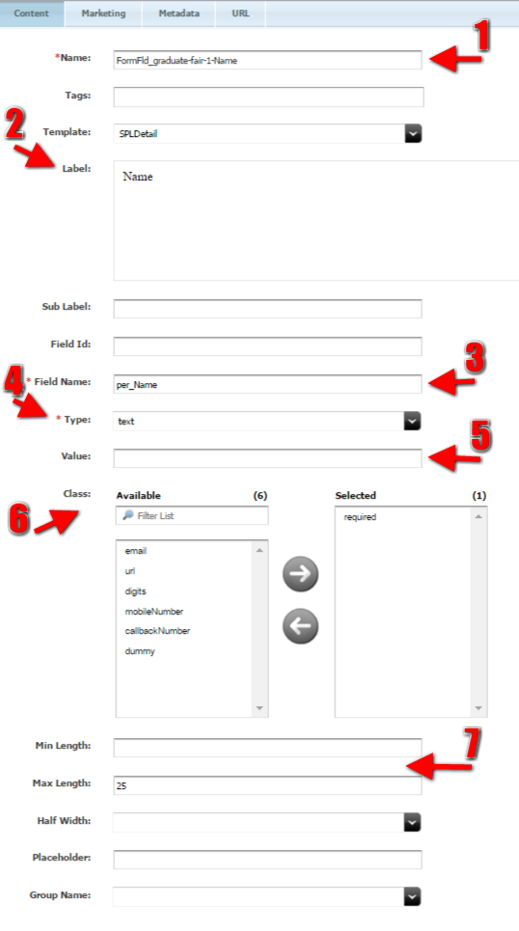

* 1. **Type** - the style of field (i.e text area, checkbox, radio buttons etc)

Here is a quick overview of the different 'Types', followed by more information & explanation further down:

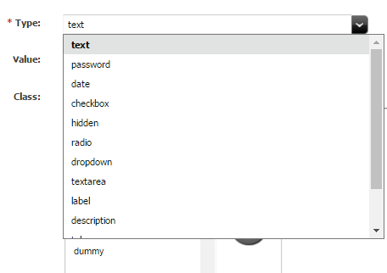

**Text**- a short text field generally used for names, emails, mobile numbers etc.

**Password** - used for passwords. The text will not display when typing

**Date** - creates a date field which requires the date to be entered in the format of dd/mm/yyyy

**Checkbox** - This was designed in the system to act as an "accept terms & conditions" checkbox where there is only one box in the form field to select. A check list can be created

**Hidden** - *To date we have not had to use this field.* This is used as a security check to ensure the user is a person and not a robot.

**Radio** - Radio button should be used when you have provided a number of options, but would only like one response from the user. i.e. yes/no

**Dropdown** - Another option for where you would like to provide a number of options to the user, but only have one outcome. i.e. can be used for states, age brackets etc

**Textarea** - This is a free text field which allows the user to free type information.  You can add a character limit on this field (there is no way to apply a specific word limit, however you can work out an estimated number of characters).  You can also adjust the height and width of this form field.

**Label -**Used to include copy (or headers) within the form where you do not require a field for input from the form user.

* 1. **Value** - depending on the type, you may or may not need to include this. This can be used for a range of things, from the names next to the radio buttons (i.e. yes/no) or to determine the size of the text area field.
  2. **Class**- this is where you can apply any rules to the field, i.e. if you would like to ensure a field is completed to submit (required field), or if you want to ensure that a mobile number or email is entered in the correct format.

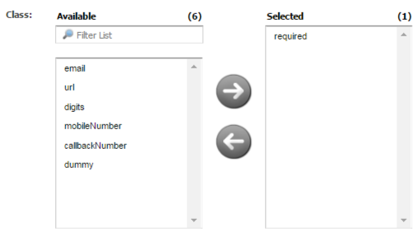

**Required** - This makes this a required field. Selecting this option, automatically includes the red asterisk to next to the question, and also prevents the user from submitting the form without completing this field.

**Email** - This will prevent the user from submitting the form unless the field is completed in an email format with [text@text.text](mailto:text@text.text)

**URL** - This will prevent the user from submitting the form unless the field is completed in an URL format with [www.text.text](http://www.text.text)

**Digits** - This will prevent the user from submitting the form unless the field is completed using digits only.

**Mobile number** - This will prevent the user from submitting the form unless the field is completed using 10 numbers beginning with '04'. This ensures the user enters an Australian mobile.

**Callback number** - This will prevent the user from submitting the form unless the field is completed using 10 numbers beginning with '0'. This allows the user to enter an Australian landline or mobile.

* 1. **Min/Max length (optional)** - if the type is text or textarea, you may wish to limit the character count of the field.

### Testing a Form using Source code

1. Once the form is setup in VCA, testcode will the provided in the form of text file to check to test whether the data in the field is captured in the Database.
2. Using the Test code the Form fields should be updated. For example fields such as ‘LABLE’ ‘MAX LENGTH’ ‘INPUT ID’ should be updated.
3. Once the fields are updated, do a ‘TEST ENTRY’ in the form and submit the form, check whether the submitted form returns the Return URL.
4. The team will cross check whether the Data is bee captured as expected and whilst everything is OK.
5. Final CODE will be provided to GO LIVE.

## Creating and updating Critical Information Summary

Critical Information Summary refers to the documents which are legally mandated for plans. Essentially they are in document assets. These documents are present in the CIS section of the website at <http://www.vodafone.com.au/cis>. All the CIS documents are visible on the website. Even when a document is updated with new information the old document can still be viewed on the website. All CIS documents have an AU code with the exception of documents which are for prepaid plans (both mobile and MBB).

Create a document asset with the required PDF. Follow the steps listed in the “create a document” section. Please take note of the below box.

For plans CIS document the name must always start with unique AU code. For prepaid since there is no AU code the convention dictates that category name like “*365 Day*” or “*All Time*” or “*Flexi Cap*” is added in front of the name. At the end you should also add month and year. The parent category to be selected is also very important. Follow the following convention for selecting categories:

Mobile plans -> *CIS – CURRENT – BLUE Plans JULY2014 – MAR2015*

MBB plans -> *CIS – CURRENT – MBB Plans AUG2014 – APR2015*

MBB Prepaid -> *CIS - CURRENT - Mobile Broadband Prepaid 2014*

Prepaid -> *CIS - CURRENT - PREPAID Sept 2014*

### Creating a CIS asset

1. Click on Content 🡪 New 🡪 Document
2. **Add the name of the asset. Naming convention should be followed.**

The naming convention of a CIS asset starts with CIS followed by AU code and title of the PDF like “CIS-AU10261 $19 Gold 24 Month Plan for Select 3 Customers Only ” . In case where AU code is not present, it is replaced by month and year of the PDF like “CIS-Mar2016 $19 Gold 24 Month Plan for Select 3 Customers Only ”.

Customers Only ”

1. The plan category should be selected based on the CIS category. If a new category is to be added to this dropdown you should contact the DEV team.
2. The plan type should be appropriately selected.
3. The plan price needs to be added in the format “*xx.xx*”.
4. The plan name should be added carefully as this name will be visible on the website. The name should sufficiently describe the CIS.
5. The “Plan from date” attribute holds the value of date from which CIS would be applicable. You must double check the value of this attribute as this will decide the date from which a new CIS would be visible on website.
6. Associate the appropriate document asset to the Document field.

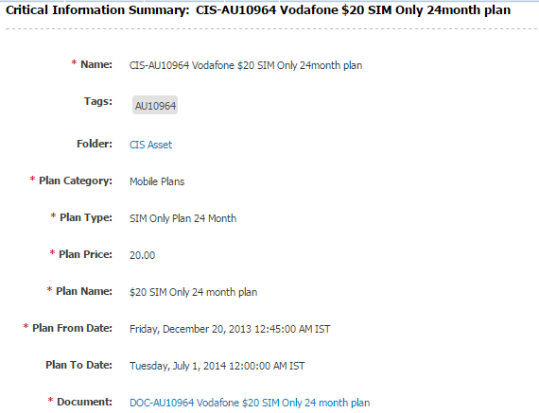

For CIS updates

9./rest/CIS?field:planCategory:equals=Mobile%20Plans&field:planFromDate:lessthaneq=08/06/2016

NB: All individual CIS PDF URLs also need to be flushed.

CIS Tool (When CIS does not appear on CIS page)

10.Run the following for indexing purposes:

http://vca-prod.prod.ucms.aws.vodafone.com.au/sites/ContentServer?pagename=OpenMarket/Xcelerate/Search/Event

11.The above is used to refresh the CIS cache

12.Run it in Internet Explorer, why? ¯\_(ツ)_/¯

13.!important: Make sure you're in the right CMS

14.Nothing will be shown once the tool is run, in summary, it'll just show an empty page. So how do you know the refresh happened?

15.That the browser icon is no longer the loading icon

16.That the browser icon is actually the browser icon

17.That the browser has stopped loading

18.Verify CIS at delivery server by confirming your NEW or UPDATED CIS's are there using the following JSON URL:

19.http://vca-prod.prod.ucms.aws.vodafone.com.au/rest/CIS?field:planCategory:equals=Prepaid&field:planFromDate:lessthaneq=27/07/2017

20.!important: The highlighted texts are important to note

21.prod - make sure you're in the right CMS (super importante por favor)

22.Prepaid - make sure you're in the right plan category

27/07/2017 - make sure the date is updated to the current date

23.After confirming the new/updated CIS appears in the data, flush the page URL in Cloudfront (update as required) e.g.

/rest/CIS?field:planCategory:equals=Prepaid&field:planFromDate:lessthaneq=27/07/2017

### Archiving a CIS asset

As described earlier, a CIS asset does not go to EOL. Instead that asset is simply archived. To archive a CIS asset we add an end date to the CIS asset. A new CIS and associated document asset is then created for the subsequent dates.

<https://vodafone.atlassian.net/wiki/spaces/DDP/pages/148996588/CIS+Documents+-+WebCenter> follow the URL for reference

<https://vodafone.atlassian.net/wiki/spaces/DDP/pages/340197385/Cloudfront+Cache+Flush+URLs>

Page URL for the checking the CIS: <https://www.vodafone.com.au/about/legal/critical-information-summary/plans>

## Setting up Device Landing Page

For the purpose of merchandising a device, device specific campaign page is set up on WCS. This is a normal page like any other VCA pages, additionally a bundle module is added to display the hero price of the device.

### Creating an Bundle asset

Bundle assets are created for rendering hero pricing information on the respective campaign pages. Price-points and Device assets are associated to the bundle asset which helps in rendering the required information onto the campaign page.

1. Click on Content -> New and select bundle.

The naming convention of a bundle asset should be followed. It always starts with “Bundle_” followed by the device name, its capacity and plan separated by ‘-’ delimiter.

**1. Add the name of the bundle and its capacity in the Name attribute.**

**2. In the Folder attribute add the parent folder from the content tree. Refer the screenshot.**

**3. Associate the device asset to the bundle. Creation of device asset is explained in the next section.**

**4. Associate the price-point to the bundle. This helps in rendering the pricing and offer info.**

**5. Enter the total min. cost which is minimum monthly spend (Device+Plan) x 24 months.**

1. **Link asset is associated to the Link attribute which takes to the e-store page.**

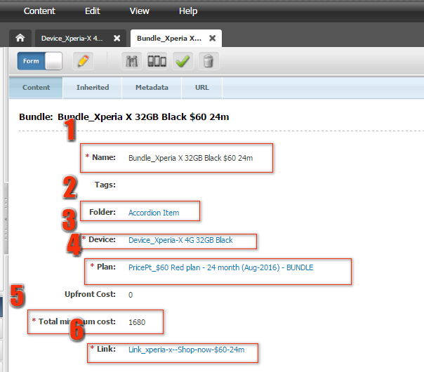

1. Click on save button to save the asset.

### Creating an device asset

Device assets are usually associated with the bundle asset specific to the device.

Click on Content -> New and select device.

The naming convention of a device asset should be followed. It always starts with “Device_” followed by the device name and its capacity separated by ‘-’ delimiter.

**1. Add the name of the device and its capacity in the Name attribute.**

**2. In the Folder attribute add the parent folder from the content tree. Refer the screenshot.**

**3. Add the name of the device and its capacity in the Device name attribute.**

**4. Link asset is associated to the Link attribute which takes to the e-store page.**

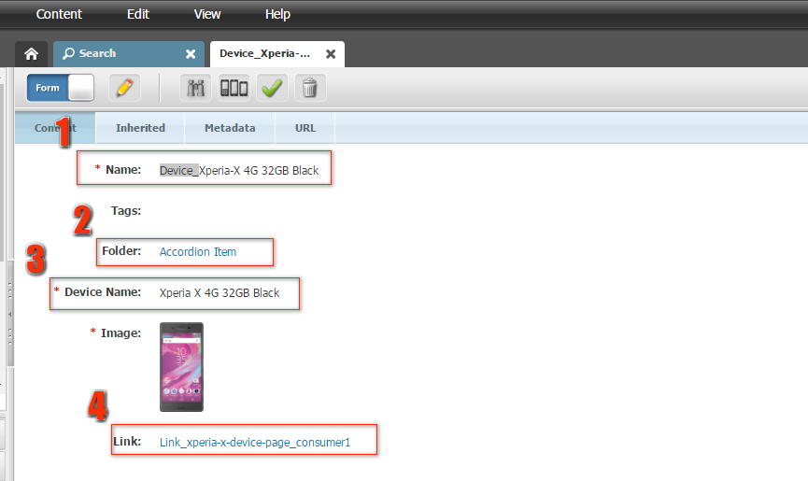

5. Click on save button to save the asset.

### Refreshing the device listing page

Following urls are categorised as device listing page:

Mobile Phones: <http://www.vodafone.com.au/mobile-phones>

Tablets: <http://www.vodafone.com.au/tablets>

Mobile Broadband: <http://www.vodafone.com.au/mobile-broadband/modems>

The device listing pages’ content comes from API. Whenever a new device is launched or a device goes EOL then the respective page must be refreshed to add/remove the device from the listing page. This refresh is done after the respective changes have been made to ATG. Following are the steps to refresh the listing page.

1. Log into WCS
2. On the Tools section of the homepage, select the appropriate option for the listings page you want to refresh.
3. Click on Refresh Estore API.

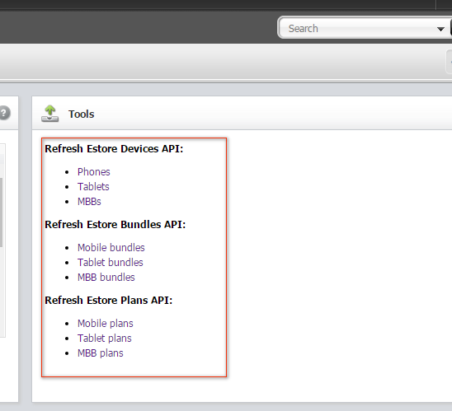

1. For the device to reflect on the site, following json URLs also need be cleared via Akamai cache.
2. Mobile Phones: <http://www.vodafone.com.au/api/dlp_phones.json>
3. Tablets: <http://www.vodafone.com.au/api/dlp_tablets.json>
4. MBB: <http://www.vodafone.com.au/api/dlp_mbb.json>

# Caching in WCS & Audit Process

WCS has an inbuilt caching mechanism. The caching on WCS is on pages and WCS holds the cache for 12 hours and clears automatically. BAU requests which are not time critical can be published to production and changes can be viewed once the WCS clears its cache. Campaign launches and time sensitive BAU requests should be published and WCS cache needs to be cleared immediately so that the changes are reflected on the site.

We can manually clear WCS cache using Akamai. Following are the steps to clear cache using Akamai:

Login URL: <https://invalidate.aws.vodafone.com.au/login> - You will have to be on a VPN to access this.

Things to note + quirks:

* Assets will automatically have their cached flush after 24 hours since their last flush.
* When planning the REST modules for plan sliders, it may take 5-10 minutes before the plan slider loads on the page again.

## How to clear the cache of a page

This process will clear the cache over a page. This will usually happen in a few seconds if it's a short list of pages, but may take up to 10-15 minutes for a sidewise cache flush.

NOTE: This guide will run through how to flush the cache for the live site. To flush QA environments its the same process but instead log into the "Test" environment instead of "Production"

1. Log into Cloudfront using the above URL and **your Vodafone login** details. Make sure to login to Production.

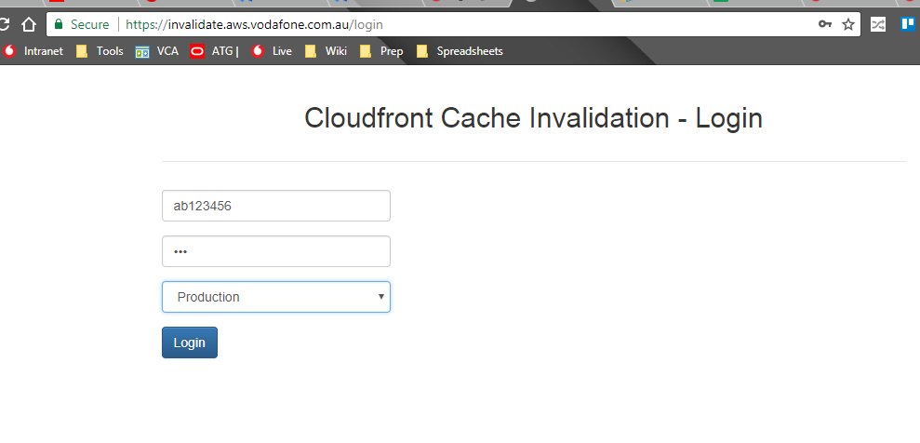

1. Navigate to the "[UCMS-PRODUCTION](https://invalidate.aws.vodafone.com.au/#UCMS-PRODUCTION)" tab and click on the heading with "[shop.vodafone.com.au](http://shop.vodafone.com.au/)" underneath

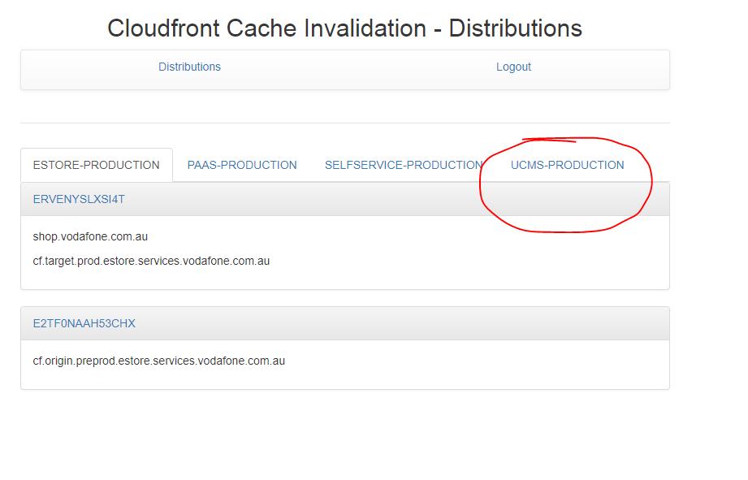

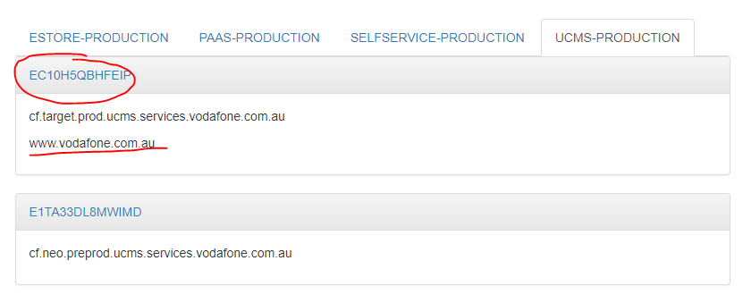

1. Click on the "New invalidation" tab
2. Type in your URL paths with each URL being on a new line.
   1. NOTE: This tool is DIFFERENT to Akamai. **Do not add "https://www.vodafone.com.au".**
      1. Some examples:
         1. [https://www.vodafone.com.au](https://www.vodafone.com.au/)/plans should be just "/plans" in Cloudfront
         2. [https://www.vodafone.com.au](https://www.vodafone.com.au/)/ should be just "/" in Cloudfront
   2. You can flush all child pages by using * . e.g. /plans/* to flush all pages under /plans/
   3. For sitewide cache flush just use * .
3. Click 'create' to flush the cache
4. You can check the progress under 'Invalidations' tab

The page for which cache needs to be cleared should be entered in both http as well as https urls. Please refer to the screenshot. If there has been a change in the price point asset then following url needs to be added: <http://www.vodafone.com.au/sites/REST/resources/v1/aggregates/VCA/Box/1448486835538?assetDepth=3>

The id at the end represents the asset id for the price point asset.

A single URL should be added in each line.

## Audit Process

As a producer, you would have to audit the site often. This is to find all the touchpoints impacted by a project or group of projects. This could include

• Offer launches/extensions/removals

• Refreshes (plans and/or brand)

• Device launches/EOLs

• Component projects, etc.

Here are the main steps when auditing the site:

1. Create a google spreadsheet with columns for pagename, URL, and touchpoints to be updated. Here is a sample.

2. Use the Site IA to identify relevant pages or URLs

3. If the audit is related to an offer, use the offer list to cross-check all the touchpoints

4. If you're looking for instances of a specific word/phrase, use Google search engine to look for touchpoints.

• From Google, search for site:www.vodafone.com.au "<text here>" this will provide you with all relevant pages.

5. Remember to include the Cludo search content when auditing. This includes

a. Cludo banners

b. keywords

# Half Price for Prepaid MBB and Voice

## Half Price Overview

The prepaid products are sold at an Half Price for a particular cycle time. We will receive the product details that will undergo the half price cycle from the Prepaid team Via Briefs through D-Forum. The brief will contain the following information:

-Product details

-Start/End dates

-Timelines for delivery of the terms of the offer, if the terms are not yet delivered.

-List of any other live or planned offers that will be impacted by this offer

-External marketing support details (vendor, performance media etc), if any

-Level of urgency for the delivery of offer with expected timelines

-Merchandising details etc.

Based on the brief Design and the Copy teams will be indulged. Producer will setup the ATG/VCA changes accordingly and send the in-situ to Stakeholder and Legal for Feedback & Approvals.

- If there are any feedback with respect to copy and design the respective teams are indulged to re-iterate the changes.

-Followed by produce to re-work the changes and send them back for approvals.

Once we receive final confirmation the project can be deployed as per the timelines and will be communicated via mail to the stakeholder.

## Ticker for Hot-offers page

* Two days before the end date, ticker is to be placed in the hot-offers page for Prepaid voice and MBB.
* Make sure while placing ticker it should be according to AEST/AEDT.

## Prepaid Homepage and homepage VCA changes

* Check the banner image.
* The content in the banner should be same as that of the copy deck.
* Roundel should be present according to the copy deck.
* Body copy content to be as same as the copy deck.
* Check whether the link works or not (clickable).
* All the links should be working.
* All the links should direct to correct pages.
* Check out whether correct dates are available

## Prepaid Plans Page / Prepaid Broadband Plans page VCA changes

* Check the banner image.
* The content in the banner same as that of the copy deck.
* Roundel should be present according to the copy deck.
* The Find out more link -should work.
* All the links should be working and check the tracking.
* All the links should direct to correct pages.
* The half price for the old value should be removed.
* "Check whether the price point shows the half price correctly for the new offer".
* The highlights below the price point should be correct (Now with bonus data in Oz*).
* The highlights below the half price, price point should be correct (~Now half price).
* Check out the hot offers section (highlight) for the half price information.
* Terms and conditions to be checked with the copy deck.
* Check out whether correct dates are available.

## MCP page VCA changes

* In the given touch points, update the terms for the page.

## Hot-Offers

* Check the banner image.
* "The contents of the banner should be same as that of mentioned in the copy deck".
* "The Find out more link -should be clickable and should direct to correct page and check the tracking".
* "The position of the banner should be according to the latest merchandising calendar".
* Check out whether correct dates are available.

## ATG changes

* "The add to cart for the half price offer should display half the price

**Eg**: offer for $50 hence the value to be displayed as $25".

* Check out the terms and conditions with the copy deck.
* Check out whether correct dates are available.
* Half price carousal copy should be visible for the half price offer.
* Check for the highlight.

## Working in ATG

* Create discount SKU and map it to Discount.
* Under the specific Bundle SKU map the created discount SKU and remove the existing discount SKU.
* While removing the existing discount SKU, give the End Date and in the Display Name, Management display name replace the content with --- followed by the content that’s present( meaning it is now NA).
* Add the respective terms and remove from the existing one from the bundle SKU.
* Map the half-price to the respective bundle SKU and replace the existing value to its initial price (Eg:$40->$20,now $40->$40)

## Touch Points

|  |  |
| --- | --- |
| **Offer Name** | **VCA Pages** |
| Half Price $40 MBB Prepaid Starter pack | * <https://www.vodafone.com.au/mobile-broadband/prepaid> * <https://www.vodafone.com.au/hot-offers> |
| Half price $40 Combo Plus Starter Packs | * <https://www.vodafone.com.au/> * <https://www.vodafone.com.au/hot-offers> * <https://www.vodafone.com.au/students?DealerCode=PH0002> * <https://www.vodafone.com.au/prepaid> * <https://www.vodafone.com.au/prepaid/plans> * <https://www.vodafone.com.au/mcp/data-offer> * <https://www.vodafone.com.au/mcp/anniversary-prepaid-data> * <https://www.vodafone.com.au/mcp/anniversary-prepaid> * <https://www.vodafone.com.au/mcp/prepaid-365> * <https://www.vodafone.com.au/mcp/weekenders> * <https://www.vodafone.com.au/mcp/christmas> * <https://www.vodafone.com.au/mcp/data-deal> * <https://www.vodafone.com.au/mcp/move> |

## Westpac Offer

* This offer entitles price off on prepaid bundle. It occurs along with the half price campaign and follows the same time cycle respectively based on the hero price.
* Get the price details, offer duration from the brief.
* Setup an ATG project and create the following

-Separate bundleSku for Westpac – Refer ATG documentation for bundle creation.

-Separate planSku with the discounted price.– Refer ATG documentation for planSku creation.

-Create discount sku and associated it to the bundle.– Refer ATG documentation for discounts Sku creation.

-Add all the above to their respective parent category.

* Add in the respective offer related terms from the brief.
* Push the project to staging and share the Add to cart deep link.

## Cart deep links

* <https://shop.vodafone.com.au/cart/addToCart.jsp?bundleSkuId=sku1351860432stgvha>   - Combo Plus Prepaid $40 – Westpac offer
* <https://shop.vodafone.com.au/cart/addToCart.jsp?bundleSkuId=sku1351900543stgvha>   - Combo Plus Prepaid $50 – Westpac offer

# BAUs

## BAU Overview

Any request of the Stakeholder will be raised as a JIRA ticket and accordingly assigned to the digital team for support. So, once a producer receives a BAU,

* They go through the feasibilities of the request to be fulfilled by the team. If it is feasible, the producer takes it up or keeps in under tracking to be done prior to go live date.
* If not, like when the request needs any more information, the Producer queries the Stakeholder for the needed data*
* The information being queried may be Image assets, Clarity on Copy changes, Price changes and Other Clarifications regarding the go live and so on
* The BAU once is initiated by the Producer gets moved to IN PROGRESS state. Once the changes are done, the Producer then sends out the URL to the Stakeholder. The ticket is now moved to DONE state*
* If the ticket is being placed under tracking to be done later in time, a mail is sent to the Stakeholder intimating of the state of their request. In general, the SLA days for a ticket is 5 days, before which the ticket should be closed and if not, the Stakeholder should be informed about it. Any ticket that needs assets/copy will be taken up by the designers/copyrighters and will be places under content triage team for the time being. Once the data is provided, the cycle begins

**What is Business as usual** (**BAU**)

The normal execution of standard functional operations within an organization - forms a possible contrast to projects or programs which might introduce change.

The changes that are required would be raised in the form of JIRA tickets and provided to the Producers in the form called BAUs.

## Creating New support Pages

Once a BAU is raised for the creation of a new Support Page, following steps are to be kept in mind:

* Check to see if the Copy deck (provided via mail or attached in the JIRA card) have all the clear information
* Check to see if the assets needed are provided(if not, raise it against the mail or card for the assets)
* Start building the Page(follow the instructions for the creation of various page components using the attached document below)
* Once the page has been created, if it is a “NO follow and NO Index”, then simply update the siteIA and create the Vanity URLs if provided
* If the Page is a page with meta follow, meta index, place the page under the appropriate header in the site tree
* Update the Cludo for every page with Meta follow, Meta index as YES
* Follow the Support page template
  + Every support page has to have a header(use the default assets and intimate of it)
  + The header should be relevant (eg., for mcp page creation, use the default header for mcp pages and so on)
  + Content
  + SearchBar
  + Icons(if necessary do the changes as well)
  + Terms(there should be no space between the terms accordion and the footer)
* Update the Site IA sheet
* If the Page needs to be redirected to from some other page, do the redirects as well
* Always check the mobile version

## RTDM

The RTDM (Real-time Data Monitoring) BAUs are raised by Jemma Rice. In the event of an RTDM BAU, follow the provided in the below URLs:

* <https://vodafone.atlassian.net/wiki/spaces/DDP/pages/677183492/RTDM+T+C+Configuration>
* <https://vodafone.atlassian.net/wiki/spaces/DDP/pages/7536710/S3+File+Uploads+-+images+docs+files>

## Vanity URL

Vanity URL creation BAUs require the creation of URL and associating it with the pages. Tracking needs to be obtained from the onshore Producers (or mail the one raising the BAU asking for the tracking details)

The following table has to be sent to the one raising the BAU asking for the tracking details:

|  |  |  |  |  |  |  |  |
| --- | --- | --- | --- | --- | --- | --- | --- |
|  | **Segment** | **Subscription Type** | **Product Category** | **Audience** | **Channel** | **Campaign Type** | **Campaign Name** |
|  | (Enterprise [EBU] or Customer [CBU]) | Product type (post/pre/simo) | Device category (mob/tab/mbb/all) | (new/cus/pros/rtg) | (Social [soc], eDM [edm],Paid Search [sem], Affliliates [aff], Redirect [red]) | (Retail [ret],SMS [sms], Legal [leg], Migration [mig], Service [ser]) |  |
| The URL for the page |  |  |  |  |  |  |  |

NOTES:

* Check the vanity if it has already been created already either in the vanity page or redirect page
* Only give out Vanity URLs that which don’t have multiple redirects (to see what the **target URL** is look at the **rule example** below). Ie:  [www.vodafone.com.au/prepaidoptions](http://www.vodafone.com.au/prepaidoptions) is meant to go to <http://www.vodafone.com.au/personal/prepaid/home/options/index.htm> however because of a site refresh it now redirects twice to <http://www.vodafone.com.au/personal/prepaid> . We would not want to use this vanity as there are multiple redirects in place and may be a poor experience on a slower connection.

## Short URL

Short URLs are not created preferably unless asked in particular. In the event of BAU asking for the short URLs are raised, create Vanity and intimate the ticked raiser that the general procedure is to create short URLs

If the short URLs are needed, create them under the <https://shorturl.aws.vodafone.com.au/management>

## Retire and Redirect

Steps to be followed when EOL ing a page:

* Edit the name of the Support page with a prefix of “EOL”
* Check if the Page is a Meta Follow and Meta Indexed page. If so, set the meta follow and index to NO
* Delete the URL from the page (keep track)
* Create the URL in redirect page
* Redirect every reference of the page to the necessary URL (mostly to the homepage of the particular category)
* Look for the page in site tree and place it under the “Unplaced Pages” category
* Check the <https://www.vodafone.com.au/sitemap.xml> for the page breaks, if any
* Refresh the cache of the sitemap.xml
* Update the URL in Cludo
* Update the Site IA sheet
* Redirect the pages after the EOL process and update the associated URLs

Refer the wiki document for the process:

<https://vodafone.atlassian.net/wiki/spaces/DDP/pages/159514638/How+to+retire+end+of+life+a+page+in+VCA>

## Promo code creation

The promo codes along with the particular plans will be provided in the card. Create them in ATG and follow the process of Promo code creation as in the following

<https://vodafone.atlassian.net/wiki/spaces/DDP/pages/102630206/Promo+Code+Offers>

FYI - the Promo codes can be created prior to the dates as they become active only by the start dates provided in them.

## Long Terms

Page URL: <https://www.vodafone.com.au/about/legal/plan-details>

The terms are to be updated under the appropriate category in VCA.

## Campaign Page creation and Updates

The Campaign pages need to be created as per the copy deck and associated with the needed pages. Update the URL in Cludo.

Campaign Page creation and Updates

# User Creation, Termination and Password Reset

## UAM Overview

* DL-AU-Digital-Operations-IND receives emails from UAM Request team to create ATG User ID Creation /Password Reset or ATG ID Termination.
* UAM Team will send email with the details such as Employee on boarded ID, however this information is not sufficient enough to proceed with the ATG User ID Creation /Password Reset request.
* Request the team to provide details such as Full Name and Email address.
* Check whether we have got the name, TechM mail id and correct ATG Id.
* Follow the below detailed steps to complete the request and reply the team with the relevant information such as ATG ID.
* Password has to be shared only with the user via their email address for privacy.
* Please note if the request is delayed, UAM team will raise an escalation. The SLA is 5 business days.
* Once the request is complete please raise a BAU request using the link <http://intranet.vodafone.com.au/resources/digital-work-request> to keep them on track.

## User Creation

Go to : <http://bcc.prod.estore.aws.vodafone.com.au/atg/bcc/home>

Go to Personalization-> CSR users

Click the Plus Symbol in it and give new Store user.

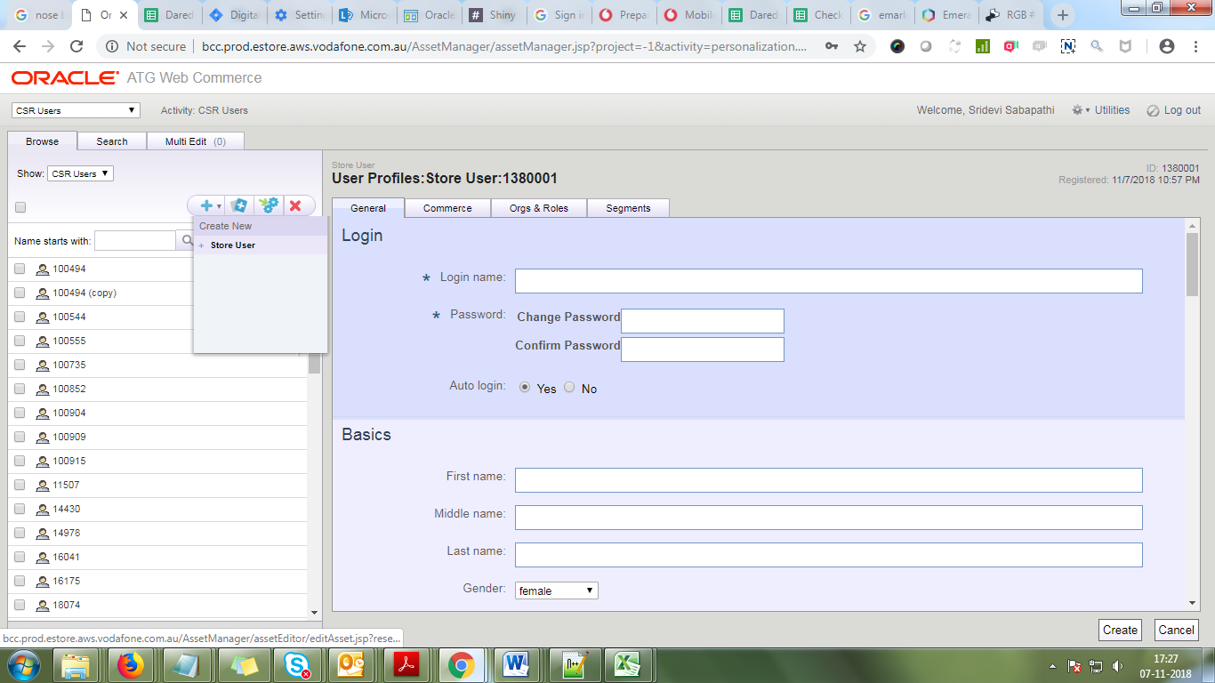

* Give the name of the user.
* For Password please follow the below format.
* If the name of the user is Nxxx Pxxx and ATG Id is 61012345.
* Then we will keep the Username as NP12345. We could use the same for the password or we could change the cases for the alphabets used.
* Few examples: NP12345, nP12345, Np12345, np12345.
* Save them, under org & roles please change the role as admin.
* Once done send the mail to the user separately and reply to the UAM request team mail by sharing the user name.

## Password Reset

For password reset we need to find the correct user in the system and change the password according to the below examples.

If the name of the user is Nxxx Pxxx and ATG Id is 61012345.

Reset could be like the following: NP12345, nP12345, Np12345, np12345.

Once done send the mail to the user separately and reply to the UAM request team mail by sharing the user name.

## User Termination:

For user termination, find the correct user id and go to Org & Roles.

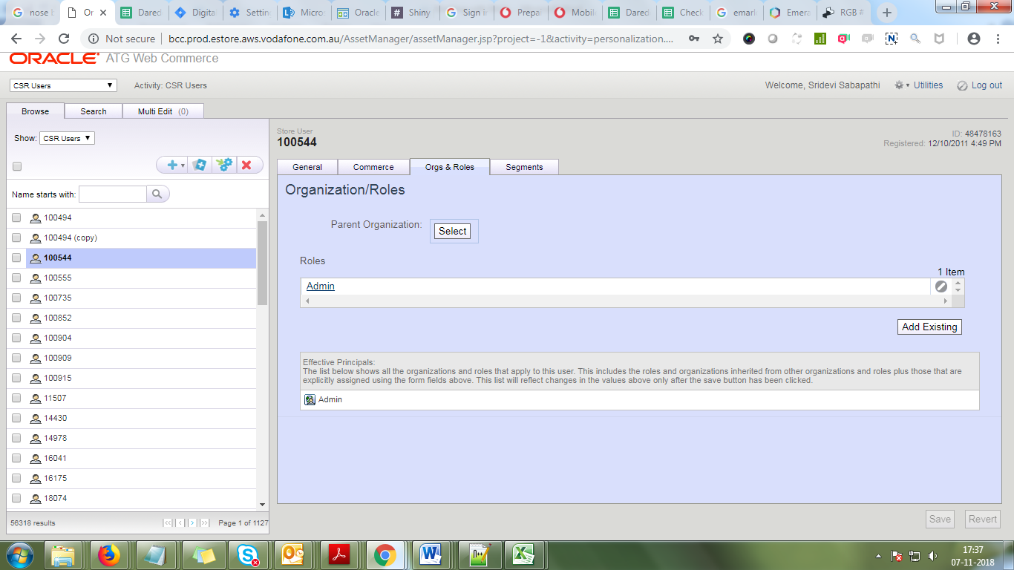

Remove the Admin role from the user and give save.

User is terminated. Send the mail to the UAM request team.

# ****Offers****

## Offers Overview

* Digital Sales team is first point of contact for Digital Operations for any BAU offers.
* Digital Sales team gathers as much information/details about the offer as available.
* Digital Sales team to engage for delivery through the D-Forum.
* Digital Sales team would present the offer in D-forum where they would present the following information:
  + Offer brief containing details of the offer.
  + Timelines for the terms of the offer if the terms are not present in offer brief.
  + Offer priority from sales and business perspective.
  + Performance marketing support details, if any.

## Upgrades Offer

* Use the following test MSISDN (or if you have your own upgradeable MSISDN)
* 61410671638 ( Password@1 )
* Log in through My Vodafone, 'Current plan' > 'Upgrade'
* Navigate to either 'Mobile + Plan' or 'Plan only' upgrade options
* Repeat Default journeys accordingly
* NOTE: DO NOT PROCEED PAST CHECKOUT PAGE
* 2nd Service (note: This offer only surfaced when you checkout as existing customer)
* After going through Default journey, checkout as an existing customer
* Enter a valid MSISDN (you can use your own Vodafone MSISDN to checkout as this would require a One Time Password to proceed)
* Total value should include 1% off original price

## Delivery of the offer

* After the offer is presented in D-Forum, it is then prioritized and a delivery team is then assigned to work on the offer.
* Iteration Managers will understand the details of the offer and will decide if a kick-off meeting with the Digital Sales team or relevant team members is required.
* Depending on the offer construct and priorities, if the offer requires merchandising, Iteration Managers will engage Digital Product Owners for merchandising support.
* The assigned squad will create assets and build the offer within the CMS.
* The offers will be delivered with all touch points including merchandising on the start date of the offer.

## ****Urgent/Reactive Offers****

**These offers are defined as a response to a competitor or filling an immediate sales gap.**

1. Product Manager engages with Copy writer, and both attend the CBU alignment session for reactive offers.
2. Product Manager writes the brief and emails to Copy writer and DL-offers.

* PLEASE NOTE: Standard reactive offer process applies in parallel for the Digital Operations delivery team at this point.

1. Copy writer writes copy for relevant platforms.
2. Copy writer sends copydeck to:

* Designer to mock up digital assets.

1. Designer seeks digital asset feedback from Product manager.
2. Meeting with relevant retail stakeholders and Copy writer to seek feedback.
3. If required, copy is updated and reissued to:

* Designer to update digital assets.

1. If ready together, digital sends all assets to legal. Otherwise, digital and retail send assets to legal separately with a cc of Copy writer, Iteration Manager & Designer.
2. If required, copy is updated and reissued to:

* Designer to update digital assets

1. Assets deployed by all teams.